50 Meals Under $10

- CREAMY MUSHROOM CHICKEN W CRISPY ONIONS 1
- CAJUN SAUSAGE AND RICE SKILLET 4
- SLOW COOKER HAMBURGER STEW 7
- PESTO SHRIMP PASTA 10
- ONE POT LEMON ARTICHOKE CHICKEN AND RICE 13
- BEEF TACO SKILLET 16
- CREAMY PESTO PASTA WITH CHICKEN & BROCCOLI 19
- EASY BBQ CHICKEN SANDWICHES 22
- SUMMER SWEET CORN SALAD 25
- SPINACH STUFFED PORTOBELLOS 28
- PIZZA PASTA SALAD 31
- SALISBURY STEAK WITH MUSHROOM GRAVY 34
- TURKEY CHILI SMOTHERED SWEET POTATOES 37
- LOUISIANA STYLE RED BEANS AND RICE 40
- ROASTED CAULIFLOWER TACO BOWLS 43
- CREAMY CHICKEN AND RICE SKILLET 47
- CRUNCHY CHICKEN RAMEN STIR FRY 50
- SLOW COOKER CHICKEN NOODLE SOUP 53
- SMOKY ROASTED SAUSAGE AND VEGETABLES 56
- LENTILS WITH CREAMY MUSHROOM GRAVY 59
- CHILI CORNBREAD SKILLET 62
- VEGETABLE BARLEY SOUP 65
- TERIYAKI MEATBALL BOWLS 68
- GARLIC BUTTER BAKED CHICKEN THIGHS 71

- MUSHROOM AND SPINACH PASTA WITH RICOTTA 74
- CHIPOTLE BUTTERNUT SQUASH AND QUINOA SALAD 77
- HERB ROASTED PORK TENDERLOIN 80
- CHICKEN AND LIME SOUP 82
- SWEET AND SOUR PORK CHOPS WITH VEGETABLES 85
- CREAMY COCONUT CURRY LENTILS WITH SPINACH 88
- TOMATO MOZZARELLA PASTA SALAD WITH BALSAMIC VINAIGRETTE 91
- BBQ BEEF AND BEANS 94
- BAKED SPICY CHICKEN SANDWICHES 97
- SPICY ORECCHIETTE WITH CHICKEN SAUSAGE AND KALE 100
- ONE POT TERIYAKI CHICKEN AND RICE 103
- MARINATED PORTOBELLO MUSHROOM BURGERS 106
- EASY CILANTRO LIME CHICKEN 109
- TEMPEH BURRITO BOWLS 112
- EASY OVEN BAKED FISH WITH TOMATOES 115
- VEGAN PEANUT STEW 117
- KALE SWISS AND MUSHROOM STRATA 120
- BBQ BEEF AND CABBAGE 123
- MEDITERRANEAN HUMMUS BOWLS 126
- SLOW COOKER CHICKEN TORTILLA SOUP 128
- RATATOUILLE FRITTATA 131
- ONE POT CREAMY CAJUN CHICKEN PASTA 134
- VEGAN WINTER LENTIL STEW 137
- CHEDDAR CHEESEBURGER MEATLOAF 140
- ZUPPA TOSCANA 143
- EASY SLOW COOKER CHICKEN TIKKA MASALA 146

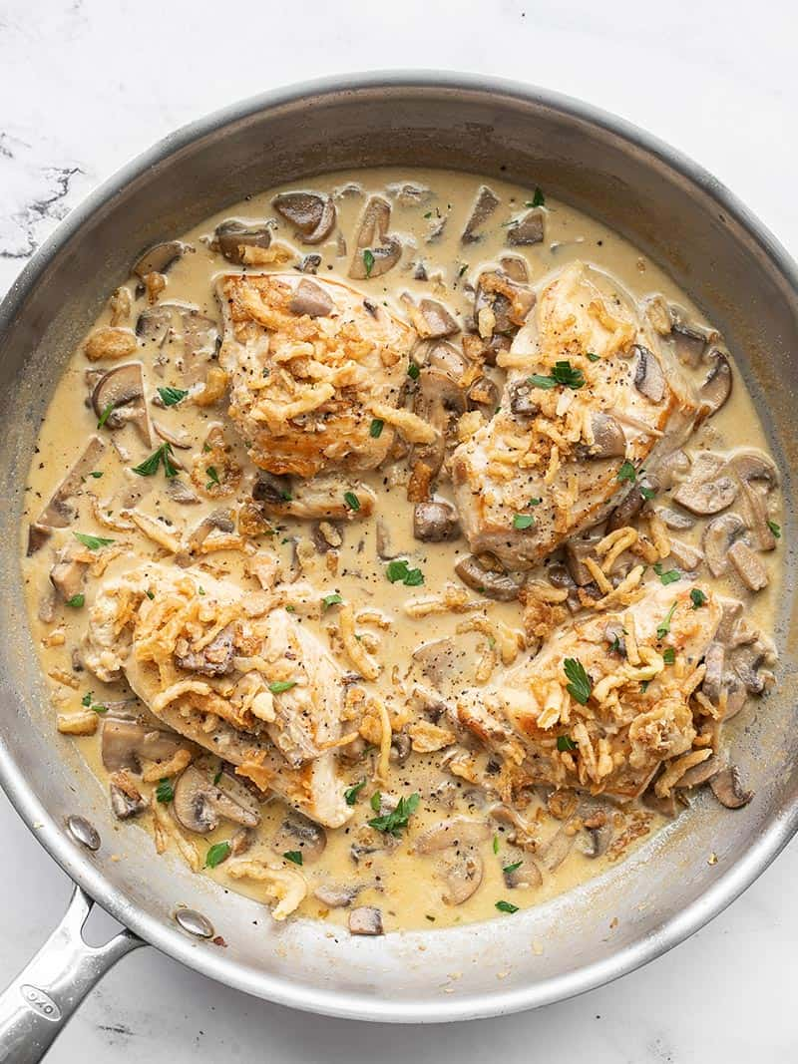
CREAMY MUSHROOM CHICKEN WITH CRISPY ONIONS
$8.70 RECIPE / $2.18 SERVING

Prep Time: 10 mins
Cook Time: 25 mins
Total Time: 35 mins
Servings: 4

Ingredients

- 8 oz. baby bella mushrooms ($1.69)
- 2 boneless, skinless chicken breasts (about 1.3 lbs. total) ($5.63)
- 1 pinch salt ($0.02)
- 1 pinch pepper ($0.02)
- 2 Tbsp butter, divided ($0.26)
- 4 cloves garlic ($0.32)
- 1/2 cup chicken broth ($0.07)
- 1/2 cup heavy cream ($0.39)
- 1/4 cup crispy fried onions ($0.37)
- 1 Tbsp chopped fresh parsley (optional garnish) ($0.05)

Directions
- Rinse and slice the mushrooms. Set the sliced mushrooms aside.
- Place the chicken breasts on a cutting board and cover with plastic wrap. Use a mallet or rolling pin to gently pound the chicken until it is an even thickness, about ¾-inch thick. Cut each chicken breast into two pieces, and season with a pinch of salt and pepper.
- Add one tablespoon of the butter to a large skillet and heat over medium. Once the butter is melted and the skillet is hot, add the chicken and cook until golden brown on both sides (about 5 minutes per side). Remove the chicken to a clean plate and cover with foil or an upside-down plate to keep it warm.
- Add the second tablespoon of butter and the sliced mushrooms to the skillet. Sauté the mushrooms until they release all their water, and the skillet begins to dry up again. Add the minced garlic and sauté for about a minute more.
- Pour the chicken broth into the skillet and stir to dissolve any browned bits off the bottom of the skillet. Add the heavy cream and stir to combine.
- Return the chicken to the skillet and spoon mushroom cream sauce over each piece. Allow the chicken to simmer in the sauce for about 5 minutes more, or until the sauce is slightly reduced. Top the chicken with the crispy fried onions and serve.
Nutrition Facts
Serving: 1serving ・ Calories: 369.8kcal ・ Carbohydrates: 5.25g ・ Protein: 36.13g ・ Fat: 22.4g ・ Sodium: 345.45mg ・ Fiber: 0.65g
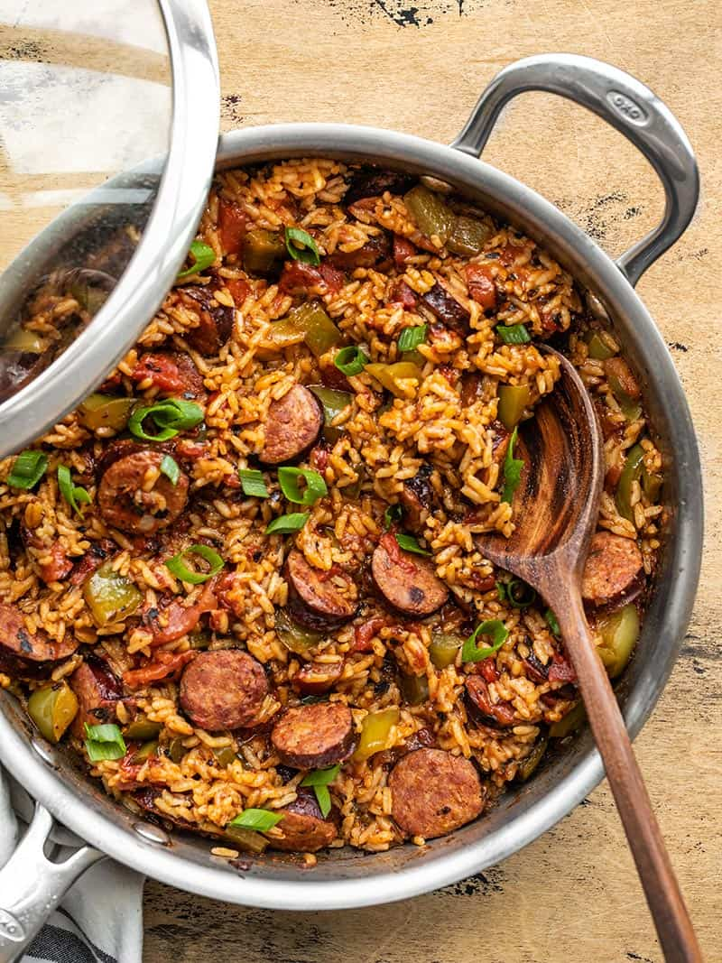
CAJUN SAUSAGE AND RICE SKILLET
$7.21 RECIPE / $1.80 SERVING

Prep Time: 15 mins
Cook Time: 30 mins
Total Time: 45 mins
Servings: 4 (1.5 cups each)

Ingredients

- 14 oz. Andouille sausage* ($3.99)
- 1 Tbsp cooking oil ($0.04)
- 1 bell pepper ($0.89)
- 1 tsp smoked paprika ($0.10)
- 1/2 tsp dried oregano ($0.05)
- 1/2 tsp dried thyme ($0.05)
- 1/4 tsp garlic powder ($0.02)
- 1/4 tsp onion powder ($0.02)
- 1/8 tsp cayenne pepper ($0.02)
- 1/8 tsp freshly cracked black pepper ($0.01)
- 1 15oz. can fire roasted diced tomatoes ($1.00)
- 1 cup long grain white rice ($0.62)
- 1.5 cups chicken broth ($0.20)
- 2 green onions, sliced ($0.20)

Directions
- Slice the sausage into ¼-½ inch thick slices. Add the sausage and cooking oil to a deep skillet or Dutch oven and sauté over medium heat until the sausage is well browned. Don't worry if the sausage begins to brown on the bottom of the skillet. That's extra flavor that will cook into the rice later.
- While the sausage is cooking, dice the bell pepper. Once the sausage is browned, add the bell pepper to the skillet and continue to sauté for about one more minute.
- Add the spices (smoked paprika, oregano, thyme, garlic powder, onion powder, cayenne, and black pepper) to the skillet with the sausage and bell pepper and continue to sauté for one minute more to toast the spices.
- Add the fire roasted diced tomatoes (with juices), rice, and chicken broth to the skillet. Stir to combine and dissolve any browned bits off the bottom of the skillet.
- Place a lid on the skillet, turn the heat up to medium-high, and allow the broth to come to a full boil. Once it reaches a boil, turn the heat down to low and let the skillet simmer for 20 minutes. After 20 minutes, remove the skillet from the heat and let it rest, with the lid on, for an additional 5 minutes.
- After the skillet has rested, remove the lid, and fold the sausage and rice to redistribute the rice and sausage throughout. Top with sliced green onions and serve!
Nutrition Facts
Serving: 1.5cups ・ Calories: 547.75kcal ・ Carbohydrates: 50.8g ・ Protein: 22.23g ・ Fat: 28.8g ・ Sodium: 1328.93mg ・ Fiber: 4.15g
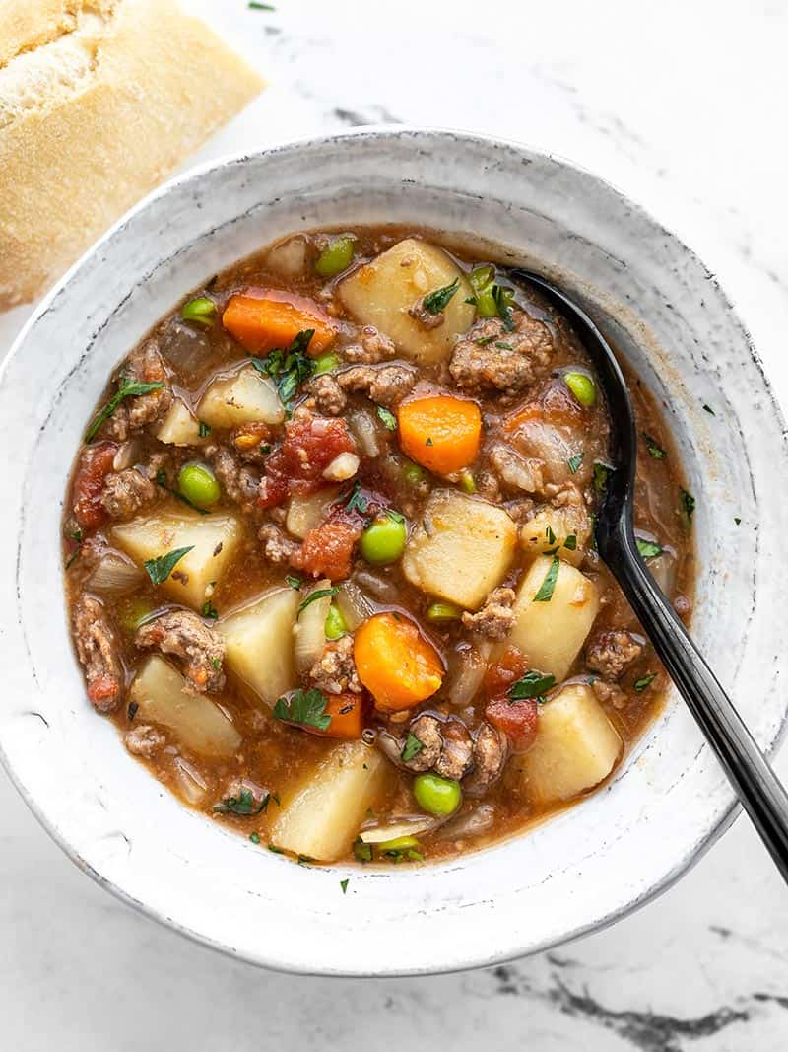
SLOW COOKER HAMBURGER STEW
$9.88 RECIPE / $1.65 SERVING

Prep Time: 15 mins
Cook Time: 4 hrs 15 mins
Total Time: 4 hrs 30 mins
Servings: 6 (1.5 cups each)

Ingredients

- 2 lbs. russet potatoes ($1.20)
- 1/2 lb. carrots (about 4 carrots) ($0.45)
- 1 yellow onion (0.32)
- 2 cloves garlic ($0.16)
- ½ tsp dried rosemary ($0.05)
- ½ tsp dried thyme ($0.05)
- 1/4 tsp freshly cracked black pepper ($0.02)
- 1 lb. ground beef ($5.69)
- 1 15oz. can stewed tomatoes ($1.00)
- 2 cups beef broth ($0.26)
- 2 Tbsp Worcestershire sauce ($0.02)
- 1 Tbsp soy sauce ($0.06)
- 1 cup frozen peas ($0.60)

Directions
- Peel and dice the potatoes into 1-inch cubes. Peel and slice the carrots. Dice the onion and mince the garlic. Add the potatoes, carrots, onion, garlic, rosemary, thyme, and pepper to a slow cooker (4 quarts or larger).
- Brown the ground beef in a skillet, then drain off the excess fat. Add the browned and drained beef to the slow cooker along with the can of stewed tomatoes (with juices). Finally, add the beef broth, Worcestershire sauce, and soy sauce to the slow cooker.
- Give the contents of the slow cooker a brief stir to make sure everything is evenly combined (the broth may not fully cover the other ingredients). Place the lid on the slow cooker and cook on high for four hours, or low for eight hours.
- After cooking on high for four hours or low for eight hours, remove the lid and stir the stew. Use the back of a spoon to slightly mash some of the potatoes, which will help thicken the stew.
- Add the frozen peas (no need to thaw) and stir to combine into the stew. Taste the stew and add extra salt if needed (I did not add any, this will depend on the salt content of your beef broth). Serve hot with bread for dipping!
Nutrition Facts
Serving: 1.5cups ・ Calories: 348.27kcal ・ Carbohydrates: 41.42g ・ Protein: 20.15g ・ Fat: 11.83g ・ Sodium: 751.72mg ・ Fiber: 5.07g
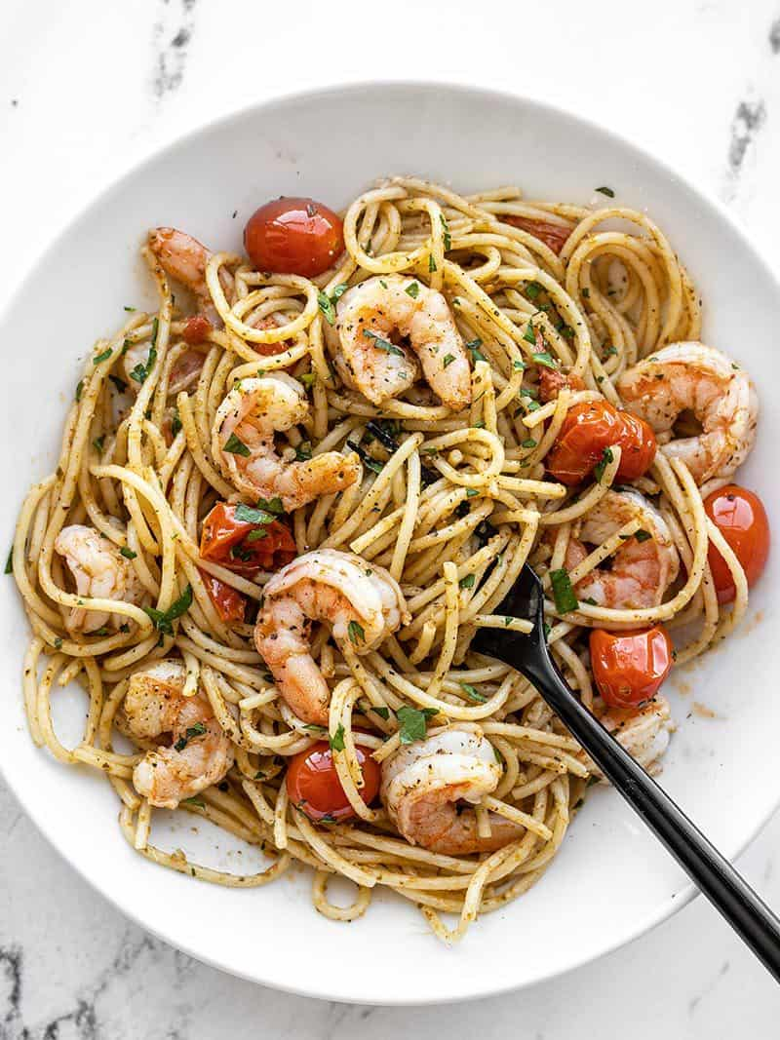
PESTO SHRIMP PASTA
$$8.07 RECIPE / $2.02 SERVING

Prep Time: 10 mins
Cook Time: 15 mins
Total Time: 25 mins
Servings: 4

Ingredients

- 12 oz. shrimp, peeled and deveined ($4.99)
- 8 oz. angel hair pasta ($0.53)
- 2 Tbsp olive oil, divided ($0.24)
- 2 cloves garlic, minced ($0.16)
- 1 pint grape tomatoes ($1.49)
- 1/4 cup basil pesto ($0.55)
- 1 Tbsp grated Parmesan ($0.11)

Directions
- If using frozen shrimp, place them in a colander and run cool water over top to thaw (this should only take a few minutes). Peel the shrimp and remove the tails. Pat the shrimp dry with a paper towel.
- Bring a large pot of water to a boil for the pasta. Once boiling, add the pasta and continue to boil until the pasta is tender (about seven minutes). Reserve about ½ cup of the starchy pasta water before draining the pasta in a colander.
- While the pasta is cooking, prepare the rest of the dish. Heat 1 Tbsp olive oil in a large skillet. Once hot, add the prepared shrimp and sauté just until the shrimp turns pink and opaque (2-3 minutes). Remove the cooked shrimp to a clean bowl.
- Add another tablespoon olive oil to the skillet and add the grape tomatoes and minced garlic. Continue to sauté over medium until the tomatoes begin to burst and release their juices. If the garlic begins to brown before the tomatoes have burst, add a couple tablespoons of water to the skillet to slow the browning.
- Once the tomatoes have broken down in the skillet, add the cooked and drained pasta, ¼ cup pesto, and about half of the reserved pasta water. Stir to coat everything in the pesto, adding more of the pasta water if needed to loosen the pasta and spread the pesto over everything.
- Finally, return the cooked shrimp to the skillet and stir to combine with the pasta. Top with grated Parmesan, then serve!
Nutrition Facts
Serving: 1Serving ・ Calories: 446.23kcal ・ Carbohydrates: 49.3g ・ Protein: 26.4g ・ Fat: 15.58g ・ Sodium: 602.68mg ・ Fiber: 3.78g
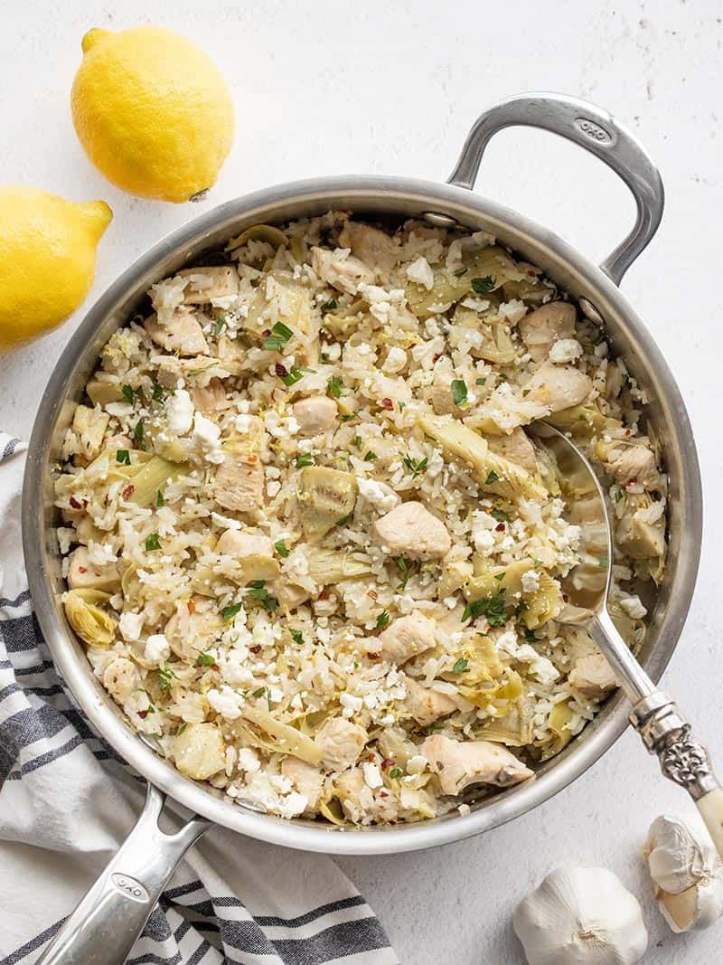
ONE POT LEMON ARTICHOKE CHICKEN AND RICE
$7.39 RECIPE / $1.85 SERVING

Prep Time: 5 mins
Cook Time: 25 mins
Total Time: 30 mins
Servings: 4

Ingredients

- 1 fresh lemon ($0.43)
- 1 lb. Kirkwood Fresh Chicken Breasts (boneless, skinless) ($2.49)
- 2 Tbsp Carlini Extra Virgin Olive Oil ($0.23)
- 4 cloves garlic ($0.16)
- 1 tsp Stonemill Dried Oregano ($0.10)
- 1/4 tsp Stonemill Crushed Red Pepper ($0.02)
- ¼ tsp salt ($0.02)
- 1 12oz. jar Tuscan Garden Quartered Artichoke Hearts ($2.59)
- 1 cup Earthly Grains Long Grain White Rice ($0.25)
- 1.5 cups Chef's Cupboard Chicken Broth ($0.45)
- 1 oz. Emporium Selection Feta Cheese Crumbles ($0.55)
OPTIONAL GARNISH
- 2 Tbsp chopped parsley ($0.10)

Directions
- Zest and juice the lemon. You'll need about 2 Tbsp lemon juice and ½ tsp lemon zest (plus some for garnish).
- Drain and roughly chop the artichoke hearts. Mince the garlic. Cut the chicken breast into ½-inch pieces.
- Add the olive oil to a deep skillet or Dutch oven and heat over medium. Once hot, add the chicken pieces and sauté over medium for about 2 minutes (it will not be fully cooked at this point).
- Add the minced garlic, oregano, red pepper, and salt to the skillet with the chicken. Continue to sauté for about one minute more.
- Finally, add the artichoke hearts, uncooked rice, chicken broth, 2 Tbsp lemon juice, and ½ tsp lemon zest to the skillet. Stir briefly to combine, place a lid on top, then turn the heat up to medium-high.
- Allow the broth to come up to a full boil, then turn the heat down to low or just above low to reduce the broth to a simmer. Let the chicken and rice simmer for 15 minutes without lifting the lid or stirring. After 15 minutes, remove the skillet from the heat and let it rest, undisturbed, for five minutes more.
- Finally, lift the lid, fluff the rice with a fork, and gently redistribute the chicken and artichoke hearts throughout the rice. Top the skillet with crumbled feta, another pinch of lemon zest, and chopped parsley (if desired). Serve hot and enjoy!
Nutrition Facts
Serving: 1serving ・ Calories: 409.48kcal ・ Carbohydrates: 43.65g ・ Protein: 31.73g ・ Fat: 11.65g ・ Sodium: 880mg ・ Fiber: 4.25g
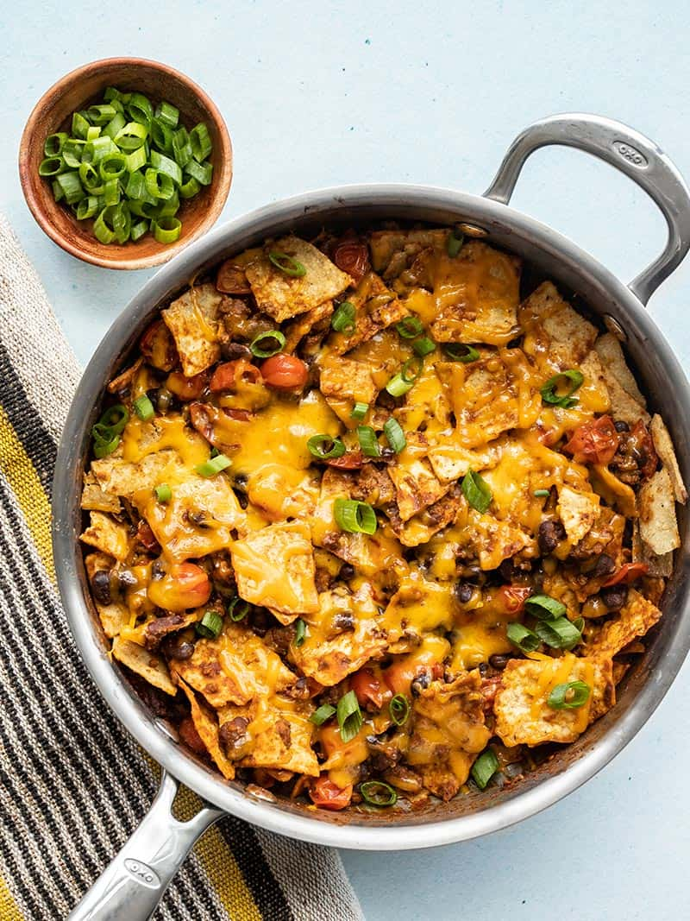
BEEF TACO SKILLET
$6.30 RECIPE / $1.58 SERVING

Prep Time: 5 mins
Cook Time: 20 mins
Total Time: 25 mins
Servings: 4

Ingredients

HOMEMADE TACO SEASONING
- 1 Tbsp chili powder* ($0.30)
- 1 tsp smoked paprika ($0.10)
- 1 tsp ground cumin ($0.10)
- 1/4 tsp cayenne pepper ($0.02)
- 1/2 tsp dried oregano ($0.05)
- 1/4 tsp salt ($0.02)
- 1/4 tsp freshly cracked black pepper ($0.02)
SKILLET INGREDIENTS
- 1/2 lb. ground beef ($2.85)
- 1 15oz. can black beans ($0.89)
- 1 pint grape tomatoes (or one large tomato) ($1.49)
- 4 oz. tortilla chips ($0.50)
- 2 oz. shredded cheddar cheese ($0.42)
- 1 green onion ($0.11)

Directions
- Combine the ingredients for the homemade taco seasoning in a small bowl (chili powder, smoked paprika, cumin, cayenne, oregano, salt, and pepper).
- Slice the green onion and cut the grape tomatoes in half (if using one large tomato, cut it into a small dice).
- Add the ground beef to a skillet and cook over medium until it is fully browned. If you're using a higher fat content beef (20% or higher), drain the excess fat before moving to the next step. If you're using a very lean ground beef (<10% fat) you may need to add a touch of oil to the skillet to keep the beef from sticking.
- While the beef is cooking, rinse and drain the can of black beans. Add the black beans to the skillet with the prepared taco seasoning. Continue to stir and cook over medium heat for about 2 minutes more, or until heated through.
- Add the tomatoes to the skillet and continue to cook over medium, stirring often, until the tomatoes begin to break down a bit (about three more minutes).
- Finally, add the tortilla chips and stir to combine with the other ingredients in the skillet.
- Top the skillet with the shredded cheese, place a lid on top, and let it heat for 1-2 minutes, or just until the cheese is melted. Sprinkle the sliced green onions over top just before serving.
Nutrition Facts
Serving: 1g ・ Calories: 487.05kcal ・ Carbohydrates: 51.88g ・ Protein: 26.4g ・ Fat: 20.5g ・ Sodium: 863.3mg ・ Fiber: 15.1g
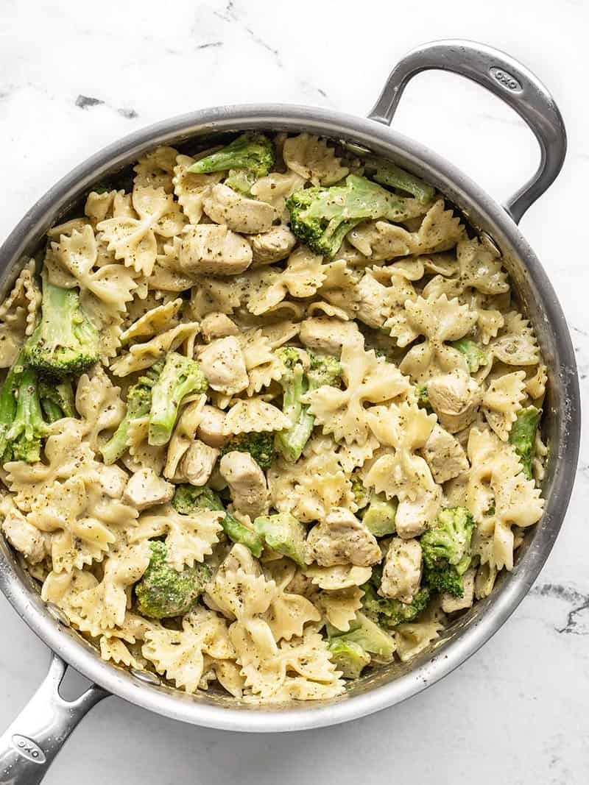
CREAMY PESTO PASTA WITH CHICKEN AND BROCCOLI
$5.48 RECIPE / $1.37 SERVING

Prep Time: 5 mins
Cook Time: 20 mins
Total Time: 25 mins
Servings: 4

Ingredients

- 8 oz. bow tie pasta ($0.67)
- 8 oz. frozen broccoli florets ($1.00)
- 1 Tbsp olive oil ($0.12)
- 1 lb. boneless, skinless chicken breast ($2.49)
- 1/3 cup basil pesto ($0.73)
- 1/2 cup chicken broth ($0.07)
- 4 oz. cream cheese ($0.40)

Directions
- Bring a large pot of water to boil for the pasta. Once it reaches a full boil, add the pasta and continue to boil just until the pasta is tender, but still slightly firm in the center (7-8 minutes). Once the pasta is tender, add the frozen broccoli florets to the water with the pasta and continue to cook for 2-3 more minutes, or until the broccoli is tender. Drain the pasta and broccoli in a colander.
- While the pasta is cooking, cut the chicken breast into ½-inch pieces. Heat one tablespoon of olive oil in a large skillet over medium heat. Once hot, add the chicken and continue to cook until the outside of the chicken pieces are white, but they're still tender in the center (they will continue to cook as more ingredients are added).
- Add the chicken broth to the skillet with the chicken and allow it to heat through. Once hot, add the cream cheese (cut into small pieces) and pesto. Continue to stir and cook until the cream cheese has melted and created a smooth, creamy sauce with the pesto and chicken broth.
- Finally, add the cooked and drained pasta and broccoli to the skillet and stir to coat it in the cream sauce. If the sauce becomes too dry or thick, add another splash of chicken broth to loosen it up. Serve hot.
Nutrition Facts
Serving: 1Serving ・ Calories: 606.33kcal ・ Carbohydrates: 53.58g ・ Protein: 37.18g ・ Fat: 28.33g ・ Sodium: 725.78mg ・ Fiber: 7.15g
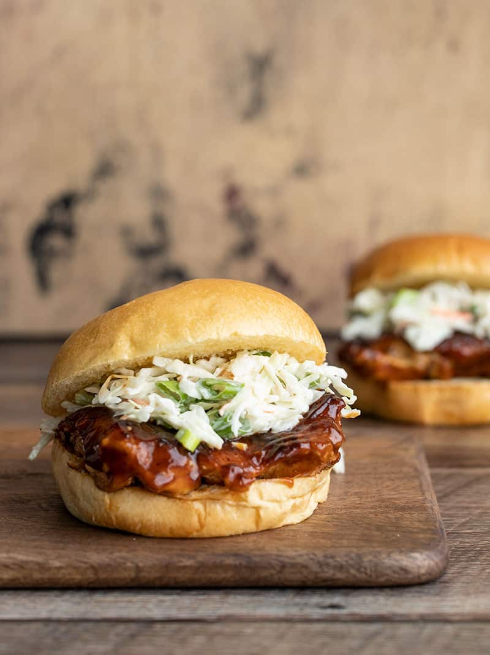
EASY BBQ CHICKEN SANDWICHES
$7.04 RECIPE / $1.76 SERVING

Prep Time: 10 mins
Cook Time: 15 mins
Total Time: 25 mins
Servings: 4

Ingredients

- 1 tsp smoked paprika ($0.10)
- 1/2 tsp garlic powder ($0.05)
- 1/4 tsp salt ($0.02)
- 1/4 tsp pepper ($0.02)
- 1 lb. boneless, skinless chicken thighs ($2.99)
- 1 Tbsp cooking oil ($0.04)
- 1/4 cup BBQ sauce ($0.11)
- 7 oz. coleslaw mix* ($0.65)
- 2 green onions, sliced ($0.20)
- 1/4 cup ranch dressing ($0.37)
- 4 buns ($2.49)

Directions
- Combine the smoked paprika, garlic, powder, salt, and pepper in a small bowl. Cut any large chicken thighs in half to make them more sandwich-sized (you'll want four pieces total). Season both sides of the chicken thighs with the prepared spice mix.
- Heat the cooking oil in a large skillet over medium heat. Once hot, swirl to coat the surface of the skillet. Add the seasoned chicken and cook for 5-7 minutes on each side, or until the chicken thighs are well browned and cooked through.
- Remove the chicken from the heat and brush BBQ sauce over both sides of each piece.
- Add the coleslaw mix, sliced green onions, and ranch dressing to a bowl. Stir until everything is combined and evenly coated in dressing.
- To build the sandwiches, place one piece of BBQ chicken on each bun and top with a heaping scoop of the ranch slaw. Serve immediately.

Nutrition Facts
Serving: 1sandwich ・ Calories: 415.23kcal ・ Carbohydrates: 32.28g ・ Protein: 28.18g ・ Fat: 18.73g ・ Sodium: 1552.98mg ・ Fiber: 2.3g
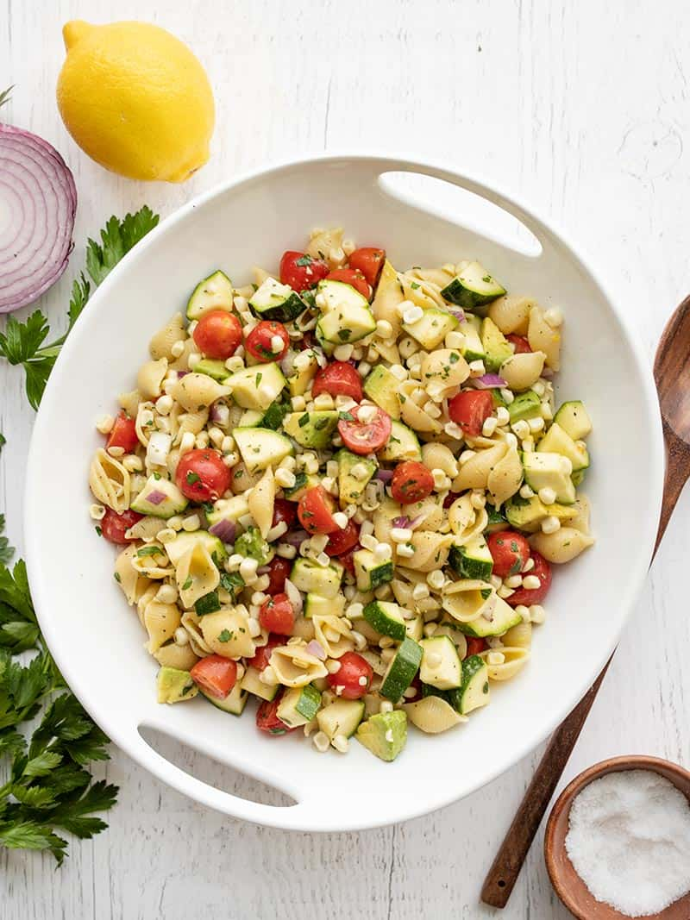
SUMMER SWEET CORN SALAD
$7.67 RECIPE / $0.96 SERVING

Prep Time: 15 mins
Cook Time: 15 mins
Total Time: 30 mins
Servings: 8 (1 cup each)

Ingredients

LEMON VINAIGRETTE
- 1/4 cup olive oil ($0.64)
- 1 fresh lemon ($0.89)
- 1/4 tsp dried basil ($0.03)
- 1 tsp Dijon mustard ($0.04)
- 1/8 tsp salt ($0.02)
- 1/8 tsp pepper ($0.02)
- 1/4 cup chopped parsley ($0.20)
SALAD*
- 8 oz. pasta shells ($0.63)
- 2 cobs sweet corn ($0.80)
- 1 pint grape tomatoes ($2.50)
- 2/3 lb. zucchini ($0.89)
- 1/4 cup diced red onion ($0.11)
- 1 avocado ($0.89)

Directions
- Zest and juice the lemon. You'll need 2 Tbsp juice and ½ tsp zest. Combine the lemon juice, lemon zest, olive oil, basil, Dijon, salt, pepper, and chopped parsley in a bowl or jar. Whisk the ingredients in a bowl, or close the jar and shake until combined. Set the vinaigrette aside.
- Bring a large pot of water to a boil for the pasta. Add a couple large pinches of salt to the pasta water, then add the pasta. Continue to boil until the pasta is tender (about 7 minutes), then drain in a colander. Rinse the pasta briefly with cool water, then allow it to drain well.
- While the pasta is cooking and draining, prepare the rest of the vegetables. Slice the corn kernels off the cobs, slice the grape tomatoes in half, dice the zucchini, finely dice the onion, and dice the avocado.
- Once the pasta has drained well and cooled, add it to a large bowl with the prepared vegetables. Pour the dressing over top, then toss until everything is evenly combined and coated in dressing. Season with a pinch of salt to taste, then serve.
Nutrition Facts
Serving: 1cup ・ Calories: 255.84kcal ・ Carbohydrates: 35.68g ・ Protein: 5.95g ・ Fat: 11.54g ・ Sodium: 68.91mg ・ Fiber: 4.28g
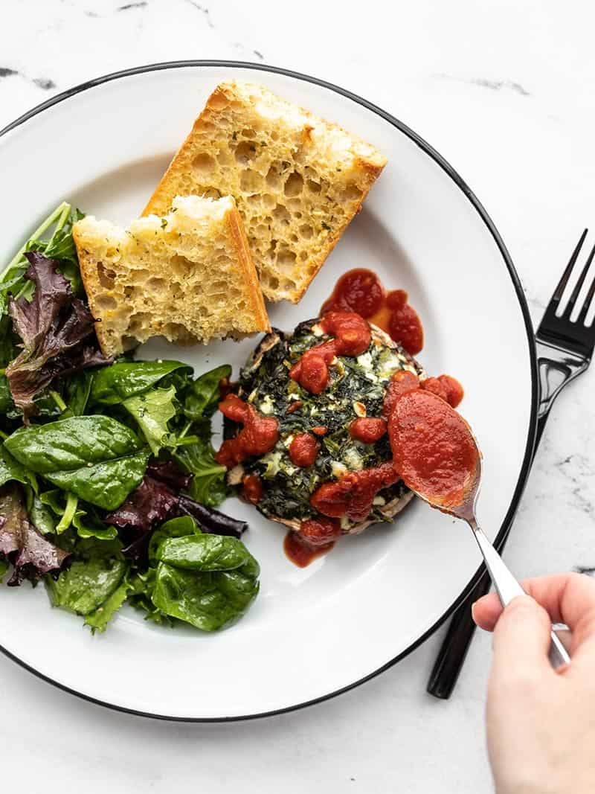
SPINACH STUFFED PORTOBELLOS
$7.23 RECIPE / $1.81 SERVING

Prep Time: 15 mins
Cook Time: 25 mins
Total Time: 40 mins
Servings: 4

Ingredients

- 1/2 lb. frozen spinach ($0.65)
- 1/2 cup cottage cheese ($0.27)
- 1/2 cup shredded mozzarella ($0.42)
- 1 large egg ($0.23)
- 2 oz. feta ($1.09)
- 1/4 tsp garlic powder ($0.02)
- 1/8 tsp salt ($0.02)
- 1/8 tsp freshly cracked black pepper ($0.02)
- 1/8 tsp crushed red pepper ($0.02)
- 4 portobello mushrooms ($3.98)
- 1 Tbsp olive oil ($0.16)
- 1/2 cup marinara sauce (optional) ($0.35)

Directions
- Preheat the oven to 400ºF. Thaw the frozen spinach and squeeze out as much water as possible.
- Place the squeezed spinach in a bowl and add the cottage cheese, mozzarella, feta, egg, garlic powder, salt, pepper, and crushed red pepper. Stir until everything is evenly combined.
- Wipe any dirt or debris from the portobello mushrooms. Remove the stems. Brush a little oil over the mushroom caps and season with a pinch of salt. Place the mushrooms, gill sides up, on a baking sheet. Divide the spinach and cheese filling between the four mushrooms, mounding it inside the caps.
- Bake the stuffed portobellos in the preheated oven for 25 minutes or until the cheese mixture on top is lightly browned. Mushrooms contain a lot of water, so don't be alarmed to see liquid seeping from the mushrooms.
- Serve each spinach stuffed portobello drizzled with 2 Tbsp marinara sauce, if desired.
Nutrition Facts
Serving: 1stuffed mushroom ・ Calories: 207.78kcal ・ Carbohydrates: 9.68g ・ Protein: 14.03g ・ Fat: 12.8g ・ Sodium: 761.4mg
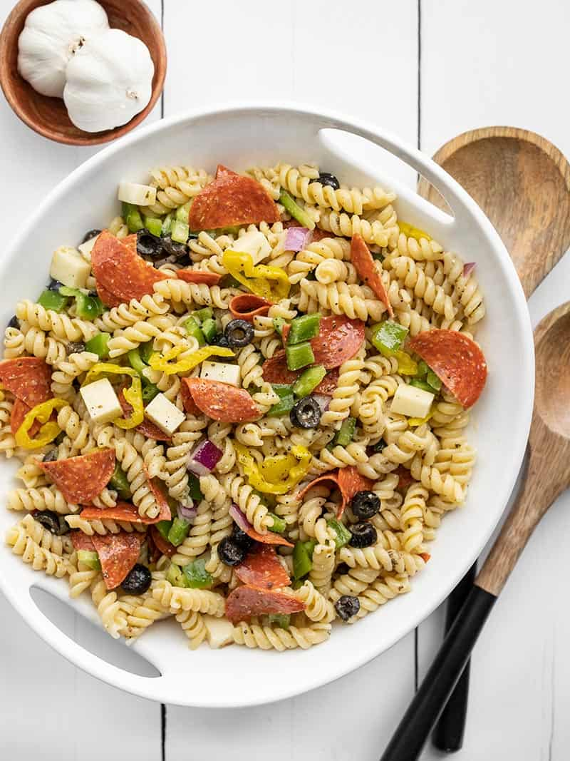
PIZZA PASTA SALAD
$7.98 RECIPE / $1.00 SERVING

Prep Time: 10 mins
Cook Time: 15 mins
Total Time: 25 mins
Servings: 8 (1 cup each)

Ingredients

HOMEMADE ITALIAN DRESSING
- 1/2 cup olive oil ($0.84)
- 1/4 cup red wine vinegar ($0.40)
- 1 tsp Dijon mustard ($0.06)
- 1/4 tsp garlic powder ($0.02)
- 1 Tbsp Italian seasoning ($0.30)
- 1/2 tsp salt ($0.02)
- 1/4 tsp pepper ($0.02)
- 2 Tbsp grated Parmesan ($0.22)
PASTA SALAD
- 1 lb. rotini pasta ($1.00)
- 3 oz. pepperoni ($1.25)
- 4 oz. mozzarella ($1.15)
- 1 green bell pepper ($0.89)
- 1/4 cup red onion ($0.11)
- 1/2 12oz. jar banana pepper rings ($1.00)
- 1/2 4oz. can sliced black olives ($0.70)

Directions
- Make the Italian dressing first so the flavors have a few minutes to blend. Add the olive oil, red wine vinegar, Dijon, garlic powder, Italian seasoning, salt, pepper, and Parmesan to a bowl or jar. Whisk the ingredients together, or place a lid on the jar and shake until combined. Set the dressing aside.
- Cook the rotini according to the package directions (boil for 7-10 minutes, or until tender). Drain the pasta in a colander and rinse briefly with cool water. Let the pasta drain well, shaking the colander every few minutes to remove excess water from the pasta.
- While the pasta is cooking and draining, prepare the other pasta salad ingredients. Cut the pepperoni in half or into quarters, and chop the mozzarella into small cubes. Dice the bell pepper and red onion. Drain the banana pepper rings and black olives.
- When the pasta is cooked, cooled, and drained well, transfer it to a large bowl. Add the rest of the prepared ingredients (pepperoni, mozzarella, bell pepper, red onion, banana peppers, and black olives). Toss the ingredients to combine.
- Give the dressing another shake or stir before drizzling it over the pasta salad. Toss the pasta salad once again to coat everything in the dressing. Serve immediately or refrigerate until ready to eat.
Nutrition Facts
Serving: 1cup ・ Calories: 394.33kcal ・ Carbohydrates: 44.11g ・ Protein: 10.01g ・ Fat: 19.61g ・ Sodium: 385.08mg ・ Fiber: 2.18g

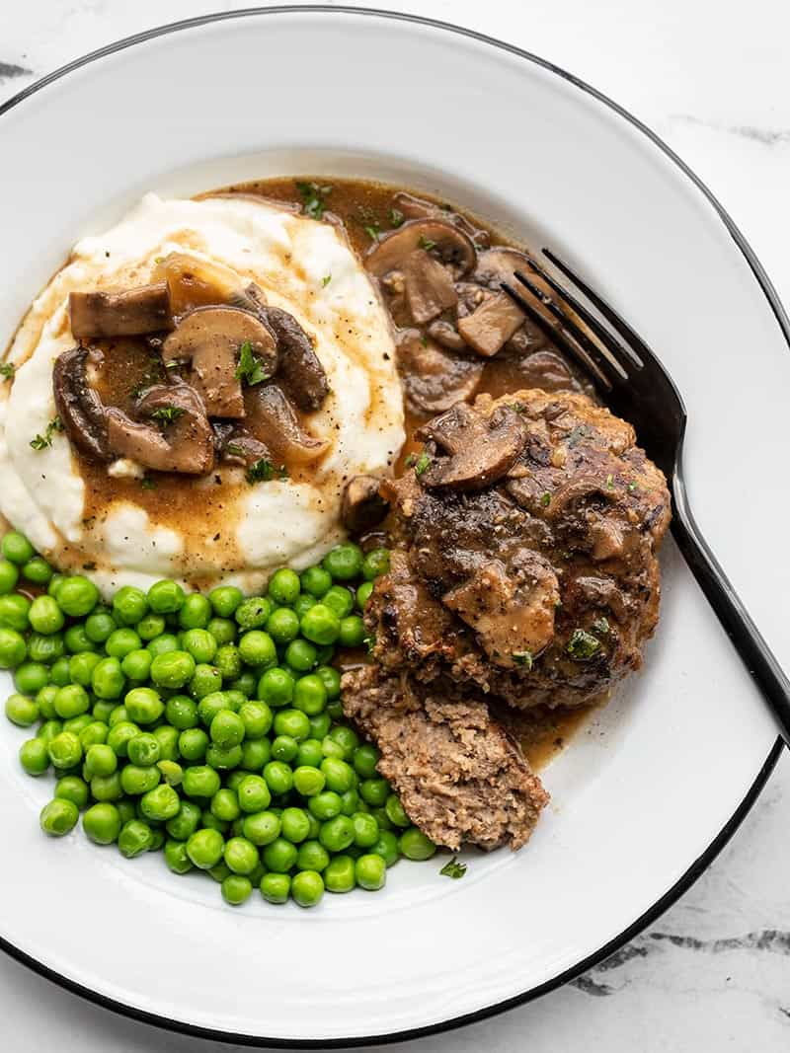
SALISBURY STEAK WITH MUSHROOM GRAVY
$8.34 RECIPE / $2.09 SERVING

Prep Time: 10 mins
Cook Time: 30 mins
Total Time: 40 mins
Servings: 4

Ingredients

- 1 yellow onion, divided ($0.32)
- 1 lb. ground beef ($5.15)
- 1/2 cup breadcrumbs ($0.13)
- 1 large egg ($0.23)
- 2 Tbsp Worcestershire sauce, divided ($0.05)
- 1 tsp Italian seasoning ($0.10)
- 1/2 tsp salt ($0.02)
- 1/4 tsp pepper ($0.03)
- 1 Tbsp cooking oil ($0.04)
- 8 oz. mushrooms ($1.69)
- 2 Tbsp butter ($0.26)
- 2 Tbsp all-purpose flour ($0.02)
- 1.5 cups beef broth* ($0.20)
- salt and pepper to taste ($0.05)

Directions
- Finely mince about ½ cup of the onion and slice the remainder of the onion. The minced onion will go in the ground beef mixture, the rest will be used for the gravy.
- Add the ground beef, minced onion, breadcrumbs, egg, 1 Tbsp of the Worcestershire sauce (the remainder will go in the gravy), Italian seasoning, salt, and pepper to a large bowl. Use your hands to mix the ingredients together until they are evenly combined. Divide the mixture into four equal parts, and shape each into a flattened oval.
- Add the cooking oil to a large skillet and heat over medium. Once the skillet is hot, add the shaped beef patties and cook for about 5 minutes on each side, or until they are well browned on each side. Transfer the cooked patties to a clean plate.
- While the beef patties are cooking, slice the mushrooms. After removing the beef from the skillet, add the sliced mushrooms and the remaining sliced onion along with a pinch of salt and pepper. Continue to cook the mushrooms and onions over medium until they are soft. Allow the moisture released from the onions and mushrooms to help you dissolve any browned bits off the bottom of the skillet as you stir.
- Once the mushrooms and onions have softened and most of the moisture has evaporated off the bottom of the skillet, add the butter and flour. Continue to stir and cook for about two minutes. The flour and butter will form a paste and begin to coat the bottom of the skillet.
- Add the beef broth and one tablespoon of Worcestershire sauce to the skillet. Stir to dissolve the flour into the broth, making sure to dissolve any flour that is stuck to the bottom of the skillet. Allow the broth to come up to simmer (still over medium heat), stirring often. Once it reaches a simmer, it will thicken into a gravy.
- Once the gravy is simmering, add the beef patties back to the skillet with the broth, mushrooms, and onions. Spoon the gravy over top, and continue to simmer the beef in the gravy for an additional five minutes. Taste the gravy and adjust the salt and pepper to your liking.
Nutrition Facts
Serving: 1steak with gravy ・ Calories: 446.88kcal ・ Carbohydrates: 20.6g ・ Protein: 27.35g ・ Fat: 27.78g ・ Sodium: 1009.73mg ・ Fiber: 1.83g
TURKEY CHILI SMOTHERED SWEET POTATOES
$9.26 RECIPE / $2.32 SERVING

Prep Time: 10 mins
Cook Time: 1 hr
Total Time: 1 hr 10 mins
Servings: 4

Ingredients

CHILI
- 1 Tbsp olive oil ($0.16)
- 1/2 lb. ground turkey ($2.00)
- 1 yellow onion ($0.32)
- 2 cloves garlic ($0.16)
- 1 15oz. can diced tomatoes ($0.59)
- 3 oz. tomato paste (1/2 of a 6oz. can) ($0.25)
- 1 15oz. can black beans ($0.79)
- 1 Tbsp chili powder ($0.30)
- 1/2 tsp dried oregano ($0.05)
- 1/2 tsp ground cumin ($0.05)
- 1 cup water ($0.00)
- 1/2 tsp Salt ($0.02)
POTATOES AND TOPPINGS
- 4 small sweet potatoes (3/4 lb. each) ($3.94)
- 1/2 cup shredded cheddar cheese ($0.43)
- Cilantro or green onions for garnish ($0.25)

Directions
- Preheat the oven to 400ºF. Wash the sweet potatoes well, then prick the skins several times with a fork. Place the sweet potatoes on a baking sheet or in a baking dish and bake for 60 minutes, or until soft and oozing from the fork holes.
- While the sweet potatoes are baking, prepare the small batch of chili. Add the ground turkey and olive oil to a large pot. Sauté the turkey over medium heat. While the turkey is cooking, dice the yellow onion and mince the garlic. Add the onions and garlic to the pot and continue to sauté until the onions are soft and translucent.
- Drain the beans and add them to the pot along with the diced tomatoes (with juices), tomato paste, chili powder, oregano, cumin, and water. Stir to combine. Allow the chili to come up to a simmer, then reduce the heat and let simmer until the sweet potatoes have finished baking, stirring occasionally. Taste and add salt to taste (about 1/2 tsp).
- Once the sweet potatoes are finished baking, carefully slice each one open lengthwise and slightly mash the insides. Spoon about 3/4 cup chili over each potato, then top with 2 Tbsp shredded cheddar. Return the potatoes to the oven for a few minutes to melt the cheese. Top with cilantro or sliced green onions just before serving.
Nutrition Facts
Serving: 1each ・ Calories: 610.63kcal ・ Carbohydrates: 86.1g ・ Protein: 25.23g ・ Fat: 18.08g ・ Sodium: 905.75mg ・ Fiber: 17.83g
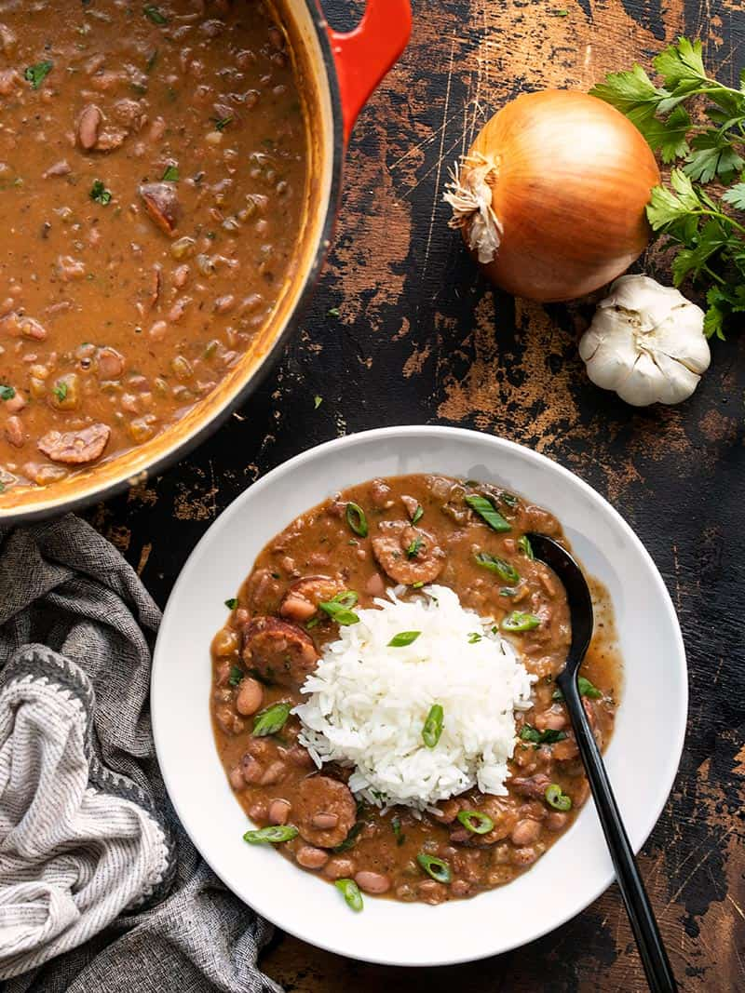
LOUISIANA STYLE RED BEANS AND RICE
$9.75 RECIPE / $1.63 SERVING

Prep Time: 15 mins
Cook Time: 2 hrs
Soaking time: 8 hrs
Total Time: 10 hrs 15 mins
Servings: 6 (1.5 cups each)

Ingredients

- 1 lb. dry red beans ($1.49)
- 2 Tbsp cooking oil ($0.08)
- 14 oz. Andouille sausage ($3.79)
- 1 yellow onion ($0.32)
- 1 green bell pepper ($0.69)
- 3 ribs celery ($0.46)
- 4 cloves garlic ($0.32)
- 2 tsp smoked paprika ($0.20)
- 1 tsp dried oregano ($0.10)
- 1 tsp dried thyme ($0.10)
- 1/2 tsp garlic powder ($0.05)
- 1/2 tsp onion powder ($0.05)
- 1/4 tsp cayenne pepper ($0.03)
- 1/4 tsp freshly cracked black pepper ($0.02)
- 2 bay leaves ($0.60)
- 6 cups water ($0.00)
- 1/4 cup chopped parsley ($0.20)
- 1 Tbsp salt, or to taste ($0.10)
- 1.5 cups long grain white rice (uncooked) ($0.93)
- 3 green onions ($0.22)

Directions
- The night before, add the dry beans to a large bowl with double their volume in water. Allow the beans to soak in the refrigerator overnight.
- When you're ready to start cooking, slice the sausage into rounds. Add the cooking oil and sliced sausage to a large pot and cook over medium until the sausage pieces are browned. Remove the cooked sausage with a slotted spoon to a clean bowl. Place the cooked sausage in the refrigerator while you prepare the rest of the dish.
- While the sausage is cooking, dice the onion, bell pepper, and celery. Mince the garlic.
- After removing the cooked sausage, add the onion, bell pepper, celery, and garlic to the pot. Sauté over medium heat, allowing the moisture from the vegetables to help dissolve any browned bits off the bottom of the pot as you stir.
- Add the smoked paprika, oregano, thyme, garlic powder, onion powder, cayenne, black pepper, and bay leaves to the pot. Stir and cook for one minute more.
- Drain and rinse the soaked beans. Add them to the pot along with 6 cups water and give the pot a brief stir to combine the ingredients.
- Place a lid on the pot, turn the heat up to medium-high, and bring it up to a boil. Once boiling, turn the heat down to medium-low, and let the pot boil for one hour, stirring occasionally. Replace the lid every time you stir.
- After boiling for one hour, the beans should be tender. Begin to smash the beans with the back of a spoon against the side of the pot. Continue smashing the beans and letting the pot simmer without a lid for 30 minutes to thicken the pot.
- While the beans are simmering for their final 30 minutes, cook the rice. Add the rice and 3 cups water to a sauce pot. Place a lid on top, turn the heat on to high, and bring it up to a boil. Once boiling, turn the heat down to low and let the rice simmer for 15 minutes. After 15 minutes, turn the heat off and let the rice rest for 5 minutes without removing the lid. Fluff the rice with a fork before serving.
- Once the red beans have thickened, add the cooked sausage back to the pot along with 1/4 cup chopped fresh parsley. Stir to combine. Taste the red beans and add salt to your liking. Start with 1 tsp and add more as needed. I used 1 Tbsp total (3 tsp).
- Serve the red beans in a bowl topped with a scoop of rice and a sprinkle of sliced green onions.
Nutrition Facts
Serving: 1.5cups ・ Calories: 668.77kcal ・ Carbohydrates: 87.28g ・ Protein: 31.8g ・ Fat: 22.75g ・ Sodium: 2209.35mg ・ Fiber: 17.05g
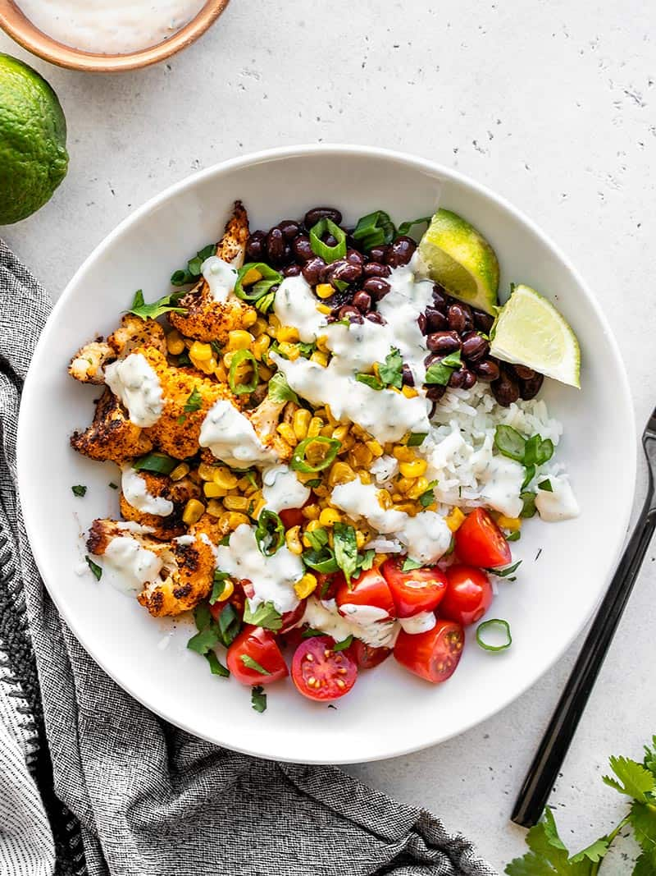
ROASTED CAULIFLOWER TACO BOWLS
$8.31 RECIPE / $2.08 SERVING

Prep Time: 20 mins
Cook Time: 40 mins
Total Time: 1 hr
Servings: 4

Ingredients

CILANTRO LIME RANCH
- 1/4 cup mayonnaise ($0.13)
- 1/4 cup sour cream ($0.11)
- 1 lime ($0.50)
- 1/4 tsp garlic powder ($0.02)
- 1/8 tsp onion powder ($0.01)
- 1 Tbsp finely chopped cilantro ($0.05)
- 1 green onion, chopped ($0.11)
- 1/4 tsp salt ($0.02)
TACO ROASTED CAULIFLOWER
- 1 head cauliflower ($2.39)
- 2 Tbsp olive oil ($0.32)
- 1/2 Tbsp chili powder* ($0.15)
- 1/2 tsp smoked paprika ($0.05)
- 1/2 tsp ground cumin ($0.05)
- 1/8 tsp cayenne pepper ($0.02)
- 1/4 tsp dried oregano ($0.02)
- 1/4 tsp salt ($0.02)
- freshly cracked pepper ($0.03)
BOWL INGREDIENTS
- 1 cup long grain white rice ($0.62)
- 1.5 cups water ($0.00)
- 1 15 oz. can black beans ($0.89)
- 1 cup frozen corn ($0.20)
- 1 Tbsp cooking oil ($0.08)
- 1 pint grape tomatoes ($2.29)
- Fresh cilantro and sliced green onion for garnish ($0.20)

Directions
- Prepare the cilantro lime ranch first, so the flavors have time to blend. Zest the lime, then squeeze the juice from half, and cut the other half into wedges for serving. You'll need about 1 Tbsp lime juice. Finely chop about 1 Tbsp cilantro and one green onion.
- Combine the ingredients for the cilantro lime ranch in a bowl (mayonnaise, sour cream, 1 Tbsp lime juice, 1/2 tsp lime zest, garlic powder, onion powder, chopped cilantro, chopped green onion, salt). Refrigerate the cilantro lime ranch until you're ready to eat.
- Next, preheat the oven to 400ºF. Line a baking sheet with parchment paper. Cut the head of cauliflower into florets, then place them in a bowl. In a separate small bowl, combine the ingredients for the taco seasoning (chili powder, smoked paprika, cumin, cayenne, oregano, salt, and some freshly cracked pepper). Drizzle the olive oil over the cauliflower, followed by the taco seasoning, then toss until the cauliflower is evenly coated in oil and spices.
- Spread the seasoned cauliflower out over the prepared baking sheet. Roast the cauliflower in the preheated oven for 20-30 minutes, or until it's brown and crispy on the edges.
- While the cauliflower is roasting, begin cooking the rice. Add the rice and 1.5 cups water to a sauce pot. Place a lid on top, turn the heat up to high, and bring the water up to a boil. Once it reaches a full boil, turn the heat down to low and let the rice simmer for 15 minutes without lifting the lid. After 15 minutes, turn the heat off and let the rice rest for 5 minutes without lifting the lid. Finally, fluff the rice with a fork and divide it between four bowls or containers.
- Add the undrained can of black beans to a small sauce pot and heat over medium-low, stirring occasionally, until heated through (if making the bowls for meal prep, skip heating the beans).
- Add 1 Tbsp cooking oil to a large skillet and heat over medium. Once the oil is hot and shimmering, add the frozen corn. Cook the corn, stirring only occasionally, until it is browned and blistered (about 7-8 minutes). Season with a pinch of salt and pepper.
- Slice the grape tomatoes, roughly chop the cilantro, and slice a green onion for garnish.
- To build the bowls, divide the roasted cauliflower, cooked rice, beans, corn, and tomatoes between four bowls or containers. Top with a pinch of cilantro, sliced green onion, and a wedge of lime. Drizzle the cilantro lime ranch over top just before eating.
Nutrition Facts
Serving: 1bowl ・ Calories: 515.33kcal ・ Carbohydrates: 68.85g ・ Protein: 13.68g ・ Fat: 22.1g ・ Sodium: 647.78mg ・ Fiber: 12.78g
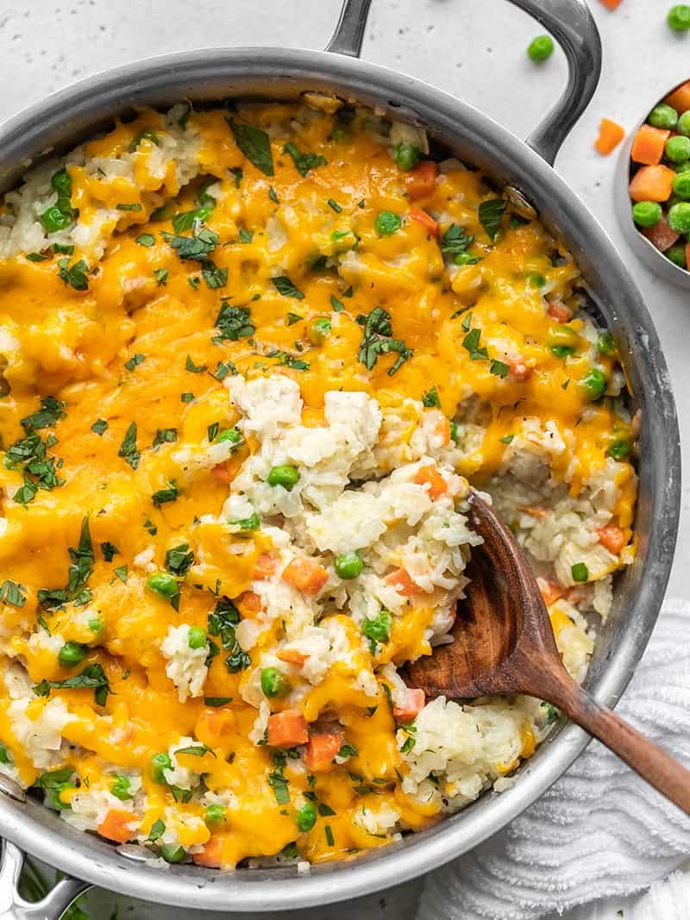
CREAMY CHICKEN AND RICE SKILLET
$7.12 RECIPE / $1.78 SERVING

Prep Time: 5 mins
Cook Time: 45 mins
Total Time: 50 mins
Servings: 4 1.5 cups each

Ingredients

- 1 yellow onion ($0.32)
- 2 Tbsp butter ($0.26)
- 1 boneless, skinless chicken breast (about 2/3 lb.) ($3.62)
- 1 cup long grain white rice ($0.62)
- 1/2 tsp dried thyme ($0.05)
- 1/4 tsp dried sage ($0.03)
- 1/4 tsp salt ($0.02)
- freshly cracked pepper ($0.03)
- 3 cups chicken broth ($0.39)
- 1/2 lb. frozen peas and carrots ($0.67)
- 1/3 cup heavy cream ($0.26)
- 4 oz. cheddar, shredded ($0.85)

Directions
- Dice the onion and add it to an oven safe deep skillet (3 qt. capacity) along with the butter. Sauté over medium heat until the onions are soft and translucent.
- While the onions are cooking, dice the chicken breast into small, 1/2-inch pieces. Add the chicken to the skillet and continue to sauté for about 3 minutes more, or just until the outside of the chicken pieces have turned opaque (the chicken will finish cooking through as it simmers with the rice).
- Add the rice, thyme, sage, salt, some freshly cracked pepper (about ten cranks of a pepper mill), and the chicken broth to the skillet and stir to combine.
- Place a lid on the skillet, turn the heat up to medium-high, and allow the broth to come to a boil. Once it reaches a full boil, turn the heat down to low and let the skillet simmer for 15 minutes, stirring occasionally, replacing the lid each time. Cooking the rice in an excess of broth and stirring occasionally as it cooks will produce a saucy rice mixture.
- After 15 minutes, the rice should be tender and saucy (if not yet tender, let it continue to cook for 5 more minutes). Stir in the frozen vegetables (no need to thaw), replace the lid, and let it sit over medium-low heat for another 5 minutes to heat the vegetables through. Finally, add the heavy cream, stir to combine, taste, and add extra salt if needed (this will depend on the salt content of the broth you used).
- Turn on the oven's broiler, top the skillet with the shredded cheese, and place the skillet in the oven under the broiler for a few minutes to melt the cheese. Serve hot.
Nutrition Facts
Serving: 1.5cups ・ Calories: 531.98kcal ・ Carbohydrates: 48.4g ・ Protein: 30.05g ・ Fat: 24.38g ・ Sodium: 1166.88mg ・ Fiber: 2.7g
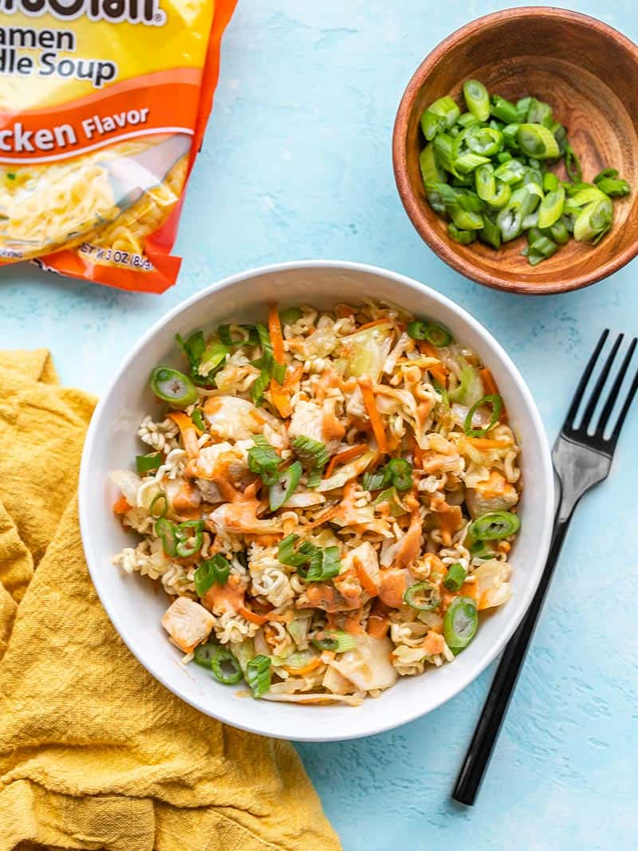
CRUNCHY CHICKEN RAMEN STIR FRY
$7.10 RECIPE / $1.78 SERVING

Prep Time: 10 mins
Cook Time: 15 mins
Total Time: 25 mins
Servings: 4 (About 1.25 cups each)

Ingredients

STIR FRY SAUCE
- 2 Tbsp soy sauce ($0.12)
- 1 Tbsp toasted sesame oil ($0.30)
- 1/2 Tbsp brown sugar ($0.02)
SRIRACHA MAYO DRIZZLE (OPTIONAL)
- 1 Tbsp mayonnaise ($0.09)
- 1 Tbsp sriracha ($0.11)
STIR FRY
- 1 boneless, skinless chicken breast (about 2/3 lb.) ($4.08)
- 2 Tbsp cooking oil ($0.08)
- 1 14oz. bag coleslaw mix (shredded cabbage and carrots) ($1.49)
- 2 cloves garlic ($0.16)
- 1 tsp grated fresh ginger ($0.10)
- 3 green onions ($0.30)
- 1 3oz. block ramen noodles (seasoning packet discarded) ($0.25)

Directions
- Prepare the sauces first so they're ready to use when needed. In a small bowl stir together the ingredients for the stir fry sauce (soy sauce, sesame oil, and brown sugar). In a separate small bowl stir together the sriracha and mayonnaise.
- Mince 2 cloves of garlic, grate about one teaspoon of fresh ginger, and slice three green onions.
- Without opening the package of ramen, use a rolling pin or mallet to crush the noodles into small pieces. Once crushed, open the package and discard the seasoning packet.
- Chop the chicken into small 1/2-inch pieces.
- Place a large skillet over medium-high heat. Once hot, add the cooking oil and swirl to coat the surface of the skillet. Add the chicken pieces and sauté until they're cooked through (3-5 minutes). Add the garlic and ginger to the skillet about half way through cooking the chicken.
- Once the chicken is cooked through, add the coleslaw mix (shredded cabbage and carrots). Continue to sauté for about 2 minutes more, or just until the cabbage begins to soften slightly (do not overcook at this step).
- Add the stir fry sauce to the skillet and continue to sauté for 1-2 minutes more, or until the cabbage has softened to your liking (I prefer mine still slightly firm).
- Finally, turn off the heat, stir in the crushed ramen, and top with sliced green onions and a drizzle of sriracha mayo.
Nutrition Facts
Serving: 1.25cups ・ Calories: 350.63kcal ・ Carbohydrates: 25.5g ・ Protein: 21.43g ・ Fat: 18.85g ・ Sodium: 692.63mg ・ Fiber: 3g
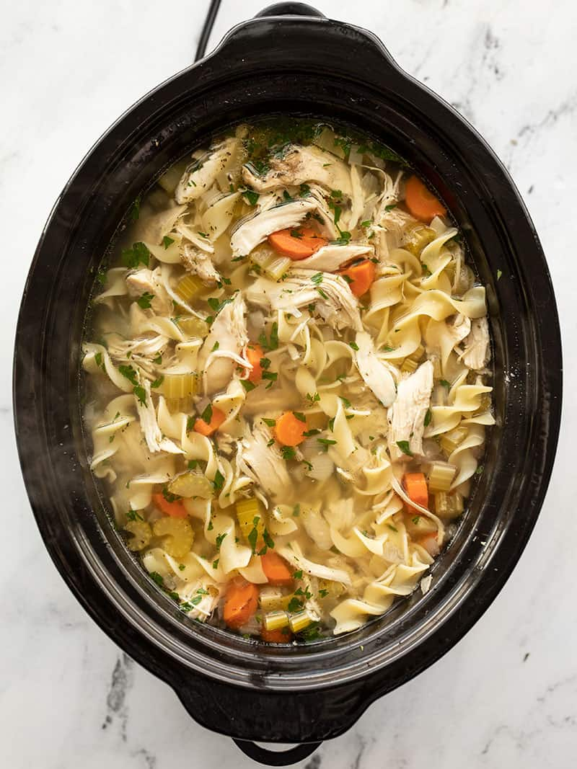
SLOW COOKER CHICKEN NOODLE SOUP
$9.22 RECIPE / $1.15 SERVING

Prep Time: 30 mins
Cook Time: 4 hrs
Total Time: 4 hrs 30 mins
Servings: 8 (1.5 cups each)

Ingredients

- 1 yellow onion ($0.32)
- 3 cloves garlic ($0.24)
- 1/2 lb. carrots (about 4 medium) ($0.30)
- 4 ribs celery ($0.43)
- 2 split chicken breasts* (2-2.5 lbs. total) ($6.30)
- 1 tsp dried basil ($0.10)
- 1 Tbsp dried parsley ($0.30)
- 1/2 tsp dried thyme ($0.05)
- 1 bay leaf ($0.15)
- 1/4 tsp freshly cracked black pepper ($0.05)
- 8 cups water ($0.00)
- 6 oz. wide egg noodles ($0.68)
- 1 Tbsp salt (or to taste) ($0.10)
- 1/4 cup chopped fresh parsley (optional) ($0.20)

Directions
- Dice the onion, mince the garlic, peel and slice the carrots, and slice the celery. Add the onion, garlic, carrots, and celery to a 6 quart slow cooker or crock pot.
- Remove the skin from the bone-in split chicken breasts, then place them on top of the vegetables in the slow cooker. Add the basil, parsley, thyme, bay leaf, and pepper to the slow cooker.
- Pour 8 cups of water over the ingredients in the slow cooker. Place the lid on the slow cooker and cook on high for 4 hours or low for 8 hours.
- After cooking on high for 4 hours or low for 8 hours, carefully remove the chicken to a cutting board and discard the bay leaf. Add the egg noodles to the slow cooker, stir to combine, and replace the lid, with the heat turned on to high.
- Use two forks to remove the chicken meat from the bones, shredding the meat as you go. Return the meat to the slow cooker and stir to combine with the soup. The noodles should be tender after about 8-10 minutes of being in the soup (this may take a few minutes longer if the slow cooker was previously set to low).
- Once the chicken has been returned to the soup and the noodles are tender, begin seasoning the soup with salt. The true flavor of the soup will not be pronounced until it is properly salted. Start with 1 tsp salt, adding more until the soup is bold and flavorful. I use about 1 Tbsp (3 tsp). Finally, stir in a handful of chopped parsley for garnish just before serving.
Nutrition Facts
Serving: 1.5cups ・ Calories: 235.2kcal ・ Carbohydrates: 20.9g ・ Protein: 27.6g ・ Fat: 4.1g ・ Sodium: 1349.6mg ・ Fiber: 2.5g
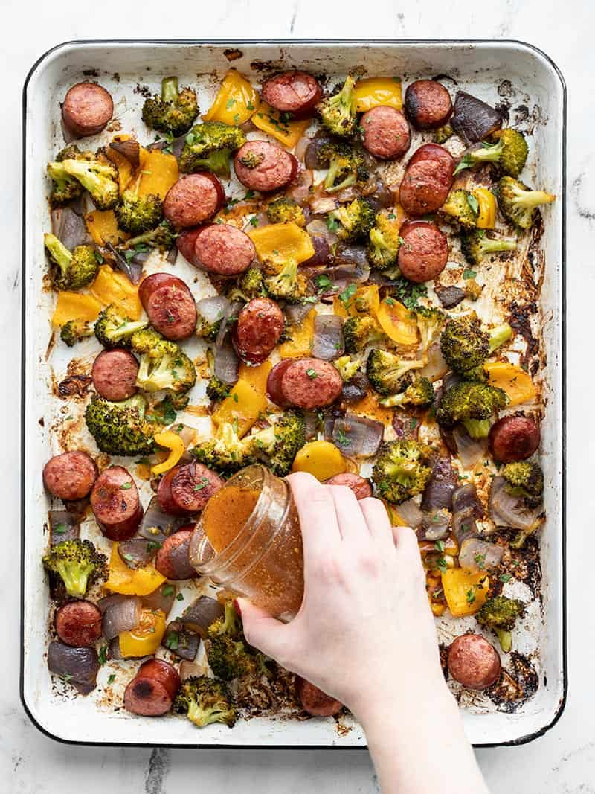
SMOKY ROASTED SAUSAGE AND VEGETABLES
$7.87 RECIPE / $1.97 SERVING

Prep Time: 15 mins
Cook Time: 40 mins
Total Time: 55 mins
Servings: 4

Ingredients

SMOKY VINAIGRETTE
- 1/4 cup olive oil ($0.64)
- 2 Tbsp red wine vinegar ($0.20)
- 1 tsp coarse deli mustard (or Dijon) ($0.08)
- 1/4 tsp garlic powder ($0.02)
- 1/4 tsp dried oregano ($0.02)
- 1/2 tsp smoked paprika ($0.05)
- 1/4 tsp salt ($0.02)
- freshly cracked black pepper ($0.03)
- 1/4 tsp sugar ($0.02)
SAUSAGE AND VEGETABLES
- 12 oz. smoked sausage ($2.75)
- 1 lb. broccoli crown ($1.69)
- 1 bell pepper (any color) ($1.00)
- 1 red onion ($0.44)
FOR SERVING
- 1 cup long grain white rice (uncooked) ($0.20)
- 1 handful chopped parsley ($0.20)

Directions
- Preheat the oven to 400ºF. Line a large baking sheet with parchment paper.
- In a small bowl or jar combine the ingredients for the vinaigrette (olive oil, red wine vinegar, mustard, garlic powder, dried oregano, smoked paprika, salt, pepper, and sugar). Whisk the ingredients together or close the jar and shake until combined. Set the vinaigrette aside.
- Slice the smoked sausage into 1/2-inch medallions. Cut the broccoli into small florets. Dice the bell pepper and onion into 1-inch pieces. Place the sausage, broccoli, bell pepper, and onion onto the baking sheet.
- Drizzle 2 Tbsp of the vinaigrette over the sausage and vegetables and toss to coat.
- Roast the vegetables in the fully preheated oven for 35-40 minutes, or until they're browned on the edges, stirring once half way through.
- While the sausage and vegetables are roasting, cook the rice. Add the rice and 2 cups water to a sauce pot. Place a lid on the pot and bring it up to a boil over high heat. Once boiling, turn the heat down to low and let simmer for 15 minutes. After 15 minutes, turn the heat off and let it rest, undisturbed, lid in place, for an additional 5 minutes. Fluff with a fork just before serving.
- After the sausage and vegetables have finished roasting, add half of the remaining vinaigrette and toss to coat. Season with an extra pinch of salt and pepper if needed.
- To serving, add about 3/4 cup rice to each bowl or container along with 1/4 of the roasted sausage and vegetables. Drizzle another spoonful of the vinaigrette over top, then finish with a sprinkle of fresh parsley.
Nutrition Facts
Serving: 1serving ・ Calories: 660.1kcal ・ Carbohydrates: 50.2g ・ Protein: 17.6g ・ Fat: 42.8g ・ Sodium: 1117.63mg ・ Fiber: 4.38g
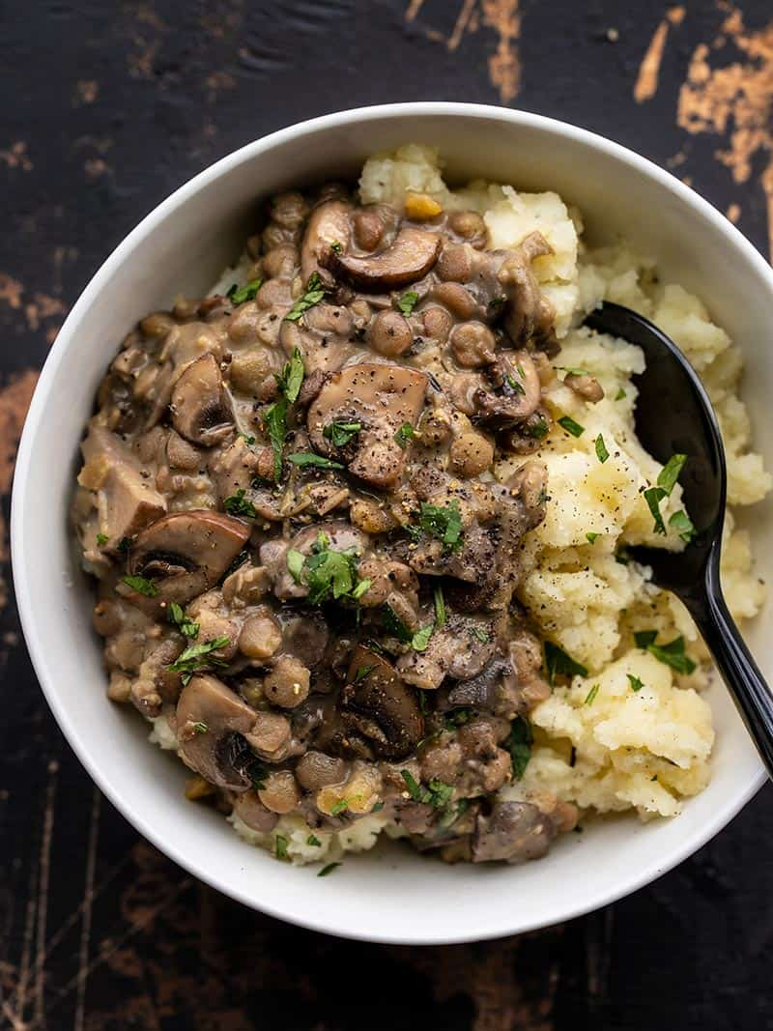
LENTILS WITH CREAMY MUSHROOM GRAVY
$5.09 RECIPE / $1.27 SERVING

Prep Time: 5 mins
Cook Time: 35 mins
Total Time: 40 mins
Servings: 4 (About 1 cup each)

Ingredients

- 2 cloves garlic ($0.16)
- 8 oz. mushrooms ($1.69)
- 2 Tbsp olive oil ($0.32)
- 1 cup brown lentils ($0.50)
- 1/2 tsp dried thyme ($0.05)
- 3/4 tsp rubbed (dried) sage ($0.07)
- Freshly cracked black pepper ($0.03)
- 2 cups vegetable broth ($0.26)
- 1 13.5oz. can coconut milk ($1.99)
- salt to taste (about 1/2 tsp) ($0.02)

Directions
- Mince the garlic and slice the mushrooms. Add the olive oil and garlic to a large skillet and sauté for about one minute. Add the sliced mushrooms and continue to sauté until the mushrooms have released all their moisture and begin to brown.
- Add the lentils, sage, thyme, freshly cracked pepper, and vegetable broth to the skillet with the mushrooms. Stir to combine. Place a lid on the skillet, let the broth come up to a boil, then turn the heat down to medium-low. Let the lentils simmer for 20 minutes (with lid), stirring occasionally.
- After simmering for 20 minutes, the lentils should be tender and most of the broth absorbed. Add the coconut milk, stir to combine, turn the heat back up to medium, and let the lentils simmer for about five more minutes (without lid), or until the mixture in the skillet has thickened to a gravy.
- Once the mixture has thickened, turn the heat off. Taste the mixture and add salt to your liking. I added about 1/2 tsp. The salt will help the herbal flavors pop and reduce the sweetness of the coconut milk.
- Serve hot with crusty bread for dipping or over mashed potatoes, rice, or pasta.
Nutrition Facts
Serving: 1cup ・ Calories: 280.05kcal ・ Carbohydrates: 37.35g ・ Protein: 13.85g ・ Fat: 9.6g ・ Sodium: 781.2mg ・ Fiber: 58.58g
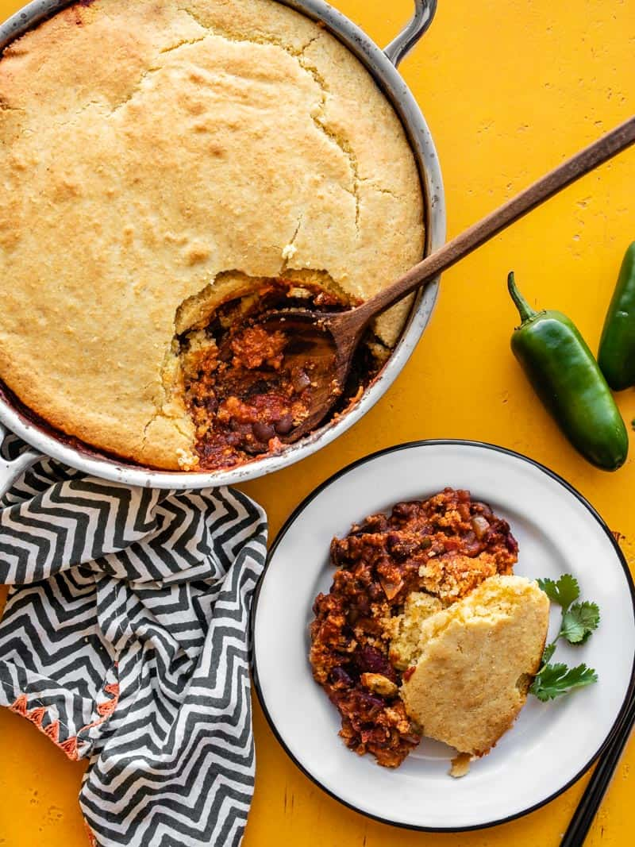
CHILI CORNBREAD SKILLET
$7.49 RECIPE / $1.25 SERVING

Prep Time: 20 mins
Cook Time: 40 mins
Total Time: 1 hr
Servings: 6

Ingredients

CHILI
- 1 Tbsp cooking oil ($0.04)
- 2 cloves garlic ($0.16)
- 1 yellow onion ($0.32)
- 1 jalapeño (optional) ($0.15)
- 1 15oz. can fire roasted diced tomatoes ($0.89)
- 1 6oz. can tomato paste ($0.39)
- 3 15oz. cans beans (kidney, pinto, black) ($2.67)
- 1 Tbsp chili powder* ($0.30)
- 1 tsp ground cumin ($0.10)
- 1/2 tsp dried oregano ($0.05)
- 1 tsp salt ($0.05)
- 1 cup water ($0.00)
- 1 cup shredded cheddar ($0.85)
CORNBREAD
- 1 cup yellow cornmeal ($0.24)
- 1 cup all-purpose flour ($0.15)
- 1/4 cup sugar ($0.20)
- 4 tsp baking powder ($0.24)
- 1/2 tsp salt ($0.02)
- 1 cup milk ($0.31)
- 1 large egg ($0.23)
- 1/4 cup cooking oil ($0.16)

Directions
- Dice the onion and mince the garlic. Slice the jalapeño lengthwise, scrape out the seeds, and then dice the pepper. Add the cooking oil, onion, garlic, and jalapeño to a large 4-quart oven safe skillet. Sauté over medium heat until the onions are soft and translucent (about 5 minutes).
- Drain the canned beans then add them to the skillet with the tomato paste, diced tomatoes, chili powder, cumin, oregano, salt, and water. Stir to combine.
- Allow the chili to come up to a simmer. Let the chili continue to simmer, stirring occasionally, as you prepare the cornbread topping.
- Begin to preheat the oven to 425ºF. In a large bowl, stir together the cornmeal, flour, sugar, baking powder, and salt until very well combined. In a separate bowl, whisk together the milk, egg, and oil. Pour the milk mixture into the bowl with the cornmeal mixture and stir just until everything is moistened.
- Sprinkle the cheddar cheese over top of the simmering chili. Carefully pour the cornbread batter over the chili and cheese, and spread it around until the surface is evenly covered.
- Transfer the skillet to the fully preheated oven and bake for 25 minutes, or until the cornbread is golden brown on the surface. To serve, simply scoop the cornbread and chili beneath onto a plate or bowl, and enjoy!
Nutrition Facts
Serving: 1Serving ・ Calories: 696.08kcal ・ Carbohydrates: 96.87g ・ Protein: 27.85g ・ Fat: 22.33g ・ Sodium: 1793.65mg ・ Fiber: 21.28g
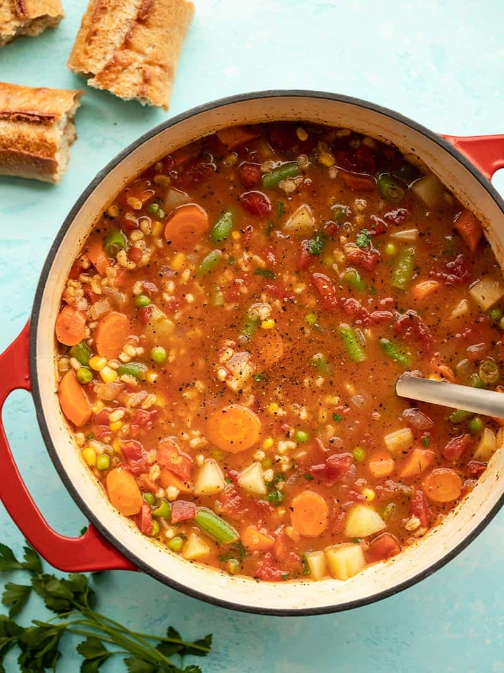
VEGETABLE BARLEY SOUP
$6.67 RECIPE / $1.11 SERVING

Prep Time: 5 mins
Cook Time: 50 mins
Total Time: 55 mins
Servings: 6 (2 cups each)

Ingredients

- 1 yellow onion ($0.32)
- 2 cloves garlic ($0.16)
- 2 Tbsp olive oil ($0.32)
- 1/2 lb. carrots (about 4) ($0.45)
- 1 28oz. can diced tomatoes ($1.59)
- 1 cup pearled barley ($0.89)
- 1/2 tsp dried basil ($0.05)
- 1/2 tsp dried oregano ($0.05)
- freshly cracked black pepper ($0.05)
- 6 cups vegetable broth ($0.78)
- 1 russet potato (about 3/4 lb.) ($1.22)
- 1 cup frozen green beans ($0.271)
- 1/2 cup frozen corn ($0.10)
- 1/2 cup frozen peas ($0.19)
- 1 Tbsp lemon juice ($0.03)
- 1 handful fresh parsley (optional garnish) ($0.20)

Directions
- Dice the onion and mince the garlic. Add the onion, garlic, and olive oil to a large soup pot and sauté over medium heat for about 5 minutes, or until the onion is soft and translucent.
- Meanwhile, peel and dice the carrots. Once the onions are soft, add the carrots to the soup pot, along with the canned diced tomatoes (with juices), barley, basil, oregano, some freshly cracked pepper, and vegetable broth.
- Stir the contents of the pot to combine, place a lid on top, turn the heat up to medium-high, and bring the broth up to a boil. Once boiling, turn the heat down to medium-low, and let the soup simmer, with the lid in place, stirring occasionally, for 30 minutes.
- While the soup simmers, peel and dice the potato into 1/2-inch cubes. After the soup has simmered and the barley is mostly tender, add the diced potatoes and continue to simmer for 10 minutes more, or just until the potatoes are tender.
- Once the potatoes are tender, add the frozen green beans, corn, and peas. Stir to combine, and heat through (about 5 minutes in the simmering soup).
- Finally, add the lemon juice to the soup and stir to combine. Taste the soup and adjust the salt or pepper to your liking. Serve hot, with fresh chopped parsley on top as a garnish, if desired.
Nutrition Facts
Serving: 2cups ・ Calories: 277.37kcal ・ Carbohydrates: 52.82g ・ Protein: 7.43g ・ Fat: 5.9g ・ Sodium: 1180.28mg ・ Fiber: 9.1g
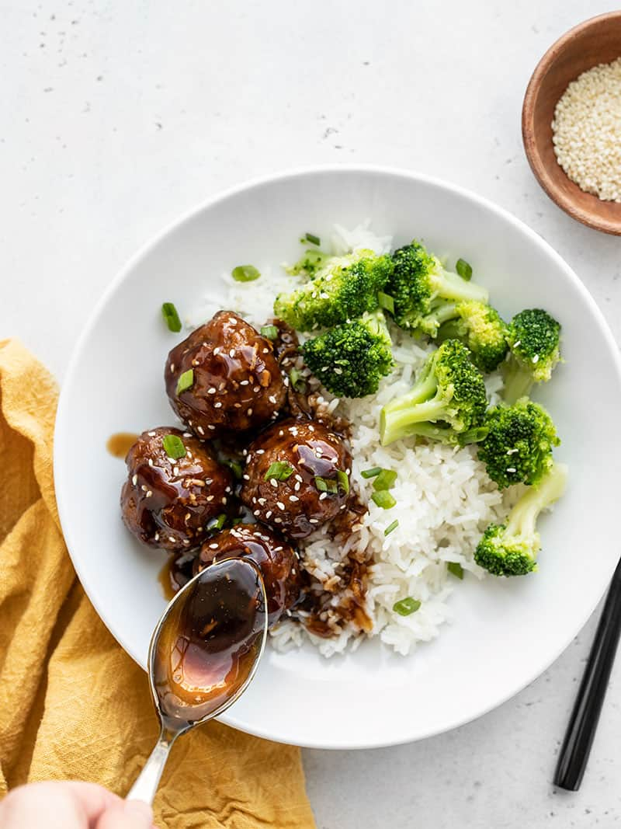
TERIYAKI MEATBALL BOWLS
$8.86 RECIPE / $2.22 SERVING

Prep Time: 20 mins
Cook Time: 20 mins
Total Time: 40 mins
Servings: 4

Ingredients

PORK AND GINGER MEATBALLS
- 1 lb. ground pork ($3.49)
- 1 large egg ($0.23)
- 1/2 cup breadcrumbs ($0.13)
- 1 clove garlic, minced ($0.08)
- 1 tsp grated fresh ginger ($0.10)
- 1/2 tsp soy sauce ($0.02)
- 2 green onions, sliced ($0.2)
TERIYAKI SAUCE
- 1/2 cup soy sauce ($0.48)
- 1/2 cup brown sugar ($0.18)
- 2 tsp grated fresh ginger ($0.20)
- 2 cloves garlic ($0.16)
- 1 cup water ($0.00)
- 2 Tbsp corn starch ($0.06)
FOR SERVING
- 1 cup jasmine rice ($0.66)
- 2 cups water ($0.00)
- 2 green onions ($0.08)
- 1 Tbsp sesame seeds ($0.08)
- 1 lb. frozen broccoli florets ($2.59)

Directions
- Preheat the oven to 400ºF. Begin with the meatball mixture. Add the ground pork, egg, breadcrumbs, minced garlic, ginger, soy sauce, and sliced green onions to a bowl. Use your hands to mix the ingredients until evenly combined.
- Divide and shape the meatball mixture into 16 ping pong sized balls. Place the shaped meatballs on a baking sheet lined with parchment paper. Baked the meatballs for about 20 minutes, or until they are golden brown and have reached an internal temperature of at least 160ºF.
- While the meatballs are cooking, begin the rice. Add the jasmine rice and water to a sauce pot. Place a lid on top and turn the heat onto high. Bring the pot up to a full boil, then turn the heat down to low and allow it to simmer, undisturbed for 15 minutes. After simmering for 15 minutes, turn the heat off and let it sit, with the lid still in place, for an additional 5 minutes. Fluff with a fork before serving.
- While the rice and meatballs are cooking, prepare the teriyaki sauce. Combine the soy sauce, brown sugar, minced garlic, grated ginger, water, and cornstarch in a medium sauce pot. Stir to dissolve the cornstarch. Place the pot over medium heat. Stir and cook the sauce until it begins to simmer, at which point the sauce will thicken and turn from opaque to a shiny sauce. Remove the sauce from the heat.
- Finally, if serving the meatball bowls immediately, cook the frozen broccoli florets according to the package instructions. If you're packing the bowls as meal prep, the broccoli florets can be added in their frozen state.
- Once the meatballs have finished baking, add them to the sauce pot with the teriyaki sauce and stir to coat.
- To build the bowls, divide the cooked rice and broccoli florets between four bowls or containers. Add four meatballs to each bowl, then drizzle the extra sauce over top. Finish the bowls by adding sliced green onion and sesame seeds to each bowl.
Nutrition Facts
Serving: 1Serving ・ Calories: 714.88kcal ・ Carbohydrates: 87.28g ・ Protein: 31.8g ・ Fat: 26.68g ・ Sodium: 1985.83mg ・ Fiber: 4.98g
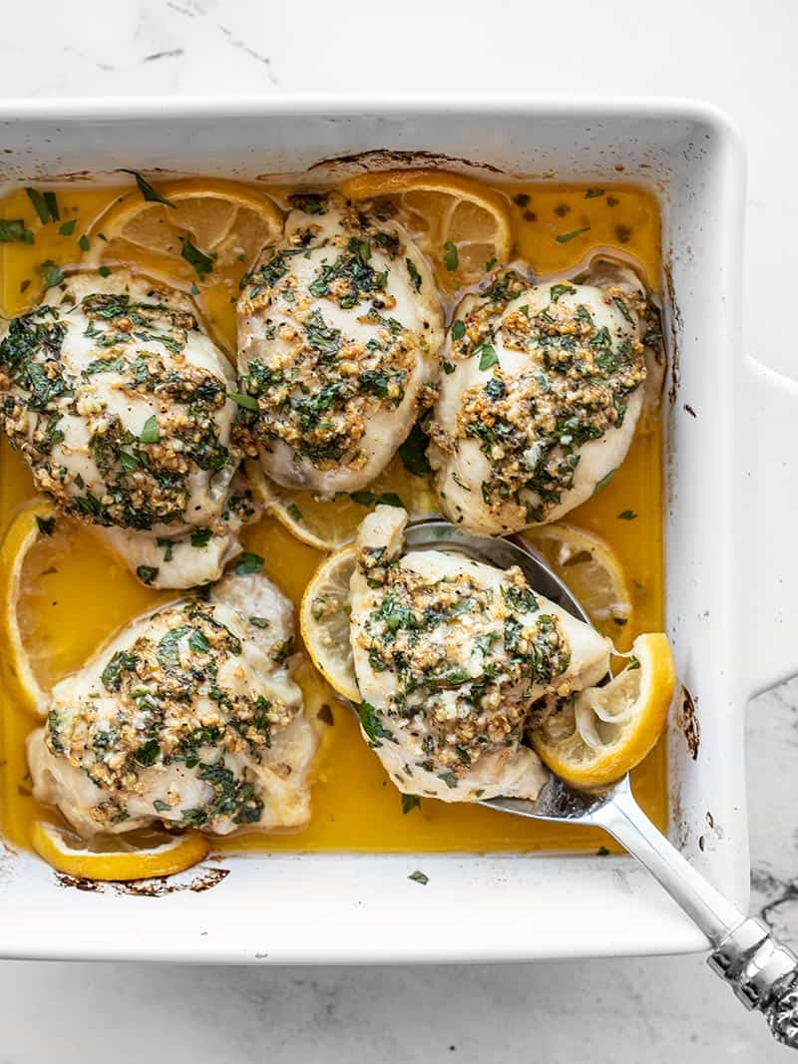
GARLIC BUTTER BAKED CHICKEN THIGHS
$6.03 RECIPE / $1.21 SERVING

Prep Time: 5 mins
Cook Time: 35 mins
Servings: 5

Ingredients

- 4 Tbsp butter ($0.40)
- 4 cloves garlic, minced ($0.32)
- 1/4 tsp paprika ($0.02)
- 1/4 tsp salt ($0.02)
- freshly cracked pepper ($0.02)
- 1 fresh lemon ($0.79)
- 2 Tbsp chopped fresh parsley (optional) ($0.10)
- 5 boneless, skinless chicken thighs (about 1.25 lbs.) ($4.36)

Directions
- Preheat the oven to 400ºF. Place the butter in a bowl and microwave for about 30 seconds, or until the butter is melted. Stir in the minced garlic, paprika, salt, some freshly cracked pepper (about 1/8 tsp), and about a tablespoon of chopped fresh parsley. Stir to combine.
- Place the chicken thighs in an 8x8" baking dish. Spoon the garlic butter mixture over the chicken thighs, using the back of the spoon to spread it over the surface of the chicken.
- Slice the lemon into half-rounds. Scatter the lemon pieces around the chicken in the dish.
- Transfer the baking dish to the oven and bake the chicken for 30-35 minutes, or until the internal temperature of the chicken thighs reaches 165ºF.
- Use a spoon to drizzle the baking juices over top of the chicken, then sprinkle the remaining tablespoon of chopped fresh parsley over top just before serving.

Nutrition Facts
Serving: 1Serving ・ Calories: 247.8kcal ・ Carbohydrates: 2.04g ・ Protein: 21.34g ・ Fat: 17.9g ・ Sodium: 329.18mg ・ Fiber: 0.48g
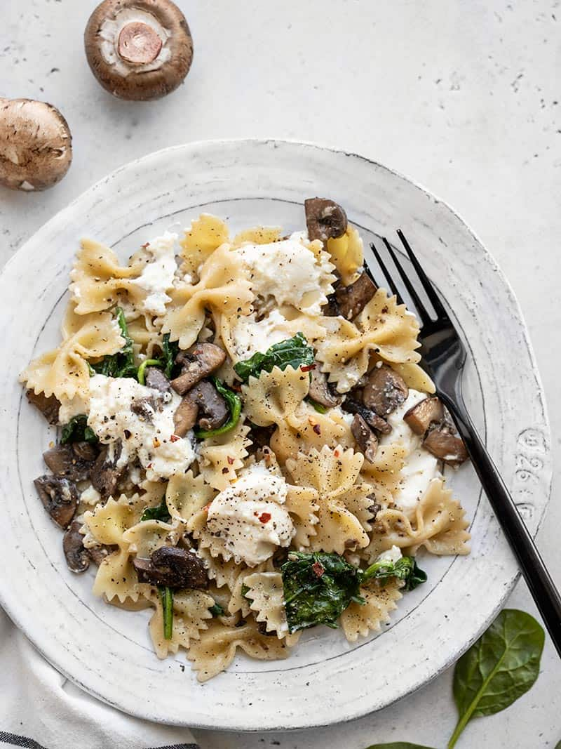
MUSHROOM AND SPINACH PASTA WITH RICOTTA
$6.74 RECIPE / $1.69 SERVING

Prep Time: 10 mins
Cook Time: 20 mins
Total Time: 30 mins
Servings: 4

Ingredients

- 8 oz. bowtie pasta ($0.53)
- 16 oz. baby bella mushrooms ($3.38)
- 2 Tbsp olive oil ($0.32)
- 2 Tbsp butter ($0.20)
- 2 cloves garlic ($0.16)
- 2 cups fresh spinach ($1.07)
- salt and pepper to taste ($0.05)
- 1/2 cup whole milk ricotta ($1.00)
- 1 pinch crushed red pepper (optional) ($0.03)

Directions
- Bring a large pot of water to a boil for the pasta. Once boiling, add the bowtie pasta and continue to boil until tender (about 7 minutes). Reserve 1/2 cup of the starchy pasta water before draining in a colander.
- While the pasta is cooking, prepare the rest of the dish. Wash and slice the mushrooms, then add them to a large skillet along with the olive oil. Sauté over medium heat until the mushrooms have released all their water, the water has evaporated, and the mushrooms begin to brown (about 7 minutes).
- While the mushrooms are cooking, mince the garlic. Add the garlic and butter to the browned mushrooms and continue to cook over medium for 1-2 minutes more, or just until the garlic softens a bit.
- By this time the pasta should be finished cooking. Add about 1/4 cup of the reserved pasta water to the skillet and stir to dissolve any browned bits off the bottom of the skillet. The starchy pasta water and butter will make a slurry that will act as a light "sauce" that helps the salt and pepper adhere to the surface of the pasta.
- Add the fresh spinach to the skillet and stir just until wilted (1 minute). Add the drained pasta to the skillet and stir until everything is evenly combined. Turn the heat off and season liberally with salt and pepper. If the pasta is dry, you can add an additional splash of the reserved pasta water.
- Finally, spoon the ricotta on top of the pasta in one-tablespoon dollops. Add a pinch of red pepper on top, if desired, and serve warm.
Nutrition Facts
Serving: 1Serving ・ Calories: 372.48kcal ・ Carbohydrates: 49.23g ・ Protein: 12.48g ・ Fat: 14.48g ・ Sodium: 296.35mg ・ Fiber: 3.6g
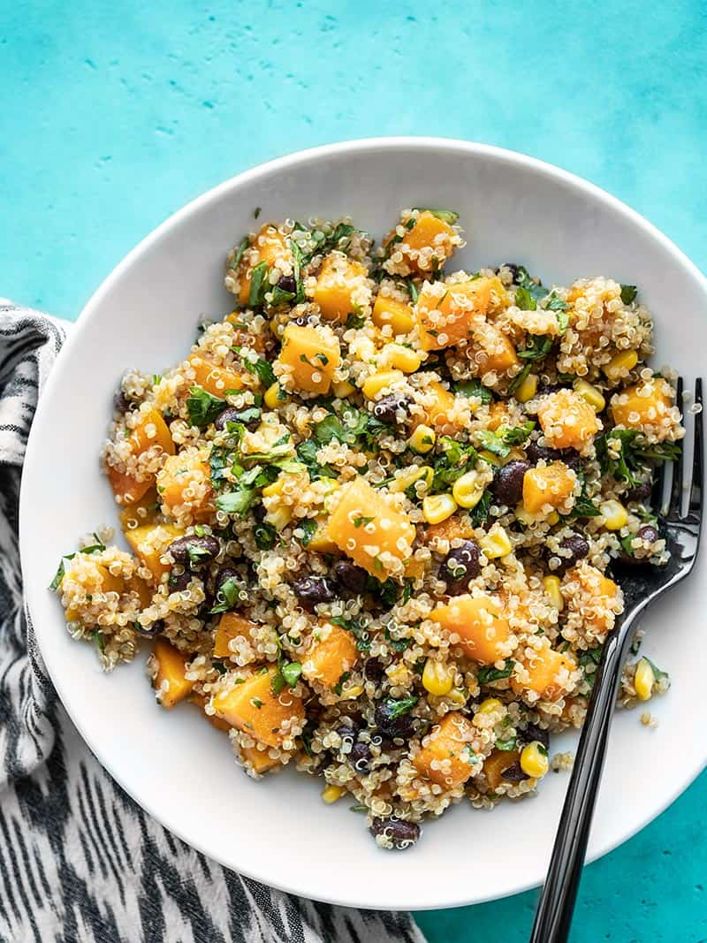
CHIPOTLE BUTTERNUT SQUASH AND QUINOA SALAD
$5.24 RECIPE / $1.31 SERVING

Prep Time: 10 mins
Cook Time: 30 mins
Total Time: 40 mins
Servings: 4 (1.25 cups each)

Ingredients

- 1 cup quinoa ($1.20)
- 2 lbs. butternut squash (about 4 cups diced) ($1.45)
- 2 Tbsp cooking oil ($0.08)
- 1 pinch salt ($0.02)
- 1 cup frozen corn ($0.20)
- 1 15oz. can black beans ($0.49)
DRESSING
- 1 cup chopped parsley ($0.35)
- 1/2 cup chopped cilantro ($0.19)
- 3 cloves garlic, minced ($0.24)
- 1/4 cup olive oil ($0.42)
- 2 Tbsp red wine vinegar ($0.20)
- 1 tsp dried oregano ($0.10)
- 1/2 tsp ground cumin ($0.05)
- 1 tsp chipotle powder* ($0.10)
- 3/4 tsp salt ($0.05)

Directions
- Rinse the quinoa well with cool water in a fine wire mesh sieve. Add the quinoa and 1.75 cups water to a sauce pot. Place a lid on the pot, turn the heat up to high, and allow it to come to a boil. Once boiling, turn the heat down to low, and let the quinoa continue to simmer for 15 minutes (lid on).
- After 15 minutes of simmering, turn the heat off, and let the quinoa rest for 5 minutes.
- While the quinoa is simmering, prepare the butternut squash. Cut the ends off the squash to provide a flat sturdy surface. Use a vegetable peeler to peel the squash. Cut the squash in half, lengthwise, then scoop out the seeds. Finally, dice the remaining squash.
- When the quinoa is finished cooking, add it to a large bowl along with the frozen corn. Stir to combine, allowing the hot quinoa to thaw the corn. Set the bowl aside.
- Next cook the butternut squash. Add the cooking oil to a large skillet and place it over medium heat. Once hot, add the diced squash and a pinch of salt. Sauté the squash until it is tender and slightly browned (about 15 minutes). If the squash begins to stick, add a tablespoon or two of water and allow the steam to loosen the squash.
- While the squash is cooking, rinse and drain the black beans, and prepare the dressing. In a small bowl, combine the chopped fresh parsley, chopped fresh cilantro, three cloves of minced garlic, 1/4 cup olive oil, 2 Tbsp red wine vinegar, 1 tsp dried oregano, 1/2 tsp ground cumin, 1 tsp chipotle powder, and 1 tsp salt. Stir to combine.
- When the butternut squash is finished cooking, add it to the bowl with the corn and quinoa. Also add the rinsed and drained black beans, and the prepared dressing. Stir to combine, then season with salt to taste, if needed. Enjoy immediately or refrigerate until ready to eat!
Nutrition Facts
Serving: 1.25cups ・ Calories: 540.75kcal ・ Carbohydrates: 75.63g ・ Protein: 16.23g ・ Fat: 23.25g ・ Sodium: 1109.98mg ・ Fiber: 17.1g
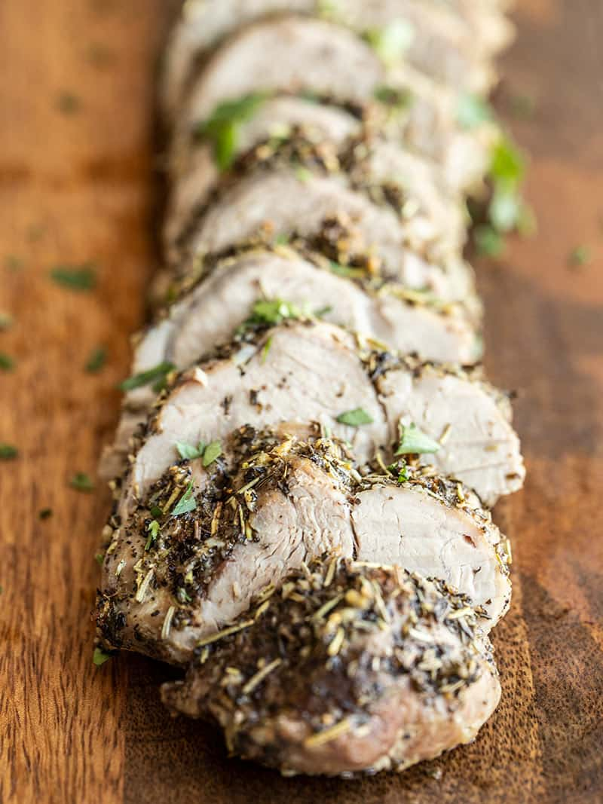
HERB ROASTED PORK TENDERLOIN
$5.53 RECIPE / $1.38 RECIPE

Prep Time: 10 mins
Cook Time: 35 mins
Total Time: 45 mins
Servings: 4

Ingredients

- 2 cloves garlic ($0.16)
- 1 tsp dried basil ($0.10)
- 1 tsp dried thyme ($0.10)
- 1 tsp dried rosemary ($0.10)
- freshly cracked black pepper ($0.05)
- 1/2 tsp salt ($0.02)
- 2 Tbsp olive oil ($0.32)
- 1.33 lbs. pork tenderloin ($4.68)

Directions
- Preheat the oven to 400ºF. Mince the garlic. Add the dried basil, thyme, and rosemary to a small dish. Use your hands to crush the dried rosemary slightly. Add the garlic, olive oil, salt, and some freshly cracked black pepper to the bowl and stir to combine.
- Place the pork tenderloin on a baking sheet or baking dish. Rub the oil and herb mix over the entire surface of the pork, including the underside.
- Place the baking dish in the preheated oven and roast the pork for about 35 minutes, or until the internal temperature reads at least 145ºF. Allow the pork to rest at room temperature for 10 minutes before slicing and serving.
Nutrition Facts
Serving: 1Serving ・ Calories: 280.1kcal ・ Carbohydrates: 2.1g ・ Protein: 28.6g ・ Fat: 17.53g ・ Sodium: 828.3mg ・ Fiber: 0.3g
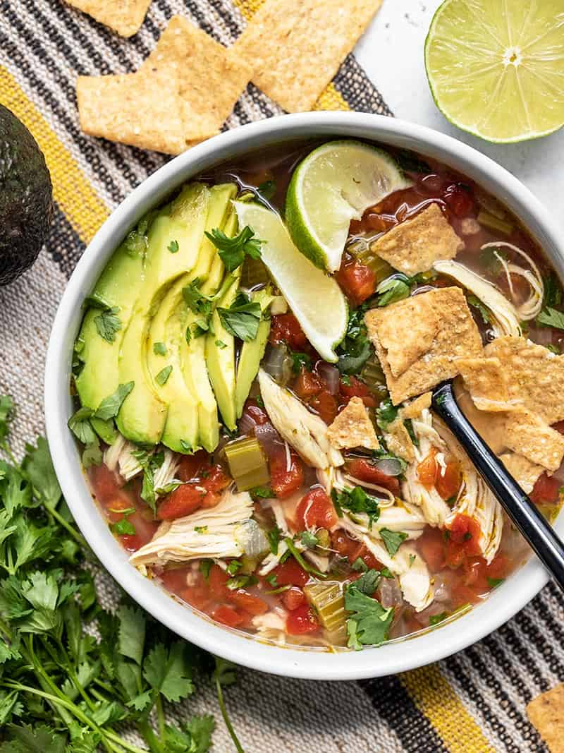
CHICKEN AND LIME SOUP
$7.76 RECIPE / $1.29 SERVING

Prep Time: 10 mins
Cook Time: 1 hr
Total Time: 1 hr 10 mins
Servings: 6 (about 1.5 cups each)

Ingredients

- 1 yellow onion ($0.21)
- 3 ribs celery (about 1/4 bunch) ($0.37)
- 1 jalapenño ($0.17)
- 4 cloves garlic ($0.32)
- 2 Tbsp olive oil ($0.32)
- 1 boneless, skinless chicken breast (about 3/4 lb.) ($2.32)
- 6 cups chicken broth* ($0.78)
- 2 10oz. cans diced tomatoes with green chiles (Rotel) ($0.90)
- 1 tsp oregano ($0.10)
- 1/2 Tbsp cumin ($0.15)
- 1 lime ($0.22)
- 1/2 bunch cilantro ($0.40)
- 1 avocado ($1.50)

Directions
- Dice the onion, celery, and jalapeño (scrape the seeds out of the jalapeño before dicing). Mince the garlic. Add the onion, celery, jalapeño, garlic, and olive oil to a large soup pot and cook over medium heat for about 5 minutes, or until the onions are soft and translucent.
- Add the chicken breast, chicken broth, diced tomatoes with chiles (with juices), oregano, and cumin to the pot. Place a lid on the pot, turn the heat up to high, and bring the broth up to a boil. Once boiling, turn the heat down to low and let the pot simmer for 45 minutes.
- After simmering for 45 minutes, carefully remove the chicken breast from the pot and use two forks to shred the meat. Return the shredded meat to the pot. Squeeze the juice of one lime into the soup (2-3 Tbsp juice).
- Rinse the cilantro and then roughly chop the leaves. Add the chopped cilantro to the soup, give it a quick stir, then serve. Slice the avocado and add a few slices to each bowl.

Nutrition Facts
Serving: 1.5Cups ・ Calories: 202.58kcal ・ Carbohydrates: 12.35g ・ Protein: 15.9g ・ Fat: 11.27g ・ Sodium: 1289.98mg ・ Fiber: 3.73g
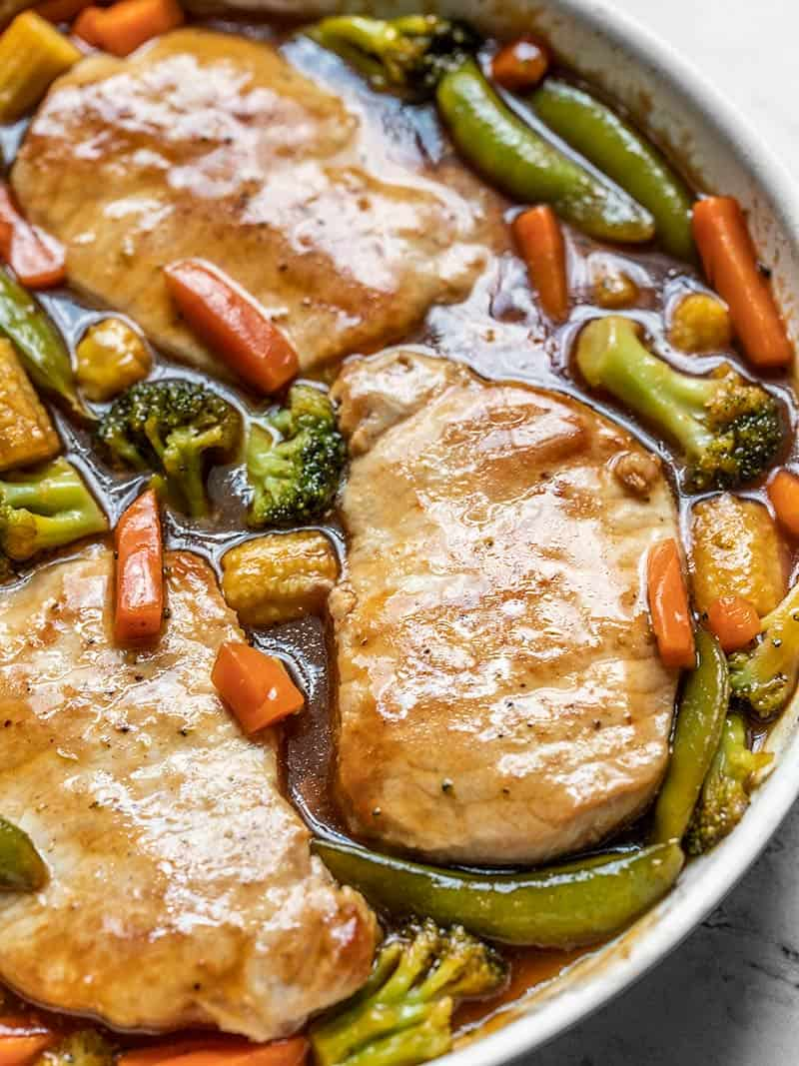
SWEET AND SOUR PORK CHOPS WITH VEGETABLES
$8.86 RECIPE / $2.22 SERVING

Prep Time: 5 mins
Cook Time: 20 mins
Total Time: 25 mins
Servings: 4

Ingredients

- 1/2 cup brown sugar ($0.32)
- 1/2 cup rice vinegar ($0.96)
- 1/4 cup ketchup ($0.20)
- 1/4 cup water ($0.00)
- 2 tsp soy sauce ($0.08)
- 2 tsp cornstarch ($0.02)
- 4 boneless, center cut pork chops, 1-inch thick (about 1.5 lbs. total) ($5.50)
- 1 pinch salt and pepper ($0.05)
- 2 Tbsp cooking oil ($0.08)
- 12 oz. frozen stir fry vegetables ($1.65)

Directions
- Add the brown sugar, rice vinegar, ketchup, water, soy sauce, and cornstarch to a bowl and whisk until the sugar and cornstarch are dissolved. Set the sauce aside.
- Season the pork chops with a pinch of salt and pepper on each side.
- Preheat a large skillet over medium, or just slightly above medium. Once the skillet is nice and hot, add the cooking oil and swirl to coat the surface. Add the pork chops and cook for about 5 minutes on each side, or until they are nicely browned. Remove the pork chops to a clean plate and cover with a second plate (turned upside down) to keep them warm.
- Add the frozen vegetables to the skillet and continue to cook and stir over medium for about two minutes, or just long enough to take some of the ice off (they may still be icy in the center). Give the sauce a brief stir in case any of the cornstarch has settled, then add it to the skillet with the vegetables. Continue to cook and stir until the sauce begins to simmer, at which point it will thicken and go from a cloudy brown to a shiny glaze.
- Add the cooked pork chops back to the skillet with the vegetables and sauce. Let the pork chops simmer in the sauce for 2-3 minutes more, or until the internal temperature reaches 145ºF. Serve hot, over rice or noodles.
Nutrition Facts
Serving: 1Serving ・ Calories: 298.33kcal ・ Carbohydrates: 41.85g ・ Protein: 9.05g ・ Fat: 11.13g ・ Sodium: 396.25mg ・ Fiber: 3.58g
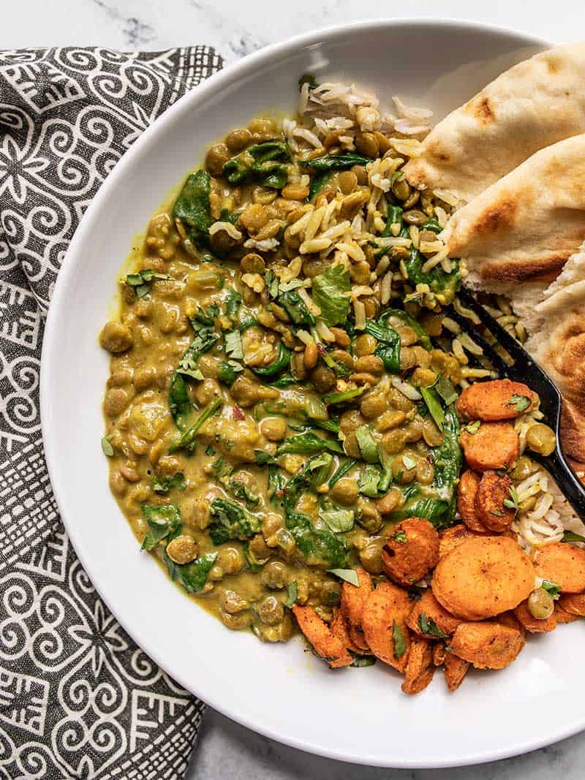
CREAMY COCONUT CURRY LENTILS WITH SPINACH
$6.29 RECIPE / $1.57 SERVING

Prep Time: 5 mins
Cook Time: 40 mins
Total Time: 45 mins
Servings: 4 (1.25 cups curry lentils + 1 cup rice)

Ingredients

- 2 Tbsp olive oil ($0.24)
- 2 cloves garlic ($0.16)
- 1 tsp grated fresh ginger ($0.10)
- 1 small yellow onion ($0.21)
- 1 Tbsp curry powder* ($0.30)
- 1 cup brown lentils (dry) ($0.67)
- 2 cups vegetable broth** ($0.26)
- 1 13oz. can coconut milk ($1.99)
- 3 cups fresh baby spinach ($1.61)
FOR SERVING (OPTIONAL)
- 4 cups cooked rice ($0.60)
- 1/4 cup chopped fresh cilantro ($0.15)

Directions
- Mince the garlic, grate the ginger, and dice the onion. Add the olive oil, garlic, and ginger to a deep skillet, Dutch oven, or soup pot. Sauté the garlic and ginger over medium heat for 1 minute, or just until the garlic becomes soft and fragrant.
- Add the diced onion to the skillet and continue to sauté over medium until the onion is soft and translucent. Add the curry powder and continue to sauté for about one minute more to toast the spices.
- Add the dry lentils and vegetable broth to the skillet. Stir to dissolve any browned bits from the bottom of the skillet. Place a lid on top, turn the heat up to medium-high, and bring the broth to a boil. Once boiling, turn the heat down to low, and let it simmer for 20 minutes, stirring occasionally.
- After simmering for 20 minutes the lentils should be tender and most of the broth absorbed. Add the can of coconut milk and stir to combine. Turn the heat back up to medium and allow the skillet to come back up to a simmer. Let it simmer without a lid for an additional 10 minutes, stirring often, to thicken the mixture.
- Once thickened, turn the heat off. Add the fresh spinach and stir gently until the spinach has wilted. Taste the mixture and adjust the salt or curry powder to your liking, if needed.
- Serve over a bowl of rice, and top with chopped cilantro if desired.
Nutrition Facts
Serving: 1.25Cups ・ Calories: 494.13kcal ・ Carbohydrates: 83.93g ・ Protein: 17.83g ・ Fat: 8.18g ・ Sodium: 844.08mg ・ Fiber: 8g
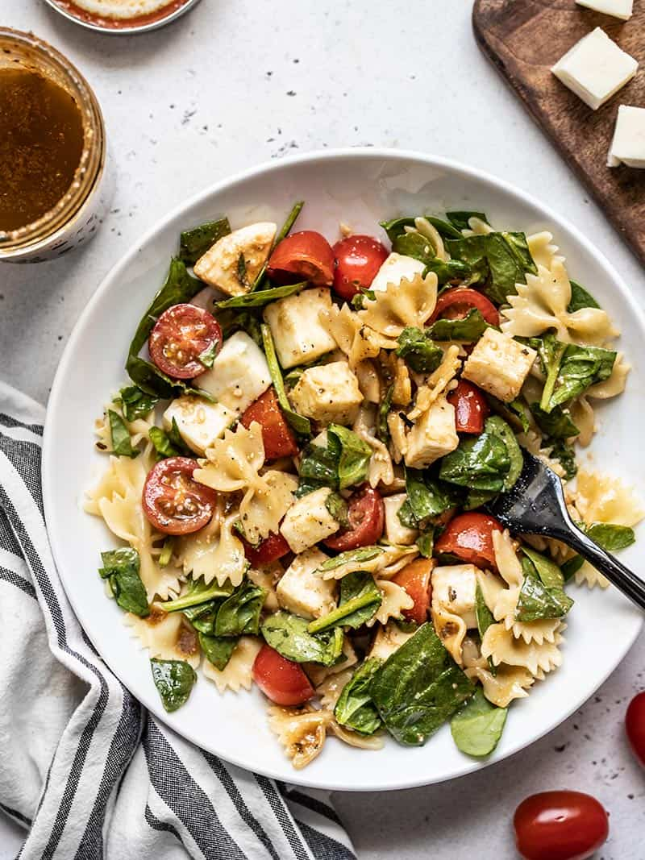
TOMATO MOZZARELLA PASTA SALAD WITH BALSAMIC VINAIGRETTE
$8.59 RECIPE / $1.43 SERVING

Prep Time: 10 mins
Cook Time: 15 mins
Total Time: 25 mins
Servings: 6 (about 1.5 cups each)

Ingredients

- 8 oz. bowtie pasta ($0.67)
- salt for pasta water ($0.02)
- 3 cups fresh spinach ($1.20)
- 1 pint grape tomatoes ($2.50)
- 8 oz. mozzarella* ($2.60)
PARMESAN BALSAMIC VINAIGRETTE
- 1/3 cup olive oil ($0.55)
- 3 Tbsp balsamic vinegar ($0.41)
- 2 Tbsp mayonnaise ($0.17)
- 2 Tbsp grated Parmesan ($0.22)
- 1/2 Tbsp Dijon mustard ($0.09)
- 1 clove garlic, minced ($0.08)
- 1/2 tsp dried basil ($0.05)
- 1/4 tsp salt ($0.01)
- freshly cracked pepper ($0.02)

Directions
- Fill a pot with water and add two large pinches of salt. Cover the pot and bring it to a boil over high heat. Once boiling, add the pasta and continue to boil until the pasta is tender. Drain the pasta in a colander, give it a brief rinse with cool water, and let it drain well while you prepare the rest of the salad.
- While waiting for the pasta to cook, prepare the rest of the salad. Start with the Parmesan Balsamic Vinaigrette. Combine all the dressing ingredients in a jar or blender. Either blend until combined or shake your jar until the ingredients are well combined. Set the dressing aside until needed.
- Roughly chop the spinach and slice the grape tomatoes in half. Dice the mozzarella into 1/2-inch cubes.
- Add the spinach, tomatoes, and mozzarella to a large bowl. Once the pasta is well drained and mostly cool, add it to the bowl with the mozzarella and vegetables. Make sure the pasta is no longer hot, so it doesn't wilt the spinach or melt the cheese.
- Toss the ingredients to combine. If serving the salad later, store it like this without dressing. If serving immediately, add half of the dressing and toss to coat. Add more dressing as desired.
Nutrition Facts
Serving: 1.5Cups ・ Calories: 429.18kcal ・ Carbohydrates: 36.62g ・ Protein: 15.67g ・ Fat: 24.6g ・ Sodium: 567.75mg ・ Fiber: 3.03g
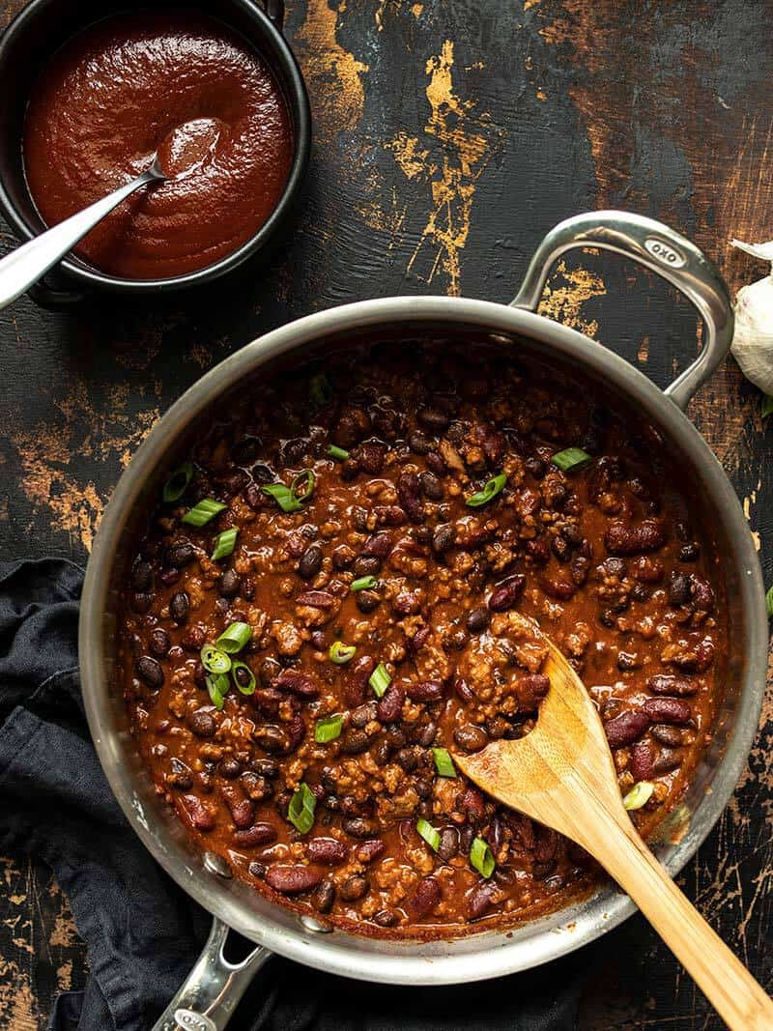
BBQ BEEF AND BEANS
$7.68 RECIPE / $1.92 SERVING

Prep Time: 5 mins
Cook Time: 25 mins
Total Time: 30 mins
Servings: 4

Ingredients

- 1 Tbsp cooking oil ($0.04)
- 2 cloves garlic, minced ($0.16)
- 1/2 lb. ground beef ($2.65)
- 1 15oz. can kidney beans ($0.89)
- 1 15oz. can black beans ($0.89)
HOMEMADE BBQ SAUCE*
- 8 oz. tomato sauce ($0.25)
- 2 Tbsp tomato paste ($0.10)
- 2 Tbsp apple cider vinegar ($0.12)
- 2 Tbsp brown sugar ($0.08)
- 2 Tbsp molasses ($0.35)
- 1/2 Tbsp Dijon mustard ($0.05)
- 1 tsp Worcestershire sauce ($0.02)
- 1 tsp smoked paprika ($0.10)
- 1/4 tsp garlic powder ($0.02)
- 1/4 tsp onion powder ($0.02)
- 1/8 tsp cayenne pepper ($0.01)
- freshly cracked pepper ($0.02)
- salt to taste ($0.02)
FOR SERVING
- 4 cups cooked rice ($0.80)
- 4 oz. shredded cheddar ($0.85)
- 2 green onions, sliced ($0.22)

Directions
- Add the oil and minced garlic to a large skillet. Sauté the garlic for one minute over medium heat. Add the ground beef and continue to sauté until cooked through. If using a higher fat content beef, drain the excess fat before moving on to the next step.
- Rinse the two cans of beans, then drain them well. Add the beans to the skillet with the ground beef.
- Add the ingredients for the Homemade BBQ Sauce to the skillet (tomato sauce, tomato paste, apple cider vinegar, brown sugar, molasses, Dijon, Worcestershire sauce, smoked paprika, garlic powder, onion powder, cayenne, and some freshly cracked pepper).
- Stir and cook the mixture until the sauce ingredients have combined and created a thick sauce. Allow the sauce to come up to a simmer and then simmer the beef and beans in the sauce for 5 minutes, stirring often. Taste the sauce and add salt to taste (I added 1/2 tsp).
- To serve the BBQ Beef and Beans, place 1 cup cooked rice in each bowl, top with 1 cup of the BBQ Beef and Beans, then top with about 1/4 cup shredded cheddar and a sprinkle of sliced green onion.
Nutrition Facts
Serving: 1Serving ・ Calories: 742.13kcal ・ Carbohydrates: 100.15g ・ Protein: 35.45g ・ Fat: 21.73g ・ Sodium: 1749.25mg ・ Fiber: 13.63g
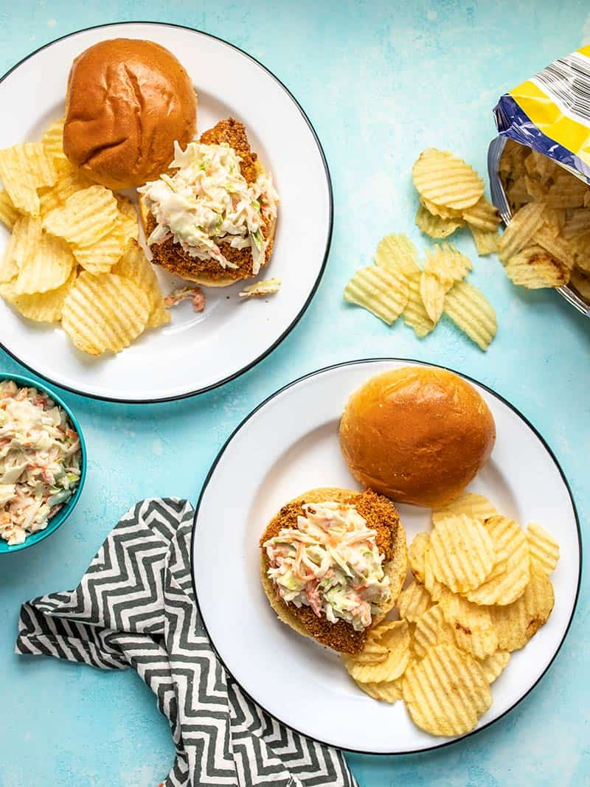
BAKED SPICY CHICKEN SANDWICHES
$6.93 RECIPE / $3.47 SERVING

Prep Time: 15 mins
Cook Time: 25 mins
Total Time: 40 mins
Servings: 2

Ingredients

BAKED SPICY CHICKEN
- 1/2 cup breadcrumbs ($0.13)
- 1/4 tsp garlic powder ($0.02)
- 1/2 tsp smoked paprika ($0.05)
- 1/2 tsp cayenne ($0.05)
- 1/8 tsp salt ($0.01)
- freshly cracked pepper ($0.02)
- 1.5 Tbsp cooking oil ($0.06)
- 1/4 cup plain yogurt ($0.25)
- 1/8 tsp salt ($0.01)
- 1 tsp hot sauce ($0.04)
- 1 boneless, skinless chicken breast (about 2/3 lb.) ($3.99)
HONEY YOGURT SLAW
- 3 cups shredded cabbage slaw mix (pre-bagged) ($0.65)
- 2 Tbsp mayonnaise ($0.17)
- 1/3 cup plain whole milk yogurt ($0.33)
- 1/2 Tbsp honey ($0.06)
- 1 tsp Dijon mustard ($0.06)
- 1 tsp apple cider vinegar ($0.02)
- 1/4 tsp salt ($0.02)
- freshly cracked pepper ($0.02)
FOR SERVING
- 2 buns ($1.00)

Directions
- Preheat the oven to 425ºF. Place a wire cooling rack over a baking sheet to hold the breaded chicken.
- In a wide shallow bowl or container, combine the bread crumbs, garlic powder, smoked paprika, cayenne, salt, and some freshly cracked pepper for the chicken's breading. Once combined, add the cooking oil and stir until the seasoned breadcrumbs resemble damp sand.
- In a separate wide shallow bowl or container, combine the yogurt, salt, and hot sauce.
- Place the chicken breast on a cutting board, cover with plastic, then use a mallet or rolling pin to gently pound the chicken breast to an even thickness, no more than 3/4-inch thick. Cut the chicken breast in half, then season with a pinch of salt and a pinch of cayenne.
- Dip each piece of chicken into the yogurt and hot sauce mixture, making sure to fully coat the chicken, then into the seasoned bread crumbs, again coating both sides. Place the coated chicken on the prepared baking sheet with wire rack.
- Bake the chicken for 25 minutes, or until the internal temperature reaches 165ºF, carefully flipping the chicken once half way through.
- While the chicken is baking, prepare the honey yogurt slaw. In a small bowl stir together the mayonnaise, yogurt, honey, Dijon, vinegar, salt, and some freshly cracked pepper.
- Place the shredded cabbage slaw mix in a large bowl, pour the prepared dressing over top, and stir until the cabbage is coated in dressing.
- Once the chicken is finished baking, build the sandwiches. Place one piece of spicy chicken on each bun and top with a generous pile of the honey yogurt slaw. Enjoy!
Nutrition Facts
Serving: 1Serving ・ Calories: 779.4kcal ・ Carbohydrates: 80.2g ・ Protein: 48.9g ・ Fat: 30.9g ・ Sodium: 1768.05mg ・ Fiber: 9.15g
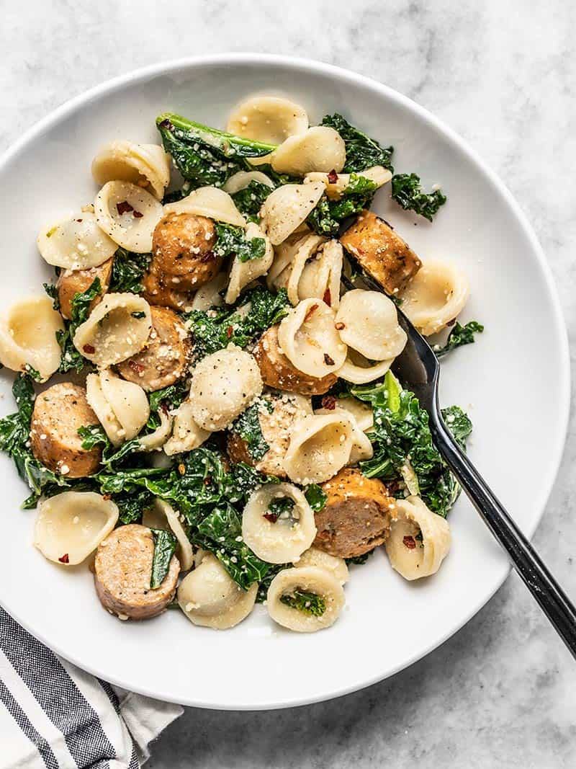
SPICY ORECCHIETTE WITH CHICKEN SAUSAGE AND KALE
$7.74 RECIPE / $1.94 SERVING

Prep Time: 5 mins
Cook Time: 15 mins
Total Time: 20 mins
Servings: 4 (about 1.5 cups each)

Ingredients

- 8 oz. orecchiette ($1.33)
- 2 Tbsp olive oil ($0.32)
- 12 oz. chicken sausage ($2.99)
- 2 Tbsp butter ($0.27)
- 2 cloves garlic, minced ($0.16)
- 8 oz. chopped kale* ($2.14)
- 1/4 cup grated Parmesan ($0.44)
- 1/4 tsp crushed red pepper ($0.02)
- 1 pinch salt ($0.02)
- freshly cracked pepper to taste ($0.05)

Directions
- Cook the orecchiette according to the package directions. Before draining the orecchiette in a colander, reserve about 1/3 cup of the starchy pasta water.
- While the orecchiette is cooking, begin preparing the rest of the recipe. Slice the chicken sausage into medallions.
- Add the olive oil and chicken sausage to a large pot and sauté over medium until the chicken sausage begins to brown (about 5 minutes).
- Add the minced garlic and butter to the pot with the sausage and continue to sauté for one more minute.
- Next, add the chopped kale and reserved pasta water. Turn the heat down to medium-low and continue to cook and stir until the kale has wilted (about 2-3 minutes). Use your spoon to dissolve any browned bits off the bottom of the pot as you stir.
- Remove the pot from the heat and stir in the cooked and drained orecchiette. If the pasta and kale are still steaming heavily, let the contents of the pot cool for about 5 minutes, stirring occasionally to release steam. You want the Parmesan to coat the pasta, but not melt.
- Once the pasta and kale is hot, but not steaming, add the grated Parmesan, crushed red pepper, salt, and about 15-20 cranks of a pepper mill. Stir to combine, then taste and add more salt if needed. Serve warm.
Nutrition Facts
Serving: 1.5Cups ・ Calories: 468.75kcal ・ Carbohydrates: 48.15g ・ Protein: 24.1g ・ Fat: 23.08g ・ Sodium: 850.65mg ・ Fiber: 3.48g
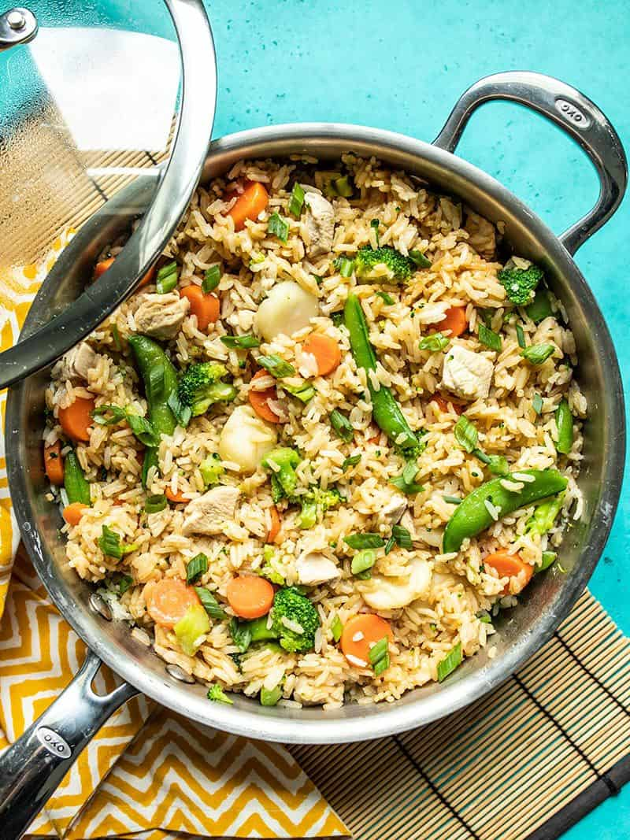
ONE POT TERIYAKI CHICKEN AND RICE
$6.26 RECIPE / $1.57 SERVING

Prep Time: 5 mins
Cook Time: 30 mins
Total Time: 35 mins
Servings: 4 (about 2 cups each)

Ingredients

- 1 boneless, skinless chicken breast (about 2/3 lb.) ($2.81)
- 1 Tbsp cooking oil ($0.04)
- 2 cloves garlic, minced ($0.16)
- 1 tsp grated fresh ginger ($0.10)
- 1.5 cups uncooked jasmine rice ($0.99)
- 2.5 cups water ($0.00)
- 12 oz. frozen stir fry vegetables ($1.59)
- 1/4 cup soy sauce ($0.24)
- 2 Tbsp brown sugar ($0.08)
- 1 tsp toasted sesame oil ($0.10)
- 2 green onions, sliced ($0.15)

Directions
- Cut the chicken breast into very small pieces, about 1/2 to 3/4-inch in size.
- Add the cooking oil, garlic, and ginger to a large, deep skillet. Cook over medium heat for about 1 minute, then add the chicken pieces and continue to sauté just until the outside of the chicken is no longer pink. Do not overcook the chicken here, it will finish cooking with the rice.
- Add the uncooked rice to the skillet and continue to sauté for 1-2 minutes more. You should hear the rice popping. Finally, add the water and give everything a brief stir to make sure there is no rice stuck to the bottom of the skillet.
- Place a lid on the skillet, turn the heat up to medium-high, and allow the water to come to a full boil. Once boiling, turn the heat down to low and let it simmer for 10 minutes.
- While the skillet is simmering over low, prepare the teriyaki sauce. In a small bowl, stir together the soy sauce, brown sugar, and toasted sesame oil. The brown sugar may not fully dissolve, but that's okay. Set the sauce aside.
- After the rice has simmered for 10 minutes, lift the lid briefly to sprinkle the frozen vegetables on top, then replace the lid immediately. Make sure the vegetables are spread evenly over the surface. Let the skillet continue to heat over low for an additional five minute.
- After steaming the rice and vegetables together for 5 minutes, turn the heat off and let the skillet rest with the lid in place for an additional five minutes.
- Give the teriyaki sauce another brief stir, lift the lid on the skillet, and drizzle the sauce over the vegetables. Make sure to scrape out all the sugar from the bottom of the bowl. Using a spatula or large spoon, gently fold the rice and vegetables together until everything is mostly coated in the sauce. Make sure to scoop all the way to the bottom of the skillet when folding, as the sauce will sink to the bottom.
- Place the lid back on top and let the skillet rest for a final 5 minutes to let the flavor soak in (heat turned off). Sprinkle sliced green onions over top just before serving.
Nutrition Facts
Serving: 2Cups ・ Calories: 498.93kcal ・ Carbohydrates: 79.45g ・ Protein: 27.53g ・ Fat: 7.2g ・ Sodium: 950.73mg ・ Fiber: 5.25g
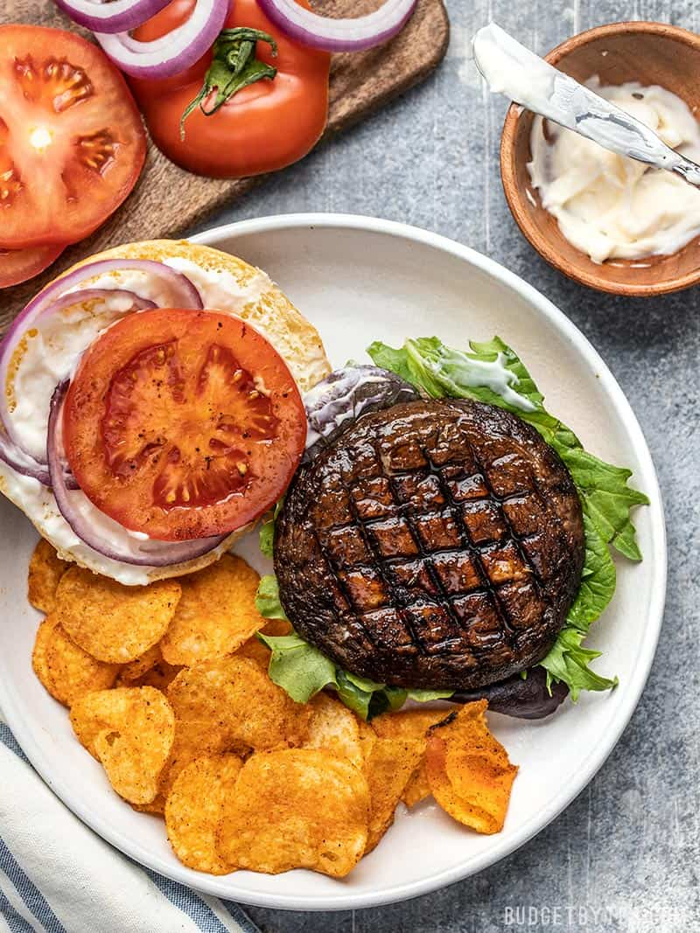
MARINATED PORTOBELLO MUSHROOM BURGERS
$5.68 RECIPE / $2.84 SERVING

Prep Time: 5 mins
Cook Time: 15 mins
Marinate Time: 30 mins
Total Time: 50 mins
Servings: 2

Ingredients

- 2 Tbsp olive oil ($0.08)
- 2 Tbsp soy sauce ($0.12)
- 1 Tbsp apple cider vinegar ($0.03)
- 1 tsp brown sugar ($0.02)
- 1/4 tsp oregano ($0.02)
- 1/4 tsp garlic powder ($0.02)
- 1/4 tsp onion powder ($0.02)
- 1 tsp smoked paprika ($0.10)
- freshly cracked pepper ($0.03)
- 2 portobello mushroom caps (about 1/2 lb. total) ($2.94)
- 2 buns ($0.83)
OPTIONAL TOPPINGS
- 1 cup spring mix ($0.32)
- 1 tomato ($0.70)
- 1/4 red onion, sliced into rings ($0.07)
- 4 Tbsp mayonnaise ($0.40)

Directions
- In a small bowl, stir together the olive oil, soy sauce, apple cider vinegar, brown sugar, oregano, garlic powder, onion powder, smoked paprika, and a little freshly cracked pepper (about 10 cranks of a pepper mill).
- Remove the stems from the portobello mushrooms.* Place the mushrooms in a shallow dish, gill sides up. Pour some of the marinade into the gills, then flip the mushrooms and pour the rest over the top. Let the mushrooms marinate for 30 minutes, flipping occasionally.
- Heat a grill or grill pan over medium to medium-high heat. Once hot, add the marinated portobello mushrooms and cook for about 7 minutes on each side, or until the mushrooms are soft and have released most of their liquid.
- Build your marinated portobello mushroom burgers on a bun with your preferred toppings. I love the classic mix of mayonnaise, sliced tomato, onion rings, and lettuce or spring mix.
Nutrition Facts
Serving: 1Serving ・ Calories: 522.05kcal ・ Carbohydrates: 39.3g ・ Protein: 9.4g ・ Fat: 38.05g ・ Sodium: 1426.45mg ・ Fiber: 3.6g
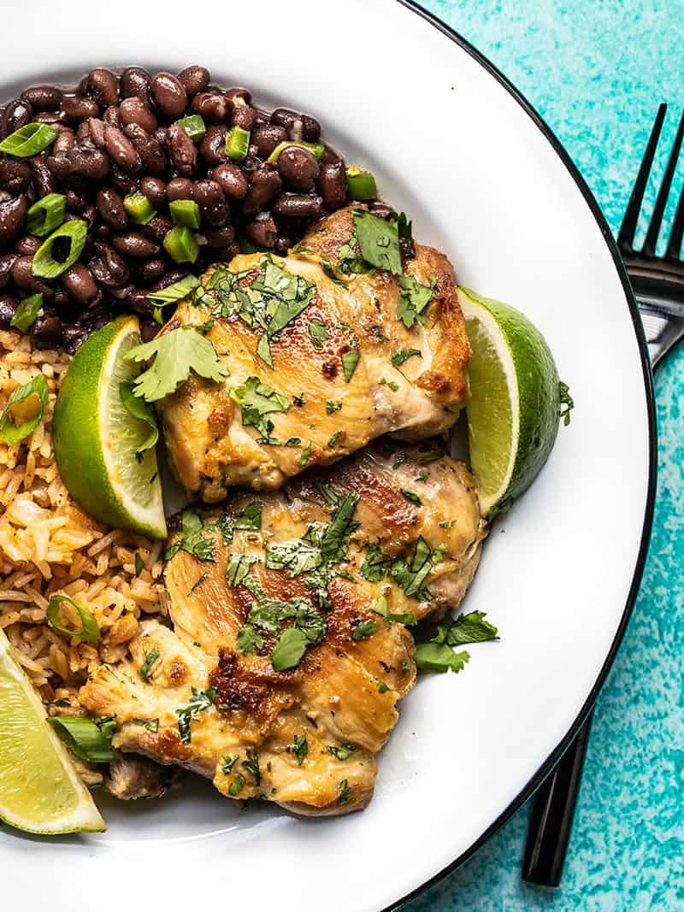
EASY CILANTRO LIME CHICKEN
$6.67 RECIPE / $1.11 SERVING

Prep Time: 10 mins
Cook Time: 15 mins
Marinate Time: 30 mins
Total Time: 55 mins
Servings: 6 (one thigh each)

Ingredients

- 2 Tbsp olive oil ($0.32)
- 4 cloves garlic, minced ($0.32)
- 1/2 tsp cumin ($0.05)
- 1/2 tsp salt ($0.02)
- freshly cracked pepper ($0.05)
- 2 limes, divided ($0.40)
- 1/2 bunch cilantro, divided ($0.40)
- 6 boneless, skinless chicken thighs (1.5 to 1.75 lbs. total) ($5.11)

Directions
- Combine the olive oil, minced garlic, cumin, salt, and some freshly cracked pepper (about 10 cranks of a pepper mill) in a small bowl.
- Zest one of the limes and then squeeze the juice. You'll need 2-3 Tbsp juice, so if needed, juice half of the second lime. Cut the remaining lime into wedges to garnish the chicken once cooked. Roughly chop the cilantro.
- Add 1 tsp of the lime zest, 2-3 Tbsp of the lime juice, and half of the chopped cilantro to the marinade. Stir to combine. (The remaining cilantro will be added fresh after cooking the chicken.)
- Place the chicken thighs in a shallow dish or a large zip top bag. Add the marinade and toss the chicken to coat. Allow the chicken to marinate for 30 minutes or up to 8 hours (refrigerated), turning it once or twice as it marinates.
- When ready to cook the chicken, heat a large skillet over medium-high heat. Once hot, add the chicken and cook for 5-7 minutes on each side, or until well browned and cooked through. My chicken had enough of an oil coating from the marinade that I did not need to add any extra to the skillet.
- Top the cooked chicken with fresher cilantro and a squeeze of fresh lime juice. Serve with any extra lime wedges.
Nutrition Facts
Serving: 1Serving ・ Calories: 238.82kcal ・ Carbohydrates: 3.42g ・ Protein: 22.63g ・ Fat: 16.28g ・ Sodium: 340.73mg ・ Fiber: 0.92g
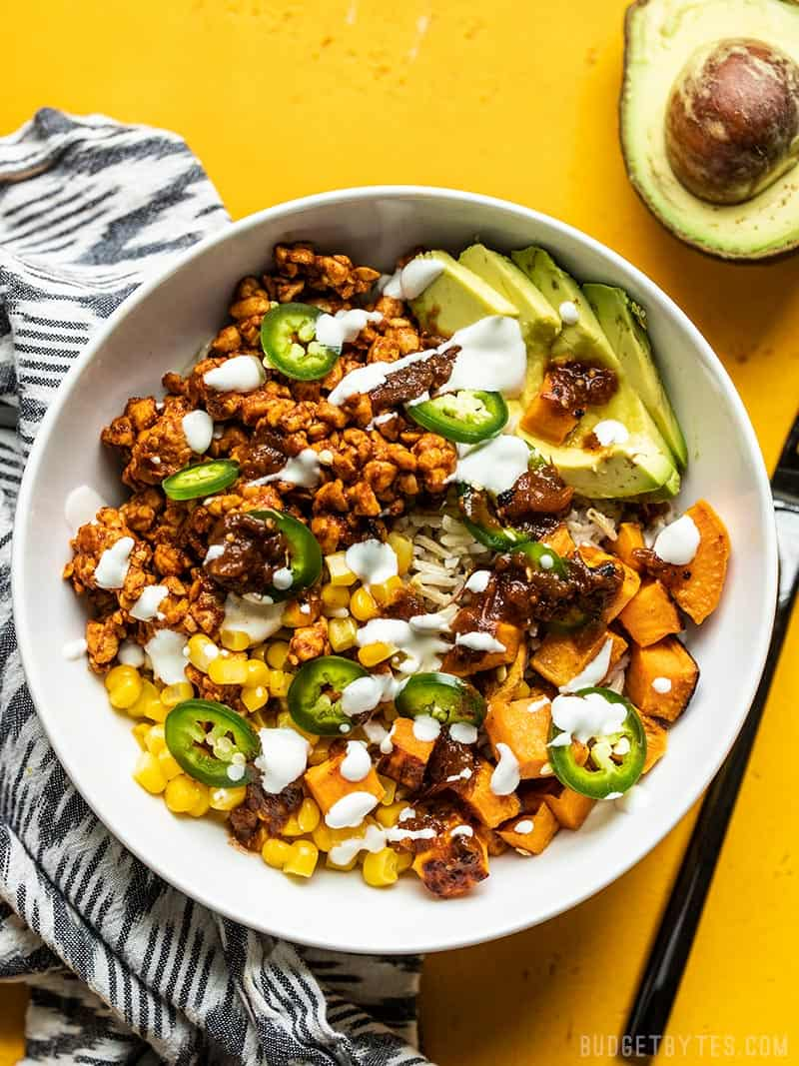
TEMPEH BURRITO BOWLS
$7.27 RECIPE / $1.82 SERVING

Prep Time: 15 mins
Cook Time: 20 mins
Total Time: 35 mins
Servings: 4

Ingredients

ROASTED SWEET POTATOES
- 1 sweet potato (about 1 lb.) ($1.47)
- 1 Tbsp cooking oil ($0.04)
SEASONED TEMPEH*
- 8 oz. tempeh ($2.49)
- 1 cup water ($0.00)
- 1 Tbsp cooking oil ($0.04)
- 1 Tbsp tomato paste ($0.05)
- 2 tsp chili powder ($0.20)
- 1/2 tsp smoked paprika ($0.05)
- 1/2 tsp cumin ($0.05)
- 1/8 tsp cayenne ($0.02)
- 1/4 tsp oregano ($0.03)
- 1/4 tsp garlic powder ($0.03)
- 1/2 tsp salt ($0.02)
- freshly cracked pepper ($0.03)
BOWL INGREDIENTS
- 4 cups cooked rice ($0.47)
- 1/2 cup salsa ($0.50)
- 1 cup frozen corn kernels, thawed ($0.30)
- 1 jalapeño ($0.18)
- 1 avocado ($1.19)
- 1/4 cup sour cream ($0.11)

Directions
- Preheat the oven to 400ºF. Peel and dice the sweet potato into 1/2-inch cubes. Spread the cubes out onto a baking sheet, drizzle with oil, then toss to coat. Season with a pinch of salt.
- Roast the sweet potatoes in the preheated oven for 20 minutes, stirring half way through. Once roasted, set aside.
- While the sweet potatoes are roasting, prepare the seasoned tempeh. Crumble the brick of tempeh into a skillet. Add the water, oil, tomato paste, chili powder, smoked paprika, cumin, cayenne, oregano, garlic powder, salt, and some freshly cracked pepper (about 10 cranks of a pepper mill). Stir briefly to combine.
- Place a lid on the skillet and turn the heat on to medium. Allow the skillet to come up to a simmer. Let the tempeh simmer, stirring every few minutes, for about 10 minutes total, or until the liquid reduces to a thick sauce.
- While the tempeh is simmering, slice the avocado and jalapeño.
- To build the bowls, place 1 cup cooked rice in the bottom of each bowl. Divide the seasoned tempeh, roasted sweet potatoes, corn, and avocado between all four bowls. Top each bowl with 1 to 2 tablespoons of salsa, 1 tablespoon of sour cream, and a few slices of jalapeño. Eat immediately or refrigerate for up to 4 days.
Nutrition Facts
Serving: 1Serving ・ Calories: 561.88kcal ・ Carbohydrates: 71.28g ・ Protein: 19.03g ・ Fat: 24.25g ・ Sodium: 1133.5mg ・ Fiber: 10.58g
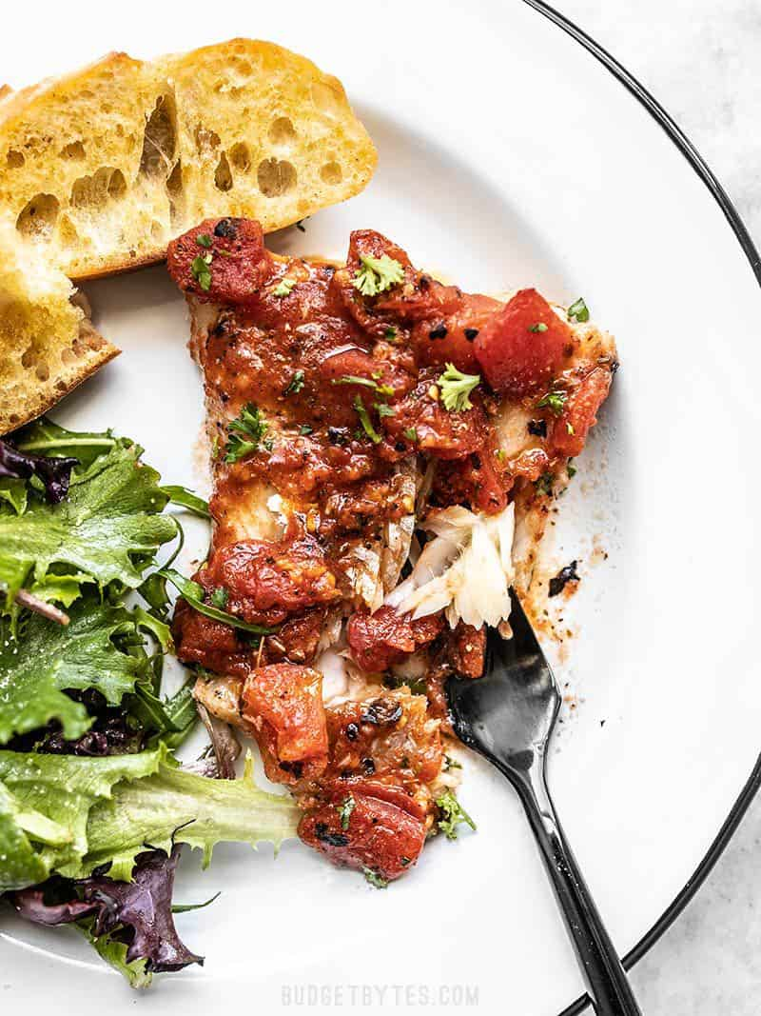
EASY OVEN BAKED FISH WITH TOMATOES
$6.61 RECIPIE / $1.65 SERVING

Prep Time: 10 mins
Cook Time: 15 mins
Total Time: 25 mins
Servings: 4

Ingredients

- 1 15 oz. can fire roasted diced tomatoes ($1.00)
- 2 cloves garlic, minced ($0.16)
- 2 Tbsp olive oil ($0.23)
- 1/2 tsp dried oregano ($0.05)
- 1/4 tsp salt ($0.02)
- freshly cracked pepper ($0.03)
- 1/2 Tbsp lemon juice ($0.06)
- 1 lb. white fish (four 4oz. fillets) ($4.95)
- chopped fresh parsley for garnish (optional) ($0.11)

Directions
- Preheat the oven to 400ºF. Drain the excess liquid from the can of diced tomatoes. Combine the diced tomatoes in a bowl with the garlic, olive oil, oregano, salt, some freshly cracked pepper (about 10 cranks of a pepper mill), and lemon juice.
- Spread about 1/3 of the tomato mixture in the bottom of a casserole dish big enough to fit all of your fillets without overlapping. Lay the fish fillets over the tomato mixture, then spoon the rest of the tomatoes over top, completely covering the fish.
- Bake the fish for about 15 minutes, or until the internal temperature reaches 145º and the fish easily flakes. Serve hot, with a sprinkle of chopped fresh parsley on top.
Nutrition Facts
Serving: 1Serving ・ Calories: 174.23kcal ・ Carbohydrates: 6.2g ・ Protein: 19.58g ・ Fat: 7.28g ・ Sodium: 696.55mg ・ Fiber: 1.05g
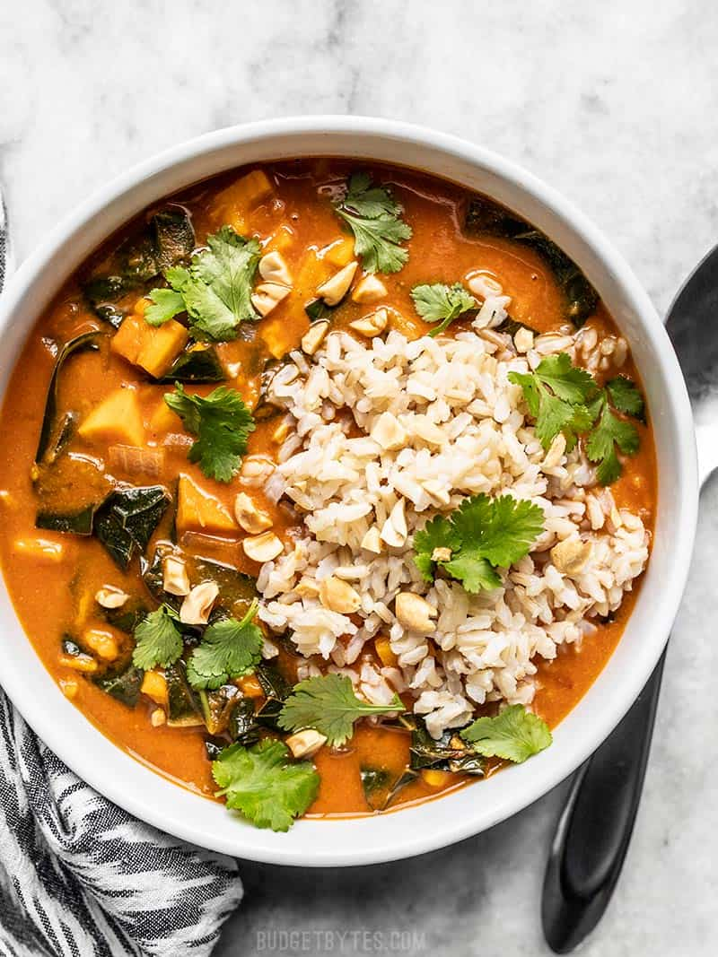
VEGAN PEANUT STEW
$6.38 RECIPE / $1.06 SERVING

Prep Time: 10 mins
Cook Time: 45 mins
Total Time: 55 mins
Servings: 6 (1.5 cups each)

Ingredients

- 1 Tbsp olive oil ($0.16)
- 4 cloves garlic ($0.32)
- 1 Tbsp grated fresh ginger ($0.30)
- 1 sweet potato (about 1 lb.) ($1.47)
- 1 medium onion ($0.21)
- 1 tsp cumin ($0.10)
- 1/4 tsp crushed red pepper ($0.02)
- 1 6oz. can tomato paste ($0.45)
- 1/2 cup natural style peanut butter ($0.55)
- 6 cups vegetable broth ($0.78)
- 1/2 bunch collard greens (4-6 cups chopped) ($0.99)
OPTIONAL GARNISHES
- 1/4 bunch cilantro ($0.25)
- 4.5 cups cooked brown rice ($0.53)
- 1/3 cup chopped peanuts ($0.16)

Directions
- Peel and grate the ginger using a small holed cheese grater. Mince the garlic, and dice the onion. Sauté the onion, ginger, and garlic in a large pot with the olive oil over medium heat for 2-3 minutes, or until the onion becomes soft and translucent.
- While the onion, ginger, and garlic are sautéing, peel and dice the sweet potato into 1/2-inch cubes. Add the sweet potato cubes, cumin, and red pepper to the pot and continue to sauté for about 5 minutes.
- Add the tomato paste, peanut butter, and vegetable broth to the pot. Stir until the peanut butter and tomato paste have mostly dissolved into the broth. Place a lid on the pot and turn the heat up to high. Allow the stew to come up to a boil. Once it reaches a boil, turn the heat down to medium-low and allow it to simmer for 15-20 minutes, or until the sweet potatoes are very soft.
- While the soup is simmering, prepare the collard greens. Use a sharp knife to remove each stem (cut along the side of each stem), then stack the leaves and cut them into 1/2-inch wide strips. Place the chopped collard greens in a colander and rinse very well
- Once the stew has simmered for 15-20 minutes and the sweet potatoes are very soft, stir in the collard greens. Let the stew simmer for about 5 minutes more, then begin to smash the sweet potatoes against the side of the pot to help thicken the stew.
- Finally, taste the stew and add salt or red pepper, if desired. Serve the stew with a scoop of cooked rice (about 3/4 cup), a few chopped peanuts, fresh cilantro, and a drizzle of sriracha, if desired.
Nutrition Facts
Serving: 1.5Cups ・ Calories: 467.9kcal ・ Carbohydrates: 63.43g ・ Protein: 14.7g ・ Fat: 19.62g ・ Sodium: 1341.67mg ・ Fiber: 9.45g
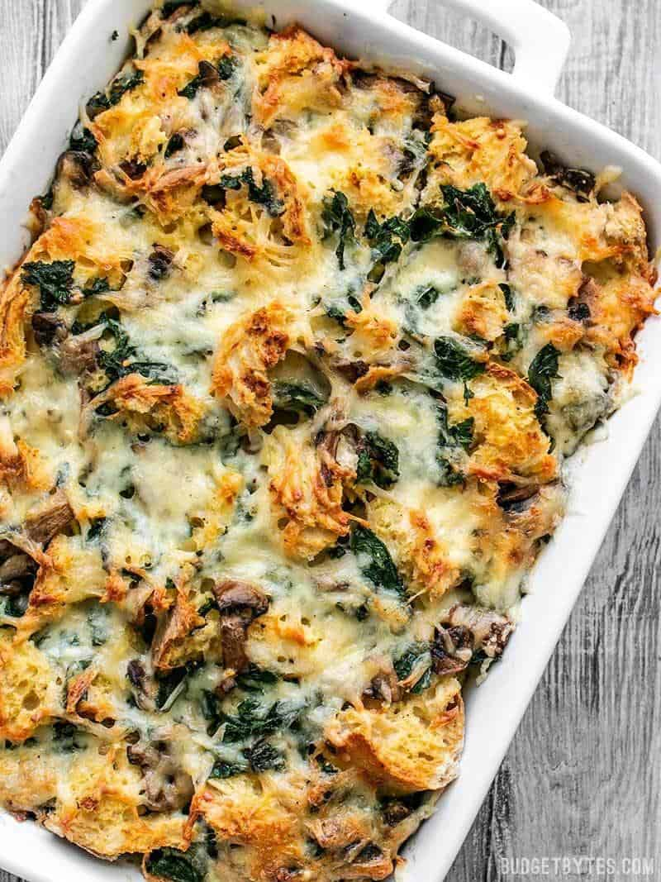
KALE SWISS AND MUSHROOM STRATA
$9.26 RECIPE / $1.54 SERVING

Prep Time: 25 mins
Cook Time: 50 mins
Refrigerate: 8 hrs
Total Time: 9 hrs 15 mins
Servings: 6 large slices

Ingredients

- 1 loaf hearty bread (about 1 lb. total)* ($1.69)
- 2 Tbsp butter ($0.12)
- 2 cloves garlic, minced ($0.16)
- 8 oz. mushrooms ($1.29)
- pinch salt and pepper
- 8 oz. chopped kale (6-8 cups) ($2.13)
- 8 oz. Swiss cheese, shredded ($1.69)
- 6 large eggs ($1.50)
- 1.5 cups whole milk ($0.50)
- 1 Tbsp Dijon mustard ($0.09)
- 1/8 tsp ground nutmeg ($0.02)
- 1/4 tsp salt ($0.02)

Directions
- The day before, prepare the strata so it can refrigerate over night. Preheat the oven to 300ºF. Tear the bread into 1/2 to 1-inch chunks and spread them out over a large baking sheet. Bake the bread chunks in the oven for 20 minutes, stirring once half-way through, to partially dry the bread.
- Meanwhile, slice the mushrooms, then add them to a large skillet with the butter, minced garlic, and a pinch of salt and pepper. Sauté the mushrooms over medium heat until they release all their moisture and begin to brown (about 5-7 minutes).
- Remove the cooked mushrooms from the skillet and add the kale in its place along with a couple tablespoons of water (this helps the kale wilt). Sauté the kale until wilted (2-3 minutes).
- Coat the inside of a 3 quart casserole dish with butter or non-stick spray. Layer half of the dry bread chunks in the bottom of the dish, then top with half of the mushrooms, half of the kale, and half of the Swiss. Wiggle the ingredients down between the bread chunks a bit, then repeat all the layers a second time.
- In a large bowl, whisk together the eggs, milk, Dijon, nutmeg, and 1/4 tsp salt. Pour the egg mixture over the prepared strata, making sure to drizzle over every surface of the strata, rather than just pouring in one spot. Cover the strata and refrigerate for 8-24 hours.
- The next day, allow the strata to sit at room temperature for 30 minutes. Preheat the oven to 350ºF. Bake the casserole for 50 minutes, or until the internal temperature reaches 160ºF and the top is deeply golden brown.
- Let the strata rest for 10 minutes, then slice into six pieces and serve!
Nutrition Facts
Serving: 1Serving ・ Calories: 507.23kcal ・ Carbohydrates: 43.65g ・ Protein: 27.27g ・ Fat: 26.58g ・ Sodium: 871.57mg ・ Fiber: 6.12g
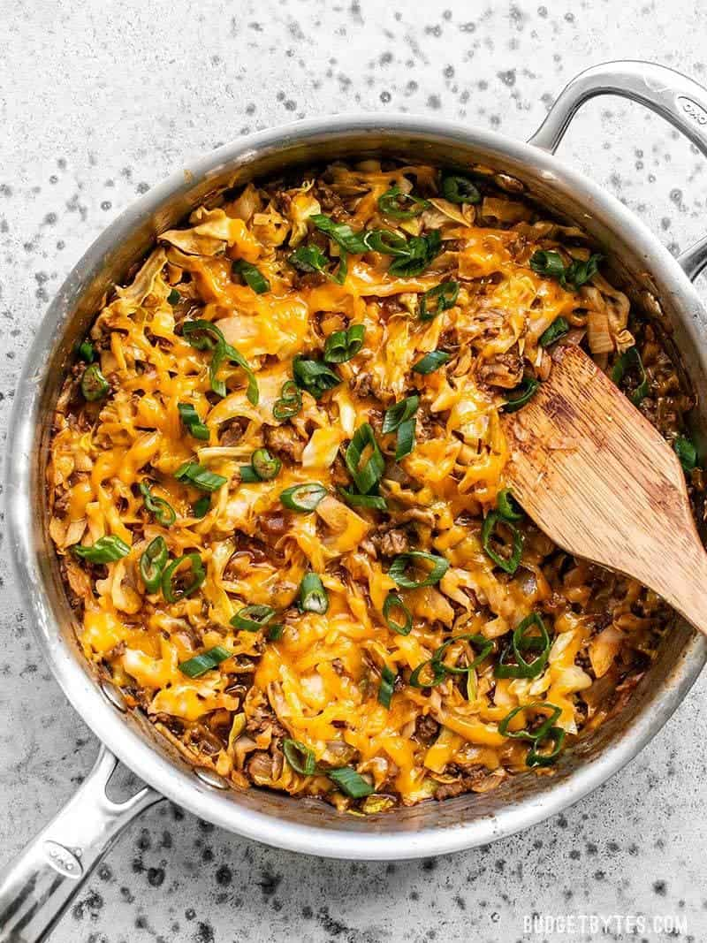
BBQ BEEF AND CABBAGE
$5.19 RECIPE / $1.73 SERVING

Prep Time: 10 mins
Cook Time: 20 mins
Total Time: 30 mins
Servings: 3 (About 1.5 cups each)

Ingredients

- 1 Tbsp olive oil ($0.16)
- 1/2 lb. lean ground beef ($2.65)
- 1 small onion ($0.32)
- 1 tsp smoked paprika ($0.10)
- 1/4 tsp garlic powder ($0.02)
- 3/4 tsp salt, divided ($0.04)
- 4-6 cups shredded cabbage (about one pound) ($0.60)
- 8 oz. tomato sauce ($0.47)
- 2 Tbsp apple cider vinegar ($0.06)
- 2 Tbsp brown sugar ($0.08)
- 1 Tbsp Worcestershire sauce ($0.06)
- 1 tsp Dijon mustard ($0.03)
- 2 oz. shredded cheddar ($0.50)
- 1 green onion, sliced ($0.10)

Directions
- Add the olive oil and ground beef to a large skillet and cook over medium heat. Begin to break up the beef as it browns.
- While the beef is browning, finely dice the onion. Add the onion, paprika, garlic powder, and salt to the skillet with the ground beef and continue to cook over medium heat until the onions are soft.
- While the onions and beef are cooking, finely shred the cabbage. Once the onions are soft, add 1/4 cup water to the skillet and stir to dissolve any browned bits off the bottom of the skillet. Add the shredded cabbage and stir to combine. Place a lid on the skillet and let simmer for about 5 minutes, stirring occasionally, until the cabbage has wilted.
- Add the tomato sauce, vinegar, brown sugar, Worcestershire sauce, and Dijon to the skillet. Stir to combine and let simmer a few more minutes without the lid, or until the liquid in the skillet has reduced slightly. Taste the sauce and add more salt if needed (I added 1/4 tsp).
- Finally, top the beef and cabbage with the shredded cheddar, place the lid back on the skillet for 1-2 minutes, or until the cheese has melted. Top with sliced green onions then serve.
Nutrition Facts
N/A

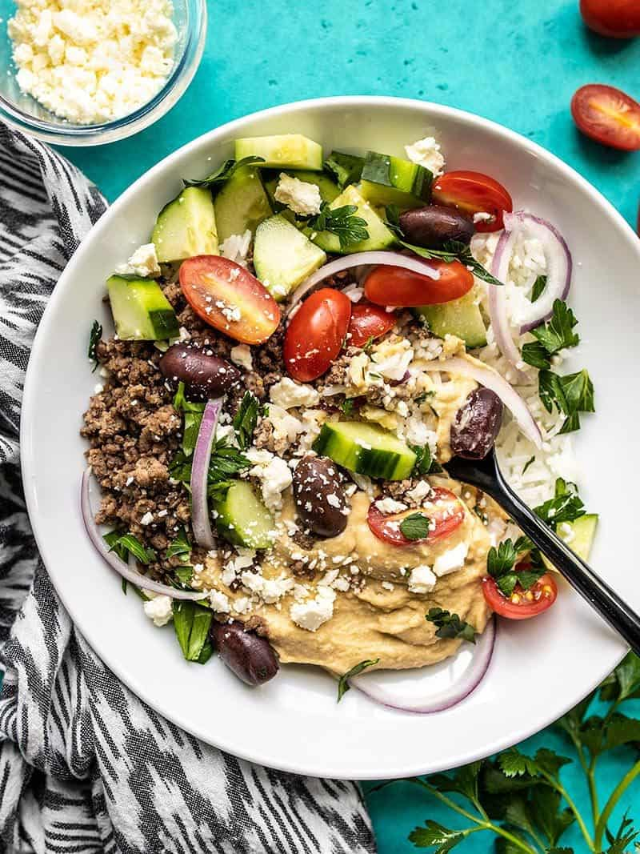
MEDITERRANEAN HUMMUS BOWLS
$9.93 RECIPE / $2.48 SERVING

Prep Time: 15 mins
Cook Time: 10 mins
Total Time: 25 mins
Servings: 4

Ingredients

SEASONED GROUND BEEF
- 1/2 lb. ground beef ($2.65)
- 1/2 tsp dried oregano ($0.05)
- 1/2 tsp cumin ($0.05)
- 1/4 tsp garlic powder ($0.02)
- 1/4 tsp salt ($0.02)
BOWL INGREDIENTS (ALL INGREDIENTS OPTIONAL)
- 4 cups cooked rice ($0.70)
- 1 cup hummus* ($1.48)
- 1 pint grape tomatoes ($1.89)
- 1/2 English cucumber ($0.75)
- 1/4 red onion ($0.07)
- 1 cup kalamata olives ($0.90)
- 2 oz. crumbled feta ($1.10)
- handful fresh parsley, chopped ($0.25)

Directions
- Add the ground beef to a skillet, along with the oregano, cumin, garlic powder, and salt. Cook and stir the beef over medium heat until fully browned and evenly combined with the spices.
- To build the bowls, add 1 cup rice and 1/4 cup hummus to each bowl. Divide the remaining ingredients among the four bowls, or in any amount that you desire. Enjoy immediately or refrigerate until ready to eat.
Nutrition Facts
Serving: 1Serving ・ Calories: 644.3kcal ・ Carbohydrates: 64g ・ Protein: 20.93g ・ Fat: 31.88g ・ Sodium: 1790.08mg ・ Fiber: 7.3g
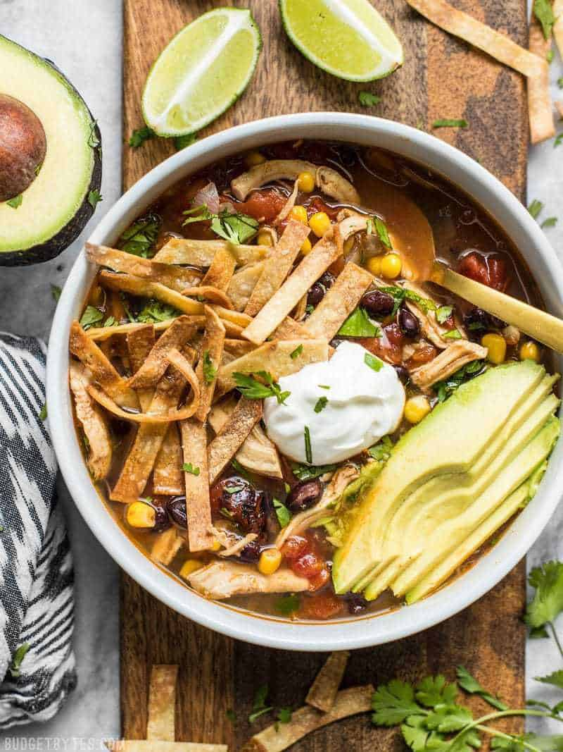
SLOW COOKER CHICKEN TORTILLA SOUP
$9.79 RECIPE / $1.63 SERVING

Prep Time: 10 mins
Cook Time: 4 hrs
Total Time: 4 hrs 10 mins
Servings: 6 (about 1.5 cups each)

Ingredients

SOUP
- 1 yellow onion ($0.32)
- 2 cloves garlic ($0.16)
- 3/4 lb. boneless, skinless chicken breast ($2.09)
- 1/2 Tbsp chili powder * ($0.15)
- 1/2 tsp ground cumin ($0.05)
- 1/2 tsp smoked paprika ($0.05)
- 1/4 tsp cayenne pepper (optional) ($0.02)
- freshly cracked black pepper ($0.03)
- 1 15oz. can fire roasted tomatoes ($1.00)
- 1 10oz. can diced tomatoes with green chiles ($0.49)
- 1 15oz. can black beans ($0.59)
- 1 cup frozen corn kernels ($0.38)
- 6 cups chicken broth** ($0.78)
TORTILLA CRISPS
- 8 6-inch corn tortillas ($0.75)
- 1 Tbsp cooking oil ($0.02)
- pinch salt ($0.02)
OPTIONAL TOPPINGS
- 1 avocado ($1.50)
- 1/4 bunch cilantro ($0.22)
- 6 Tbsp sour cream ($0.48)
- 1 lime ($0.69)

Directions
- Dice the onion and mince the garlic. Add the onion, garlic, chicken breast, chili powder, cumin, smoked paprika, cayenne, some freshly cracked pepper (about 10 cranks of a pepper mill), the fire roasted tomatoes (with juices), diced tomatoes with chiles (with juices), black beans (drained), corn, and chicken broth to the slow cooker.
- Give everything a brief stir, place the lid on the slow cooker, and cook on high for 4 hours, or low for 8 hours.
- After cooking on high for 4 hours or low for 8 hours, carefully remove the chicken breast, shred it with a fork, then return it to the soup.
- To make the tortilla crisps, preheat the oven to 400ºF. Stack the tortillas, then slice them into strips that are approximately 1/4-inch wide and 2 to 3-inches long. Place the strips in a bowl, drizzle with cooking oil, and a pinch of salt. Gently toss the strips until they're completely coated in oil.
- Spread the oil coated tortilla strips over a baking sheet in a single layer, overlapping as little as possible. Bake them in the preheated oven for 10-15 minutes, stirring once every five minutes, or until they are deeply golden brown and crispy. The total cook time will depend on the size of your strips and how crowded they are on the baking sheet, so watch them closely and adjust the cook time as needed.
- To serve, ladle the soup into bowls, top with a handful of the tortilla crisps, some chopped cilantro, a few slices of avocado, and a dollop of sour cream. Squeeze a wedge of fresh lime over top just before eating.
Nutrition Facts
Serving: 1.5Cups ・ Calories: 369.12kcal ・ Carbohydrates: 44.55g ・ Protein: 22.75g ・ Fat: 12.12g ・ Sodium: 1601.85mg ・ Fiber: 10.42g
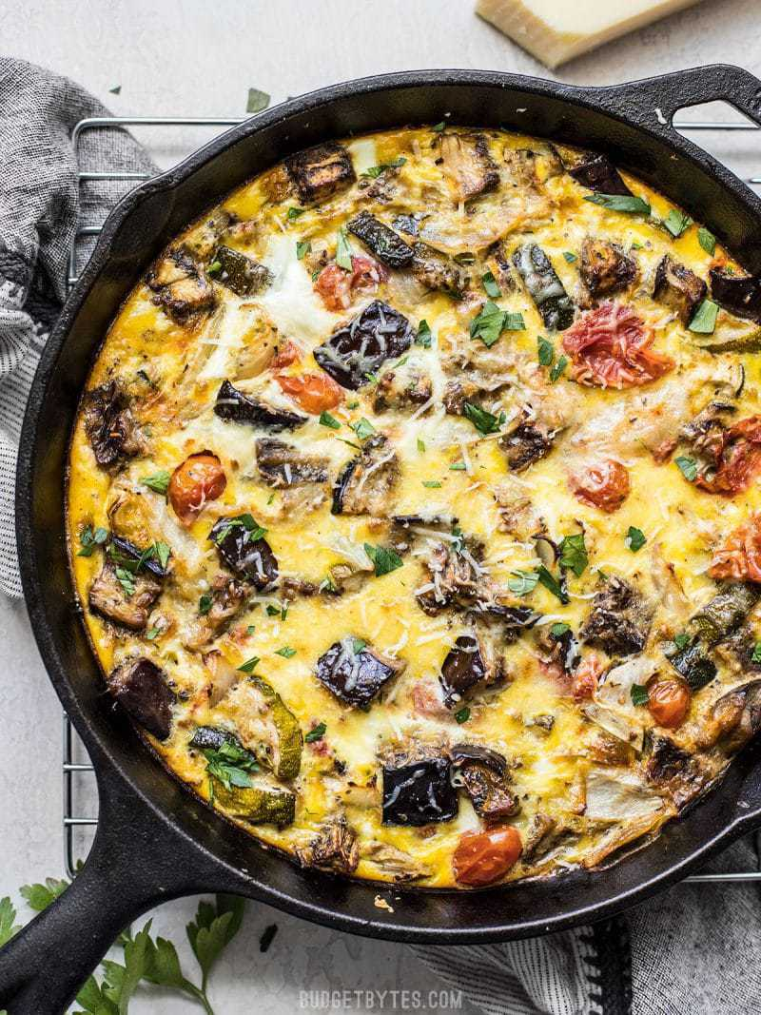
RATATOUILLE FRITTATA
$7.32 RECIPE / $0.92 SERVING

Prep Time: 15 mins
Cook Time: 1 hr 20 mins
Total Time: 1 hr 35 mins
Servings: 8

Ingredients

- 1 eggplant ($1.29)
- 1 zucchini ($0.69)
- 1 yellow onion ($0.45)
- 1 pint grape tomatoes ($1.99)
- 1/2 tsp dried basil ($0.05)
- 1/2 tsp dried oregano ($0.05)
- 1 pinch crushed red pepper ($0.02)
- 1 pinch salt and pepper ($0.05)
- 3 Tbsp olive oil, divided ($0.39)
- 2 cloves garlic, minced ($0.16)
- 6 large eggs ($1.62)
- 1/4 cup milk ($0.09)
- 1 oz. Parmesan ($0.47)

Directions
- Preheat the oven to 400ºF. Dice the eggplant and zucchini into 1-inch pieces. Slice the onion into 1/2-inch strips. Place the eggplant, zucchini, onion, and grape tomatoes (whole) onto a large baking sheet.
- Sprinkle the basil, oregano, crushed red pepper, and a pinch of salt and pepper over the vegetables. Drizzle 2 Tbsp of the olive oil over top, then toss the vegetables until they are coated in oil and spices.
- Roast the vegetables for 50 minutes, stirring every 20 minutes or so, or until they are wilted and browned on the edges, and all the grape tomatoes have burst.
- When the vegetables are almost finished roasting, add the last tablespoon of olive oil to a large oven-safe skillet. Place the skillet over medium heat and add the minced garlic. Sauté the garlic for 1-2 minutes, or just until it is soft and fragrant. Make sure to spread the oil up the sides of the skillet to help prevent the eggs from sticking.
- Add the roasted vegetables to the skillet with the garlic and stir to combine. Briefly whisk the eggs, milk, and a pinch of salt and pepper together in a separate bowl, then pour them over top of the vegetables in the skillet. Finally, top the eggs and vegetables with shredded Parmesan.
- Transfer the hot skillet to the oven (still at 400ºF) and bake the dish for about 30 minutes, or until the eggs have puffed slightly and are golden brown around the edges. The total baking time will vary slightly depending on the type of cookware and the temperature of the contents before they go in the oven.
- Once the frittata has baked, remove it from the oven, let it rest for about 5 minutes, slice it into eight pieces, and serve.
Nutrition Facts
Serving: 1Serving ・ Calories: 161.51kcal ・ Carbohydrates: 10.41g ・ Protein: 7.55g ・ Fat: 10.56g ・ Sodium: 197.23mg ・ Fiber: 3.58g
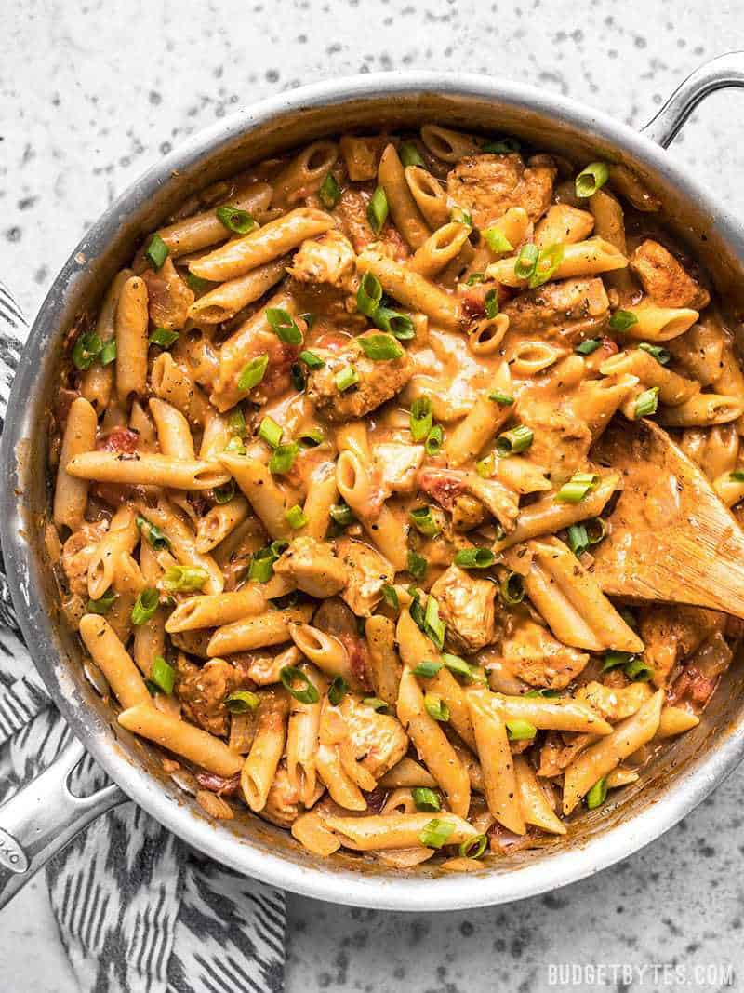
ONE POT CREAMY CAJUN CHICKEN PASTA
$9.41 RECIPE / $2.35 SERVING

Prep Time: 10 mins
Cook Time: 20 mins
Total Time: 30 mins
Servings: 4

Ingredients

CAJUN SEASONING
- 2 tsp smoked paprika ($0.20)
- 1 tsp oregano ($0.10)
- 1 tsp thyme ($0.10)
- 1/2 tsp garlic powder ($0.05)
- 1/2 tsp onion powder ($0.05)
- 1/4 tsp cayenne pepper ($0.03)
- 1/4 tsp black pepper ($0.02)
- 1/4 tsp salt ($0.02)
CHICKEN PASTA
- 1 Tbsp olive oil ($0.16)
- 1 Tbsp butter ($0.13)
- 1 lb. boneless, skinless chicken breast ($5.47)
- 1 yellow onion, diced ($0.32)
- 1/2 lb. penne pasta ($0.75)
- 15 oz. fire roasted diced tomatoes ($1.00)
- 2 cups chicken broth ($0.26)
- 2 oz. cream cheese ($0.50)
- 3 green onions, sliced ($0.25)

Directions
- Combine the ingredients for the Cajun seasoning in a small bowl. Cut the chicken into 1/2 to 3/4-inch cubes. Place the cubed chicken in a bowl, pour the Cajun seasoning over top, and stir to coat the chicken in spices.
- Add the olive oil and butter to a large deep skillet. Heat the oil and butter over medium-high until the skillet is very hot and the butter is melted and foamy. Add the seasoned chicken to the skillet and cook for a couple minutes on each side, or just until the outside gets some color. The chicken does not need to be cooked through at this point.
- Add the diced yellow onion to the skillet and continue to sauté for about 2 minutes more, or just until the onion begins to soften. Allow the moisture from the onion to dissolve any browned bits from the bottom of the skillet.
- Next, add the pasta, fire roasted diced tomatoes (with the juices), and chicken broth to the skillet. Stir just until everything is evenly combined, then place a lid on top and allow the broth to come up to a boil.
- Once boiling, turn the heat down to medium-low and let the pasta simmer for about ten minutes, stirring every couple of minutes, until the pasta is tender and the liquid is thick and saucy.
- Add the cream cheese to the skillet in chunks, then stir until it has melted into the sauce. Top the pasta with sliced green onions and serve.
Nutrition Facts
Serving: 1Serving ・ Calories: 482.65kcal ・ Carbohydrates: 51.53g ・ Protein: 34.95g ・ Fat: 14.58g ・ Sodium: 847.23mg ・ Fiber: 3.45g
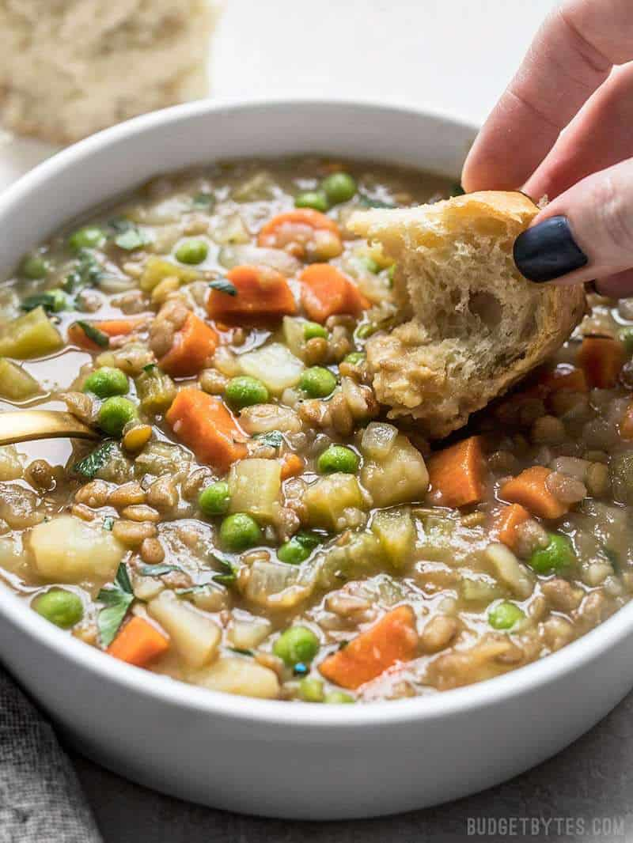
VEGAN WINTER LENTIL STEW
$5.08 RECIPE / $0.64 SERVING

Prep Time: 10 mins
Cook Time: 50 mins
Total Time: 1 hr
Servings: 8 (1.5 cups each)

Ingredients

- 2 Tbsp olive oil ($0.32)
- 1 yellow onion ($0.32)
- 4 cloves garlic ($0.32)
- 4 carrots (about 1/2 lb.) ($0.45)
- 4 stalks celery ($0.75)
- 2 lbs potatoes ($0.70)
- 1 cup brown lentils ($0.49)
- 1 tsp dried rosemary ($0.10)
- 1/2 tsp dried thyme ($0.05)
- 2 Tbsp Dijon mustard ($0.09)
- 1.5 Tbsp soy sauce ($0.09)
- 1 Tbsp brown sugar ($0.04)
- 6 cups vegetable broth ($0.78)
- 1 cup frozen peas ($0.38)

Directions
- Dice the onion and mince the garlic. Add the olive oil, onion, and garlic to a large soup pot and begin to sauté over medium heat.
- While the onion and garlic are sautéing, dice the celery, then add it to the pot and continue to sauté. As the celery, onion, and garlic are sautéing, peel and chop the carrots into half rounds. Add the carrots to the pot and continue to sauté.
- As the onion, garlic, celery, and carrots are sautéing, peel and cube the potatoes into 3/4 to 1-inch pieces. Add the cubed potatoes to the pot along with the lentils, rosemary, thyme, Dijon, soy sauce, brown sugar, and vegetable broth.
- Briefly stir the ingredients to combine, then place a lid on the pot, turn the heat up to high, and bring the stew up to a boil. Once it reaches a boil, turn the heat down to low and let it simmer for 30 minutes, stirring occasionally.
- Toward the end of the simmer time, when the potatoes are very soft, begin to mash the potatoes a bit as you stir. This will help thicken the stew.
- Finally, after 30 minutes, stir in the frozen peas and allow them to heat through. Taste the stew and add salt if needed (this will depend on the salt content of your broth, I did not add any extra). Serve hot and enjoy!
Nutrition Facts
Serving: 1.5Cups ・ Calories: 249.2kcal ・ Carbohydrates: 45.91g ・ Protein: 9.88g ・ Fat: 3.99g ・ Sodium: 964.61mg ・ Fiber: 7.86g
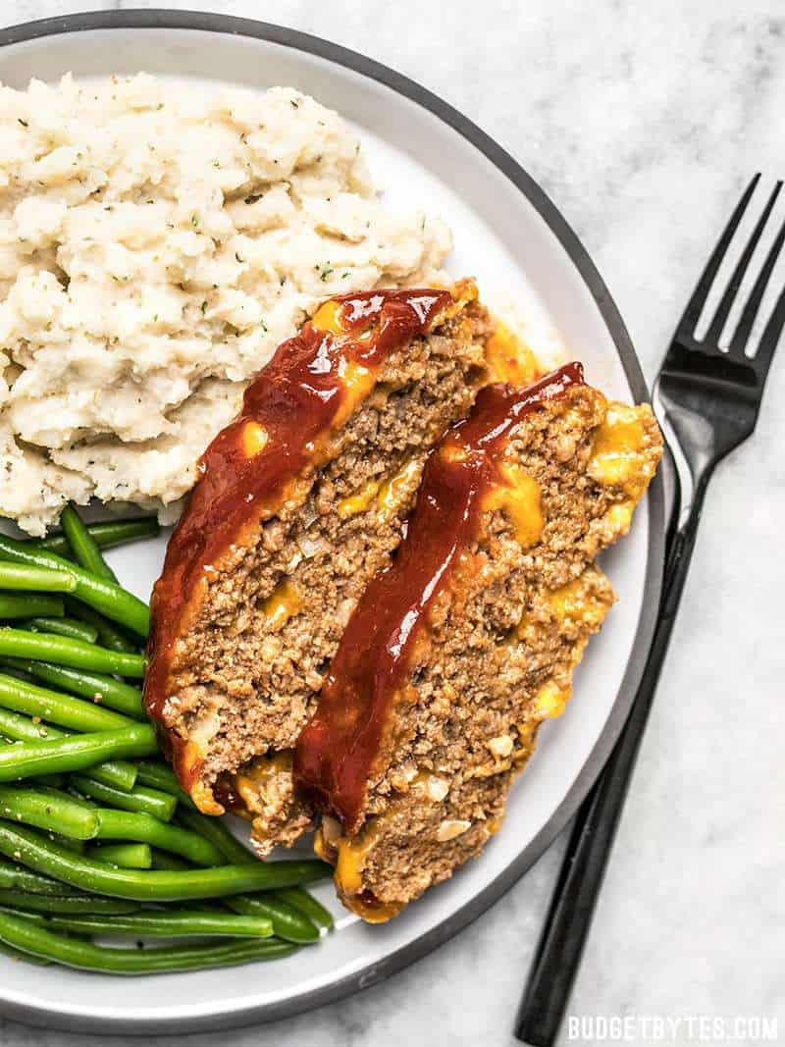
CHEDDAR CHEESEBURGER MEATLOAF
$7.31 RECIPE / $1.83 SERVING

Prep Time: 15 mins
Cook Time: 50 mins
Total Time: 1 hr 5 mins
Servings: 4 (2 slices each)

Ingredients

MEATLOAF
- 1/4 cup plain breadcrumbs ($0.06)
- 1 tsp smoked paprika ($0.10)
- 1/2 tsp garlic powder ($0.05)
- 3/4 tsp salt ($0.03)
- 1 large egg ($0.27)
- 1/2 cup minced onion ($0.16)
- 4 oz. sharp cheddar ($0.85)
- 1 lb. ground beef (85/15) ($5.29)
GLAZE
- 1/2 cup ketchup ($0.41)
- 1 Tbsp brown sugar ($0.04)
- 1 tsp yellow mustard ($0.03)
- 1 tsp Worcestershire sauce ($0.02)

Directions
- Preheat the oven to 350ºF. In a small bowl stir together the breadcrumbs, smoked paprika, garlic powder, and salt. In a separate small bowl, lightly whisk the egg.
- Finely mince the onion. Roughly chop the cheddar cheese so that it is in pieces about the same size as a small bean.
- Add the ground beef, seasoned breadcrumbs, whisked egg, minced onion, and chopped cheddar to a bowl. Use your hands to mix the ingredients together until incorporated.
- Place the meat mixture in a casserole dish or on a rimmed baking sheet and shape into a rectangle, approximately 7" long, 4" wide, and 1.5" thick.
- To make the glaze, stir together the ketchup, brown sugar, mustard, and Worcestershire sauce. Spread the glaze over the unbaked meatloaf.
- Bake the meatloaf in the preheated oven for 50-55 minutes, or until the internal temperature reaches 160ºF. Remove the meatloaf from the oven, let it sit for 5-10 minutes, then slice into eight pieces and serve.
Nutrition Facts
Serving: 1Serving ・ Calories: 449.3kcal ・ Carbohydrates: 23.6g ・ Protein: 28.65g ・ Fat: 24.33g ・ Sodium: 1099.98mg ・ Fiber: 0.63g
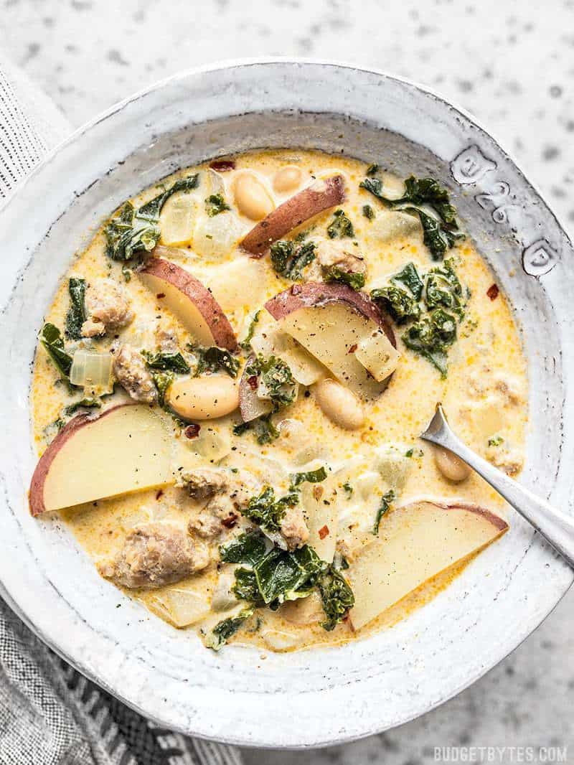
ZUPPA TOSCANA
$7.51 RECIPE / $0.94 SERVING

Prep Time: 15 mins
Cook Time: 30 mins
Total Time: 45 mins
Servings: 8 (1.5 cups each)

Ingredients

- 1/2 lb. Italian Sausage, hot or mild ($1.75)
- 1 yellow onion ($0.32)
- 2 cloves garlic ($0.16)
- 1 15 oz. can Great Northern beans ($0.49)
- 1/2 tsp smoked paprika ($0.05)
- 3 cups chicken broth* ($0.39)
- 1 cup water ($0.00)
- 2 cups half and half ($1.49)
- 1 lb. red potatoes ($1.29)
- 1/2 lb. kale, chopped ($1.50)
- pinch red pepper flakes, optional ($0.02)
- freshly cracked black pepper, optional ($0.05)

Directions
- Add the sausage to a large soup pot and sauté over medium heat, breaking it up into small pieces as it cooks. The sausage should contain enough fat to keep it from sticking, if not add a touch of olive oil. It's okay if a small amount browns on the bottom of the pot.
- While the sausage is cooking, dice the onion and mince the garlic. Add the onion and garlic to the pot and sauté until the onions are softened. The moisture from the onions should help dissolve any browned bits of sausage off the bottom of the pot.
- Drain and rinse the can of beans. Add the beans, smoked paprika, chicken broth, one cup water, and half and half to the pot. Place a lid on the pot and let it come up to a simmer over medium heat.
- While the pot is heating, cut each potato into quarters lengthwise, then slice across into thin, 1/8-inch thick slices. Add the potatoes to the pot along with the pre-chopped kale. The kale will fill the pot when it's first added, but the heat from the liquid will wilt it within a few minutes. Stir it occasionally to help the wilting process.
- Let the pot simmer over medium heat for about 15 minutes, or until the potatoes are tender. Season with red pepper flakes and freshly cracked black pepper if desired.
Nutrition Facts
Serving: 1.5Cups ・ Calories: 299.81kcal ・ Carbohydrates: 27.85g ・ Protein: 13.89g ・ Fat: 15.56g ・ Sodium: 723.19mg ・ Fiber: 5.15g
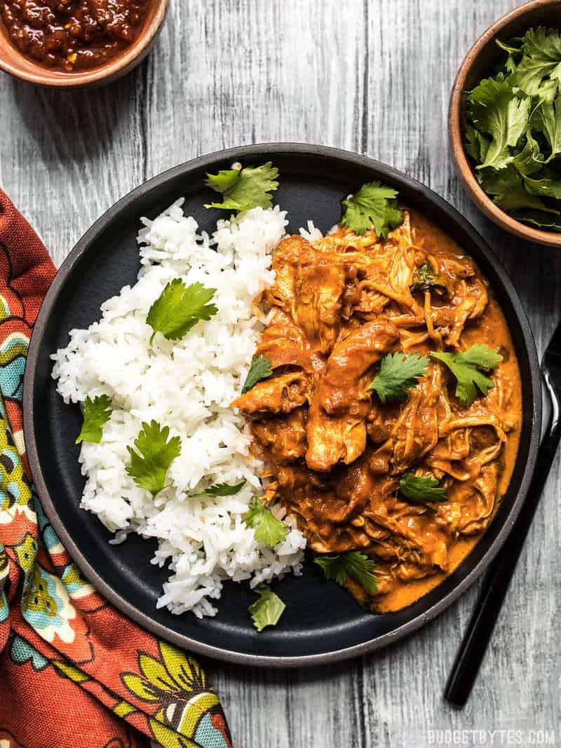
EASY SLOW COOKER CHICKEN TIKKA MASALA
$8.82 RECIPE / $2.21 SERVING

Prep Time: 15 mins
Cook Time: 3 hrs 15 mins
Total Time: 3 hrs 30 mins
Servings: 6

Ingredients

- 1.5 Tbsp garam masala ($0.45)
- 1/2 tsp cumin ($0.05)
- 1/2 tsp turmeric ($0.05)
- 1/2 tsp smoked paprika ($0.05)
- 1/2 tsp salt ($0.02)
- 1/4 tsp cayenne (optional) ($0.02)
- Freshly cracked pepper ($0.02)
- 2 lbs. boneless skinless chicken thighs ($5.78)
- 1 Tbsp cooking oil ($0.04)
- 1 yellow onion, diced ($0.32)
- 3 cloves garlic, minced ($0.24)
- 1 Tbsp grated fresh ginger ($0.11)
- 15 oz. tomato sauce ($0.50)
- 1/3 cup heavy cream ($0.32)
FOR SERVING
- 4 cups cooked rice ($0.70)
- 1/4 bunch fresh cilantro ($0.17)

Directions
- In a small bowl, combine the garam masala, cumin, turmeric, smoked paprika, salt, cayenne, and some freshly cracked pepper (about 10 cranks of a pepper mill). Sprinkle the spice mix over both sides of the chicken thighs, coating them liberally.
- Heat the cooking oil in a large skillet over medium-high heat. Once hot, add the seasoned chicken and cook for about 3 minutes on each side, or until well browned (the chicken does not need to be cooked through). Transfer the seared chicken to the slow cooker.
- Add the diced onion to the skillet and continue to cook until the onions are soft and slightly browned on the edges. Remove the skillet from the heat. Add the onions to the slow cooker, then add 1/4 cup of water to the skillet and stir to dissolve the browned bits from the bottom of the skillet. Pour the water into the slow cooker.
- Add the minced garlic, grated ginger, and tomato sauce to the slow cooker with the chicken and onion. Briefly stir, then place the lid on top, and turn the slow cooker on. Cook on high for 3 hours or low for 6 hours.
- After 3 hours on high or 6 hours on low, the chicken should be fall-apart tender. Turn the slow cooker off, then add the heavy cream. Stir gently to combine the cream with the tomato sauce. Taste the sauce and add salt if needed.
- To serve, spoon the chicken and tomato sauce over cooked rice and top with fresh cilantro.
Nutrition Facts
Serving: 1Serving ・ Calories: 324.72kcal ・ Carbohydrates: 10.32g ・ Protein: 27.62g ・ Fat: 20.78g ・ Sodium: 665.7mg ・ Fiber: 2.77g
Recognition

BUDGETBYTE$: Recipes Under $10
https://www.budgetbytes.com/category/recipes/cost-per-recipe/recipes-under-10/

