Cooking at the 99¢ Only Store

- Baked Potatoes 2
- Banana Pudding With Nila Wafers 3
- Breakfast Skillet 4
- Chicken Enchiladas With Salsa Verde 6
- Flan (Creme Caramel ) 8
- Hamburger & Macaroni Skillet 10
- Lemon Cheesecake 12
- Onion Rings 13
- Polish Sausage Skillet with Vegetables 14
- Portabella Stuffed Mushrooms 15
- Sloppy Joes 16

Baked Potatoes
INGREDIENTS
- 4 Idaho Potatoes
- Olive oil or Vegetable Oil
- Butter
- Sour Cream
- Chives or Chopped Green Onions
INSTRUCTIONS
- Pre-heat the oven to 425 degrees.
- Wash the potatoes and pat dry.
- Place on a baking tray lined with aluminum foil.
- Using a fork poke some holes into the top and bottom sides of the potatoes.
- Brush the skin with either vegetable oil or olive oil.
- Then brush some melted butter onto the skin.
- Place in the oven .
- Bake for 30 minutes then take the potatoes out of the oven and turn them over.
- Bake for another 30 minutes and take the potatoes out and turn them over once again. The potatoes have now been cooking for a total time of 60 minutes. This time stick a fork into them and if they are not yet soft return them to the oven and bake for 20 minutes more.
- After the 20 minutes flip them over for the last time and turn off the stove.
- Let the potatoes sit in the oven for 30 minutes with the oven turned off and the door closed.
- Then take the potatoes out and cut a slit down the center of them.
- Cut around the slit to make an opening on the top of the potatoes.
- And using a fork fluff the insides of the potatoes.
- Top them with butter, sour cream and chives or green onions.
- You can also add some shredded cheese or bits of bacon.

Banana Pudding With Nila Wafers
INGREDIENTS  - 2 Boxes Nilla Wafers  - 1 Cup Whipping Cream  - 1 Tablespoon Sugar  - 1 Teaspoon Vanilla Extract  - 2 Boxes Jello Instant pudding ( 3.4 oz ) French Vanilla  - 4 Cups Cold Milk  - 8 oz Cream Cheese Room Temperature  - 7 oz Condensed Milk  - 6 Bananas Sliced  Supplies Needed:  - Serving Bowl  - Electric Hand Mixer | 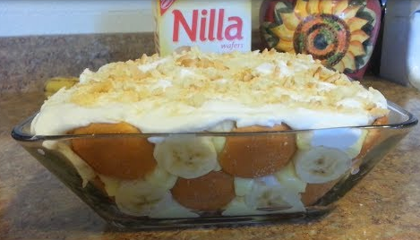
INSTRUCTIONS
- Place a mixing bowl and and the whisks in the freezer for about 20 minutes. Place the whipping cream in the freezer for 5 minutes.
- Make the instant pudding. Pour the Jello Instant pudding into a bowl. Add in the milk and whisk until you no longer feel any more lumps. Set aside.
- Make the whip cream.Pour the whipping cream in the bowl and beat with the electric hand mixer until thickened. Add sugar and vanilla extract and whip until soft peaks form. Set aside.
- Place the cream cheese into a bowl and beat. Add in the condensed milk. Beat to combine.
- Then pour the cream cheese into the pudding bowl. Fold to combine.
- Add 4 ounces of the whipped cream into the pudding bowl. Fold to combine.
- Slice the banana.
- Assemble the serving bowl. Line the bottom of the bowl with the wafers. Lay the banana slices on top. Then line the sides of the bowl with wafers alternating between wafers and bananas. Add in a layer of the pudding. Then alternate the layers of wafers, banana slices and pudding. Cover the last layer with the whipped topping.
- Cover and refrigerate overnight.
- Right before serving sprinkle on some crushed wafers.

Breakfast Skillet
INGREDIENTS
- 6 Slices of Bacon OR 1 Bag of Farmer John's Fully Cooked Sausage Links ( Use as many links as you'd like )
- 2 Tablespoons Vegetable Oil
- 1/2 Cup Chopped Yellow Onions
- 2 Cups Sliced Button Mushrooms
- 1/4 Cup Chopped Green Bell Peppers
- 1 Bag of Shredded Hash Browns ( Slightly thawed )
- 5 eggs ( Beaten )
- 2 Cups Shredded Cheddar Cheese ( Or use or favorite type of cheese )
- 1 Roma Tomato ( Chopped )
- Handful or two of Chopped Green Onions
- Salt & Black Pepper to taste
INSTRUCTIONS
- In a skillet on Medium heat cook the bacon until crispy,
- Then place the cooked bacon on a paper towel to drain.
- And cut the bacon into smaller bite size pieces. Set aside.
- Next prep everything and have it ready next to the skillet. Beat the eggs. Slice the mushrooms. Chop the tomatoes, green bell peppers, green onions and yellow onion.
- In a skillet add 2 tablespoons of cooking oil and turn the heat on to Medium High. Once the oil is heated add in the onions, mushrooms and green bell peppers. Cook for about 2 minutes.
- Then add in the shredded hash browns and mix it all together. Press down on the hash browns and cook for 5 minutes.
- If you are using bacon for this recipe then just pour the beaten eggs into the skillet to completely cover everything. Do not add the bacon yet. Save it until the very end.
- If you are using sausage links for this recipe then add in the sliced sausage links . Then pour in the beaten eggs to completely cover everything.
- Next add on the shredded cheese, tomatoes, and green onions.
- Lower the heat to Medium-Low, cover with a lid and cook for 10 to 15 minutes until the eggs are set and the cheese has melted.
- Top the breakfast skillet with the chopped bacon right before serving to keep them crispy.
- Sprinkle with salt & black pepper to taste.
- Serve immediately.

Chicken Enchiladas With Salsa Verde
INGREDIENTS
- 1 Package of Corn Tortillas 27.05 oz
- 4 Cups Cooked Shredded Rotisserie Chicken
- 3 Packages of Mexican Style Blend Cheese 8 oz each
- 2 Jars of Salsa Verde 12 oz each
To Cook The Tortillas:
- 11 Corn Tortillas
- Vegetable Oil
To Make The Filling:
- 1 Tablespoon Vegetable Oil
- 4 Garlic Cloves Minced
- 1/3 Cup Chopped Red Onions
- Cooked Shredded Rotisserie Chicken
- 1/4 Teaspoon Garlic Salt
- 1/8 Teaspoon Black Pepper
- 1 1/2 Cups Shredded Mexican Blend Cheese
- 1 Cup Salsa Verde
- 1/2 Cup Chopped Cilantro
Prepare The Baking Dish:
- Olive Oil Cooking Spray
- 1 Cup Salsa Verde
Top With: ( Optional )
- Sour Cream
Serve With: ( Optional )
- Spanish Rice
- Mexican Pickled Carrots & Jalapenos
You will need a:
- 3 Quarts Casserole Dish

INSTRUCTIONS
- Slightly cook the corn tortillas. Coat the pan with some cooking oil and turn on the heat on to Medium.
- Once the pan is hot lay a corn tortilla into the pan. Cook each side for about a minute.
- Remove and place the cooked tortilla on a plate lined with paper towels. Coat the pan with cooking oil after each tortilla. Repeat the process with all 11 of the corn tortillas. Be careful not to over cook the tortillas as they will harden Set aside.
- Pre-heat the oven to 375 degrees.
- In a pan on Medium-High heat add 1 tabespoon of vegetable oil. Once the oil is warm add in the minced garlic and chopped red onions. Saute for about a minute until the onions are translucent then add in the shredded chicken.
- Toss the chicken until it is warmed through.
- Add in the garlic salt and black pepper.
- Toss again then add in 1 1/2 cups of shredded cheese. After adding in the shredded cheese immediately turn off the heat.
- Stir then add in 1 cup of salsa verde.
- Mix and add in 1/2 cup of chopped cilantro.
- Then give it one last sprinkle of black pepper and do not stir the chicken mixture. You can leave the chicken mixture in the pan or transfer it to a bowl. Set aside.
- Coat the baking dish with some cooking spray.
- Pour in 1 cup of the salsa verde and spread a thin layer on the bottom of the dish. Set aside.
- Lay a cooked corn tortilla on a plate or cutting board. Place some of the chicken mixture in the center of the tortilla.
- Then roll the tortilla upwards.
- Place the enchiladas seam down in the baking dish.
- Pour the rest of the salsa verde over the enchiladas.
- Completely cover the enchiladas with the shredded cheese.
- Bake at 375 degrees for 25 minutes. Then increase the heat to 450 degrees and bake for 5 minutes or until the cheese has melted. Please be aware that baking time may vary with different ovens.
- Top with Sour Cream. (Optional ) Serve with Spanish Rice and a side of Mexican pickled carrots & jalapenos.

Flan (Creme Caramel )
INGREDIENTS  For the caramel sauce you will need:  - 3/4 cup sugar  To make the custard you will need:  - 4 eggs  - 1/3 cup sugar  - 2 cups whole milk  - 2 teaspoons vanilla extract  - pinch of salt | 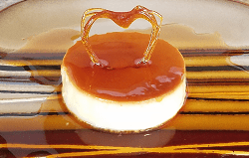
INSTRUCTIONS
- Fill a tea kettle with water and bring it to a boil.
- Pre-heat the oven to 350 degrees.
- Make the caramel sauce. In a medium saucepan add the sugar and turn the heat on to Medium. Once the sugar around the edges of the pan begins to melt push the sugar towards the center of the pan. Then evenly spread out the sugar. Repeat the process until half of the sugar has melted and continue to slowly stir the sugar until it has all dissolved. Remove the pan from the heat once it starts to smoke. Immediately pour the caramel sauce into the ramekins. Set it aside and let it cool.
- Warm the milk. In a medium saucepan add the milk. Turn the heat on to Medium. Once the milk starts to steam turn off the heat and place the pan on a different burner.
- Make the custard. In a medium mixing bowl add in the eggs, sugar, vanilla extract and salt. Whisk vigorously. Then add in the warmed milk a little bit each time while whisking the egg mixture. Once half of the milk has been added then you can pour the rest of it into the bowl. Continue to whisk until everything is well combined.
- Pour the mixture through a sieve into a measuring cup and remove any foam from the top of the custard.
- Divide the custard among the ramekins. Remove any foam or bubbles from the top of the custard.
- Tap each ramekin on the counter to remove any air bubbles.
- Place the ramekins in a deep baking tray .
- Transfer the tray to the oven and pour in the hot water. The water should reach at least half the height of the ramekins.
- Lay a sheet of aluminum foil over the custard cups.
- Bake for approximately 65-70 minutes. Check the flan at the 60 minute mark. If the flan is not done continue to bake another 5 to 10 minutes. Remove the flan from the oven when there is only a slight jiggle in the center of the flan.
- Place on the counter to cool for about an hour.
- The flan will set in 4 hours but it is best to refrigerate overnight to allow the caramel to liquify.
- When ready to serve run a knife around the edge of the ramekin. Then place a plate over custard cup and invert the flan onto the plate.
- Serve plain or with whipped cream.
Hamburger & Macaroni Skillet
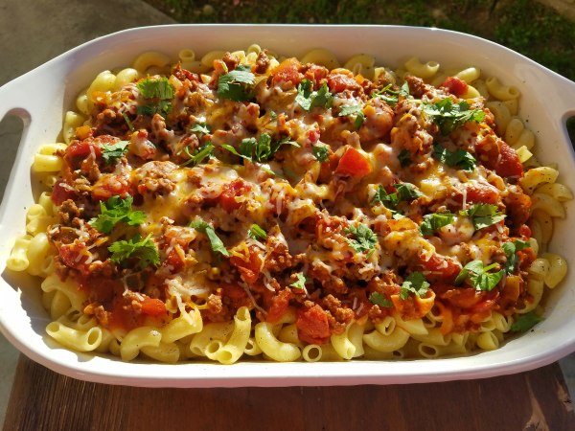
INGREDIENTS
- 1 Box Large Elbow Macaroni 16 oz
ADD TO THE SKILLET:
- 1/2 Pound Lean Ground Beef
- 4 Garlic Cloves Chopped
- 1/2 Cup onion Chopped
- 1/2 Cup Green Bell Peppers Chopped
- 1/4 Teaspoon Black Pepper
- 1/2 Teaspoon Garlic Salt
- 1/2 Teaspoon Red pepper/chili flakes
- 1/2 Teaspoon Italian Seasoning
- 3/4 Cup Pre-made beef broth Or you can use 1 beef bouillon cube + 3/4of hot water to make the beef broth
- 1 Can Tomato Sauce 15 oz
- 1 Can Italian Style Diced Tomatoes 15 oz
- 1 Tablespoon sugar
TOP WITH:
- 1 8 oz Bag Shredded Blend of Mild Cheddar & Monterey Jack Cheese Cheese ( You can also use shredded Italian Blend cheese or any cheese of your choice ) Optional
- Handful Cilantro for garnish Optional
- Serve with Garlic Toast ...Yummy !
INSTRUCTIONS
- Cook the macaroni according to the directions on the back of the box. Don't forget to add salt to the water. ( I cooked my pasta for 9 minutes )
- In a bowl add 3/4 cup of water + 1 beef buillon cube and microwave for 2 minutes. Set it aside and let the cube dissolve . Skip this step if you are going to be using pre-made beef broth.
- Chop the garlic, green bell peppers and onion.
- In a skillet on Medium-High heat brown the beef. Break the beef into smaller pieces. Drain the fat.
- Add the garlic, green bell peppers, onion and seasonings. Saute until the onions turn translucent.
- Add the beef broth and let it come to a boil.
- Then add the tomato sauce, diced tomatoes and sugar. Then bring it back to a boil.
- Reduce the heat to Low. Cover and simmer for 15 minutes. Stirring occasionally.
- Right before turning off the heat add the shredded cheese. Cover for 1 minute or until the cheese is melted.
- Sprinkle with black pepper .
- Garnish with chopped cilantro.
- Serve with Garlic Toast.

Lemon Cheesecake
INGREDIENTS
- 1 Graham Cracker Ready Crust
For the filling:
- 2 oz Blocks Cream Cheese at Room Temperature 8each
- 1 oz can Sweetened Condensed Milk 14
- 1/4 cup lemon juice Approximately 2 large lemons.
- 1/4 Teaspoon Salt
- 2 Teaspoons Vanilla Extract
- 1/2 Cup Whipping Cream
- 1 Tablespoon Lemon Zest
For the topping:
- 1 Can Whipped Cream Topping
INSTRUCTIONS
- Grate one lemon.
- Squeeze the lemons for its juice.
- Place the cream cheese into a bowl and blend with a hand mixer until creamy.
- Then add in the condensed milk and mix until smooth.
- Gradually add in the lemon juice and continue to mix.
- Add the salt and vanilla extract and mix.
- Add the whipping cream and mix.
- Lastly add in the lemon zest and mix.
- Pour the filling into the ready made graham cracker crust and smooth out the top of the filling.
- Cover and refrigerate overnight.
- When ready to serve top with whipped cream.

Onion Rings
INGREDIENTS
- Cooking OIl
- 1 Yellow Onion or Sweet White Onion
- 1 Egg
- 1 Cup milk
- 6 Ounces Panko Bread Crumbs
- Seasoned Salt to taste
- Seasoned Salt to taste
Dry Ingredients:
- 1/14 Cups All Purpose Flour
- 1 Teaspoon Baking Powder
- 1/2 Teaspoon Onion Powder
- 1/2 Teaspoon Garlic Powder
- 1/8 Teaspoon Black Pepper
- 1/2 Teaspoon Cayenne Pepper
INSTRUCTIONS
- Combine the dry ingredients. In a bowl add in the All purpose flour, baking powder, onion powder, garlic powder, black pepper, and the cayenne pepper.
- Slice the onion 1/2" inch to 1" wide. Separate the rings.
- Place a few of the onion rings into the bowl of flour. Cover and shake the bowl.
- Take the onion rings out and shake off the excess flour. Then transfer to a plate. Repeat the process until all the onion rings are coated with the flour.
- Pour the Panko bread crumbs into a bowl. Set aside.
- Now add an egg to the dry mixture and also the milk. Stir the batter until smooth.
- Place an onion ring into the batter and coat. Then pick up the onion ring and let the excess batter drip off. Next transfer the onion ring to the bowl of panko crumbs and coat. Place on a plate and repeat the process for the rest of the onion rings.
- In a wok add the cooking oil and turn on to Medium High heat. Once the oil is hot add in the onion rings. Do not overcrowd the wok. Fry for about a minute on each side or until browned. Remove from the cooking oil and place on a plate lined with paper towels. As soon as the onion rings come out of the wok immediately season the onion rings. After removing the first batch from the work let the oil come back to temperature before adding in the next batch of onion rings.
- Serve with ketchup or your favorite dipping sauce.

Polish Sausage Skillet with Vegetables
INGREDIENTS
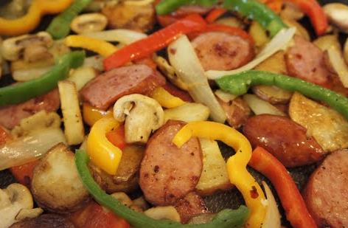
- 3 Tablespoons Cooking OIl (2 Tablespoons to fry potatoes & 1 Tablespoon to saute the bell peppers)
- 2-3 Garlic Cloves Minced
- 1/2 Yellow Onion Sliced
- 1 Carton of Button Mushrooms Sliced
- 1 Green Bell Pepper Sliced
- 1 Orange Bell Pepper Sliced
- 1 Red Bell Pepper Sliced
- 5 Red Potatoes Sliced
Season with:
- Chili Flakes Optional
- Black Pepper Optional
- Seasoning Salt Optional
INSTRUCTIONS
- In a pan on Medium-High heat add 2 tablespoons cooking oil to a pan.
- Once the oil is hot add in the potatoes. Fry for about 4 minutes until browned and then cover the skillet.
- Turn the potatoes over and reduce the heat to Medium and cover the skillet.
- Fry for another 5 minutes or until browned.
- Place the potatoes on a plated lined with paper towels and set aside.
- In the same pan turn the heat on to Medium and add in the sausages.
- Season with black pepper, chili flakes and seasoning salt.
- Cook for 3-4 minutes until browned.
- Then flip the sausages over and cook for another 3-4 minutes until the other side has browned as well.
- Place on a paper plate lined with paper towels and set aside.
- Again in the same pan on Medium-High heat add the garlic, onions and mushrooms. Saute for 1-2 minutes.
- Add in the green bell pepper, orange bell pepper, red bell pepper and saute for 7 minutes or until tender.
- If the pan is dry add in a tablespoon of cooking oil .
- Add in the potatoes and sausages and cook until they are heated through for 2-3 minutes.
Portabella Stuffed Mushrooms
INGREDIENTS  - 2 Medium Sized Portabella Caps  - 2 Tablespoons Butter  - 4 Tablespoons Extra Virgin Olive Oil  - 3 Tablespoons tomatoes Chopped  - 2 Tablespoons Onions Chopped  - 3 Cups Fresh Spinach  - 1/2 Bag (3 ounces needed only ) Monterey Jack with Jalapeno cheese Or shredded cheese of your choice.  - Salt & Pepper to taste.  - Cooked Bacon (Optional)  - Tobasco Sauce (Optional) | 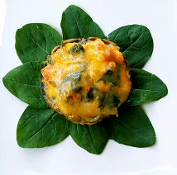
INSTRUCTIONS
- Brush some olive oil on the bottom of a baking dish.
- Clean the mushroom caps. Use a spoon to remove the gills.
- Brush the olive oil onto both sides of the mushrooms.
- Season both sides of the mushrooms with salt & pepper.
- Set aside.
- Preheat the oven to 450 degrees.
- In a pan on Medium High heat add the butter.
- Once the butter is melted add the onions and saute for 30 seconds.
- Then add the tomatoes and saute for about 1 to 2 minutes until the onions are translucent.
- Throw in the spinach and saute the spinach for about a minute.
- Once the spinach is wilted immediately turn off the heat .
- Spoon the filling into the mushroom caps.
- Add cooked bacon if desired.
- Top the mushrooms with cheese.
- Transfer the stufffed mushrooms over to the baking dish and place in the preheated oven.
- Bake for 15 minutes at 450 degrees.
- Turn the baking dish around and then bake at 500 degrees for 5 minutes.
- Total baking time is 20 minutes.
- Place under the broiler for 15-30 seconds to brown the cheese. .
- Remove from the oven and enjoy !
- Add salt & pepper to taste.
- And add a few dashes of Tobasco sauce for some heat. (optional )

Sloppy Joes
INGREDIENTS
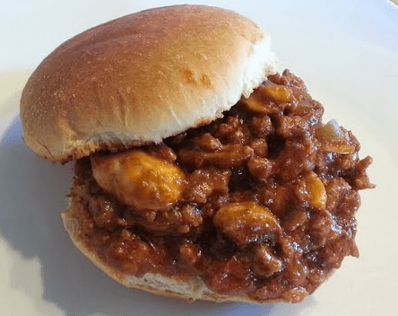
- 1 Tablespoon Vegetable Oil
- 1.17 Pound Ground Beef ( 1 Pound and 3 ounces )
- 1/2 Of A Green Bell Pepper ( Equals to 2/3 cup diced )
- 1/2 Of A Small Onion ( Equals to 1/3 cup diced )
- 5 Large Mushrooms (Equals to 1/3 cup sliced )
- 3 Garlic Cloves ( Minced )
- 1/4 Teaspoon Garlic Salt
- 1/4 Teaspoon Onion Powder
- 1/4 Teaspoon Black Pepper
- 1/2 Teaspoon Red Pepper Flakes ( Optional )
- 2 Cans Hunt's Manwich Original Sloppy Joe Sauce 15 oz each
Also needed:
- 10 Gourmet Sesame Seed Hamburger Buns
- Butter
INSTRUCTIONS
- On medium-high heat add a tablespoon of cooking oil to a pan. Once the oil is hot, toss in the chopped onions and minced garlic. Saute for about 30 seconds or until the onions are translucent.
- Add the ground beef to the pan and break the meat apart with a spatula.
- Cook the beef until it is half way done and then season the beef with garlic salt, onion powder, black pepper and red peper flakes. Give it a quick stir.
- Then toss in the green bell peppers & mushrooms . Stir to combine everything and cook for about 3 minutes.
- Drain most of the fat if there are any. Then pour in the 2 cans of sloppy joe sauce. Stir to combine. Bring to a boil.
- Then reduce the heat to low and simmer for 10 minutes. Stirring often to prevent splattering. When done, turn off heat and set aside.
- Toast your buns in a bread toaster on the first or second setting. Then coat the bottom of the pan with some butter. Turn your heat on to medium and once the butter has melted transfer the slightly toasted buns to the pan.
- Toast the bottoms of the buns until they are lightly browned and crispy. This will prevent the bread from getting soggy once you place the sloppy joe sauce onto the buns. Plus it will make your buns extra delicious!
- Spoon some of the Sloppy Joe on top of the bread .
- Serve immediately!

Recognition

Eat with Emily: 99 Cents Only Store Recipes
https://www.eatwithemily.com/99-cents-only-store-recipes/

